On – Boarding document

EUCLID APPLICATION

Abstract | This document provides a global overview of the TANDEM gateway infrastructure. In addition, the most important chains are explained in order to find your way on the TANDEM infrastructure  To be used by developers and analysts on the TANDEM platform.
Document Reference
Document Type | Guide
Context | Methods
Version | 03.10
Status | FINAL
Date of Issue | 19 May 2014
File Location
# Pages | 161

Produced by | An Decrick
Reviewed by | Elodie Doncq, Thierry Permane, Vincent Collin
Authorised by | Elodie Doncq

Table of contents
1. Introduction 7
1.1 What is EUCLID 7
1.2 The EUCLID architecture diagram 9
2. Background : definitions 10
2.1 Euroclear Participant 10
2.2 Euclid users 10
2.3 User hierarchy and segregation of functions 11
2.4 What is BESS? 13
2.5 What is Swift? 13
2.6 What is a SWIFT message? 13
3. Input and reporting on tandem 15
3.1 File Transfer 15
3.1.1 Introduction 15
3.1.2 Euclid commands 16
3.1.3 Euclid reports 16
3.1.4 Examples of commands 17
3.1.5 Example of reports 17
3.1.6 File characteristics 19
3.1.7 Testing connectivity 20
3.1.8 Overview 20
3.1.8.1 Component Description 23
3.1.8.1.1 Component Name: FT Init [$EFTPM/FTP-INIT/TDF004] 23
3.1.8.1.2 Component Name: FT receiver [$EFTPM/FTP-RECEIVER/TDF005] 23
3.1.8.1.3 Component Name: FT sender [$EFTPM/FTP-SENDER/TDF008] 23
3.1.8.1.4 Component Name: FT session [$EETPM/PT4/TDE081] 24
3.2 CONNECT:Direct 24
3.2.1 Message Format 24
3.2.2 Client Interface 25
3.2.3 Security 25
3.2.4 Overview 25
3.2.4.1 Component Description 28
3.2.4.1.1 Component Name: CD Init [N/A / N/A / TDF009] 28
3.2.4.1.2 Component Name: CD Manager [ $EFTPM / CD-MNGT / TDF007 ] 28
3.3 SWIFTNet 28
3.3.1 Message Format 28
3.3.2 Client Interface 28
3.3.3 Security 29
3.3.4 Overview 30
3.3.4.1 Component Description 31
3.4 SWIFT 31
3.4.1 Component Description 32
3.4.1.1 Component Name: Bess In interface [ $ESPM / BESS-IN- *** / TDE839 ] 32
3.4.1.2 Component Name: Bess Out interface [ $ESPM / BESS-OUT- *** or BESS-RPT-*** / N/A ] 33
3.5 EAA 34
3.5.1 Component Description 35
3.5.1.1 Component name: HMI adaptor ESES [ $GIEF ] 35
3.6 Interactive mode 36
3.6.1 NSGI 36
3.7 Euclid IP 37
4. Technical Applications on TANDEM 45
4.1 Security/User access management 45
4.1.1 Logon 45
4.1.2 Logoff 45
4.1.3 Banner 46
4.1.4 Password 46
4.1.5 Privilege 46
4.1.6 User Profile 46
4.1.7 Logon inquiry 46
4.2 Database Synchronization 47
4.2.1 Batch Replication 47
4.2.1.1 Process Diagram 47
4.2.1.2 Component Description 48
4.2.1.2.1 Component Name: Load control [ $ELPM / LOAD-CONTROL / TDE163 ] 48
4.2.1.2.2 Component Name: Loaders [ $ELPM / LOAD- *** / N/A ] 48
4.2.1.2.3 Component Name: Load Check [ $ELPM / LOAD-CHECK / TDE009 ] 49
4.2.2 Real Time Replication 50
4.2.2.1 Process Diagram 50
4.2.2.2 Component Description 51
4.2.2.2.1 Component Name: Dispatcher [ $EETPM / TRANS-DISP-** / TDE813 ] 51
4.3 Transactions validation & conversion 52
4.3.1 Transactions validation & conversion 52
4.3.1.1 Process Diagram 52
4.3.1.2 Component Description 52
4.3.1.2.1 Component Name: Validation [ $EETPM and $ESPM / **-VAL-** / N/A ] 52
4.3.1.2.2 Example : Validation 55
4.4 Reporting 60
4.4.1 Push Reporting - Real Time 60
4.4.1.1 Process Diagram 60
4.4.1.2 Component Description 60
4.4.1.2.1 Component Name: Push Reporting Router [ $EETPM / TRHA-TRS / TDE798 ] 60
4.4.2 Push Reporting – Batch ( new infra ) 61
4.4.2.1 Process Diagram ( general ) 61
4.4.2.2 More specific 62
4.4.2.2.1 Connect Direct load 62
4.4.2.2.2 Business delimiter 64
4.4.2.3 Component Description 65
4.4.2.3.1 Component Name: Batch Push Reporting Router [ $ESPM / RPT-TRG-LOAD / TDE937 ] 65
4.4.2.3.2 Component Name: Generate 65
4.4.2.4 Example Connect Direct load 65
4.4.3 Pull Reporting - Synchronous 69
4.4.3.1 Process Diagram 69
4.4.3.2 Component Description 70
4.4.3.2.1 Component Name: Parser [ $EETPM / MAPPER / TDE145 ] 70
4.4.3.2.2 Component Name: Privilege [ $EETPM / PRIVILEGE / TDE212 ] 70
4.4.3.2.3 Component Name: Scope [ $EETPM/ COMMAND-HIS / TDE215 ] 71
4.4.3.2.4 Component Name: Generate 71
4.4.4 Pull Reporting - Asynchronous 72
4.4.4.1 Process Diagram 72
4.4.4.2 Component Description 72
4.4.4.2.1 Component Name: Reporting Manager 72
4.4.4.2.2 Component Name: Reporting Router 73
5. Business applications on TANDEM 74
5.1 CUSTODY 74
5.1.1 Custody instruction and cancel: MT565 input 74
5.1.2 Custody cancel: MT592 input – Inline command 75
5.1.3 USTAX instructions 75
5.1.3.1 Business overview 75
5.1.3.2 Tandem implementation 76
5.1.3.3 Example 77
5.1.4 CTMS instructions 79
5.1.4.1 Business overview 79
5.1.4.2 Tandem implementation 81
5.1.4.3 Example 83
5.1.5 Custody output specific for Credit Suisse; income payable 86
5.1.5.1 Tandem implementation 86
5.1.6 Other specific Custody output 87
5.1.6.1 IPR: MT566/MT567/R59 87
5.1.6.1.1 Tandem implementation 88
5.1.6.2 MT564 90
5.1.6.2.1 MT564 CMA 91
5.1.6.2.2 MT564 PAR 93
5.1.6.3 MT536 96
5.1.6.4 MarkiT 97
5.1.7 DACE instructions 100
5.1.7.1 Business overview 100
5.1.7.2 Tandem implementation 103
5.1.7.3 DACE Swift Reporting with 564 and 568 messages 104
5.1.7.4 MT564 FRN 104
5.1.8 Custody Euclid reports 105
5.2 Triparty instructions 105
5.2.1 Business overview 105
5.2.2 Tandem implementation 107
5.2.3 Triparty Euclid reports 111
5.3 Settlement instructions 111
5.3.1.1 Business overview 111
5.3.2 ETCMS instructions 113
5.3.2.1 Business overview 113
5.3.2.2 Tandem implementation 114
5.3.3 ISOPART 117
5.3.4 ISODEP 118
5.3.5 Swift Reporting – SW-PAR534 119
5.3.6 Settlement euclid reports 120
5.3.7 Link / Reference 120
5.4 Money transfer instructions 120
5.4.1 Business overview 120
5.4.2 Tandem implementation 122
5.4.3 Money transfer euclid reports 123
5.5 Lending and Borrowing 124
5.5.1 Business overview 124
5.5.2 Tandem implementation 125
5.5.3 Lending and borrowing euclid reports 125
6. Annexes 127
6.1 Big general overview 127
6.2 Overview of pathways 128
6.3 Main input – output ( mainly swift ) 128
6.4 Important tables 130
6.4.1 MQ – tables 130
6.4.2 Input / output tables 131
6.4.3 Subscription tables 131
6.4.4 Custody tables 131
6.4.4.1 USTAX 131
6.4.4.2 CTMS 131
6.4.4.3 DACE 131
6.4.5 Triparty tables 132
6.4.6 Settlement tables 133
6.4.6.1 ETCMS 133
6.4.6.2 SETTLEMENT 133
6.4.7 Money transfer tables 133
6.4.8 Lending and borrowing tables 134
6.5 Aging mechanisms 134
6.6 Euclid reports and swift reports 134
6.7 BATCHCOM / NETBATCH jobs 134
6.8 BATCH LOADS + Corresponding tables 135
6.9 EOD chaining 138
6.9.1 The chaining macro (EODCHAIN) 138
Description 139
6.9.1.1 Task definition file 139
6.9.1.2 History file 140
6.9.2 End Of Day tasks 140
6.9.2.1 Overview 140
6.9.2.2 End Of Day tasks : step by step 141
6.9.2.2.1 Pre-EOD : Warn EOD has started 141
6.9.2.2.2 Task 1 : Check load UMFA present in =PT_SYS_LOD_CTL 141
6.9.2.2.3 Task 2 : Send MT533, MT540, MT565 to check that all SWIFT received before the end of day are treated 141
6.9.2.2.4 Task 3 : Stop unsolicited reporting to Euclid server 142
6.9.2.2.5 Task 4 : Check if trigger dates have been updated 142
6.9.2.2.6 Task 5 : Alter System State 143
6.9.2.2.7 Task 6 : Extraction CL to IBM 144
6.9.2.2.8 Task 7 : Extraction CU to IBM 144
6.9.2.2.9 Task 8 : Master File load (UMFA) 145
6.9.2.2.10 Task 9 : Reset worksheet generator 146
6.9.2.2.11 Task 10 : Deferred processing 146
6.9.2.2.12 Task 11 : Wait LOAD_UMFA is completed 147
6.9.2.2.13 Task 12 : Stop monitoring (Maintenance phase) 147
6.9.2.2.14 Task13 : Launch SQL programs (Maintenance phase) 147
6.9.2.2.15 Task 14 : Start monitoring (Maintenance phase) 148
6.9.2.2.16 Task15 : Change Next System Dates 148
6.9.2.2.17 Task 16 :Load system dates into table 149
6.9.2.2.18 Task 17 : Change System State (Open) 149
6.9.2.2.19 Task18 : Distribution of program objects (Transfer phase) 150
6.9.2.2.20 Task 19 : Master-file processing 150
6.9.2.2.21 Task 20 : Warn unsolicited wire’s for End Of Day 150
6.9.2.2.22 Task21 : Restart unsolicited reporting to Euclid servers 151
6.9.2.2.23 Post EOD : Warn EOD has ended 151
6.10 Main delimiters received during the day 151

Introduction

What is EUCLID

EUCLID stands for Euroclear Information Distribution.

EUCLID is the Euroclear two-way proprietary communication system.

EUCLID application receives instructions from the users, after syntactical validation passes this data to Euroclear Core systems and reports the outcome of the processing back to the users.
The processing - context validation and database updating - is performed in Euroclear Core system on IBM platform.
The Euclid application is the ‘Gateway’ service for Euroclear users (called Participants) to access Euroclear Core Systems. This is achieved via various different communications channels, namely Euclid, S.W.I.F.T., Telex and Mail. A further communication channel is provided via an internal Web access facility, NSGI (Nonstop Gateway Interface).
The Euclid application is running on HP NonStop server (Tandem) platform.

The EUCLID communication channel covers the following access types:
- File transfer
- Screen based
- Message based

File transfer

- Participants access the Euroclear System directly from their main computer. This access mode is specially designed for high-volume users who process more than 100 instructions a day. Several options are proposed:
  - Connect:Direct
  - FTP
  - SWIFTNet

Screen based
- Euclid PC ( EPC ) : it is a package, a Windows PC application written in VB and provided to low and medium volume users (less than 100 instructions a day). It is an easy-to-use user-friendly application. All functions are menu-driven. Local databases are available. That means that the client can work off-line reducing the communication costs (he can prepare his instructions in advance and request local reports based on data received from the Tandem).

- Euclid Server ( ESS ) : an application that runs under the Windows NT OS. It is written in C++. Euclid Server is connected to the Participant’s LAN. The local database of Euclid Server can be updated continuously by the Gateway (unsolicited mode).

Message based

- Swift

The two channels allowing straight through communication using ISO instructions formats are EUCLID and S.W.I.F.T.
The other two communication channels, telex and mail, are more time-consuming as they require manual intervention from EOC.
These two last channels will not be covered in this document.
All the information received by the Participant must be provided to the Core Systems (mainly the IBM system). Between Tandem and these core systems, we have batch and real time links (that means: a message based and a file transfer communications).
We have also links with other external parties via message-based interfaces such as SWIFT and MQ.
Of course, a number of internal users connect also on the Systems. We offer also different kind of access modes (Web, ODBC, MQ, …).

- Telex
- MQ (with other Clearing and Settlement organizations)
- ODBC (internal links)

Links / References

- \\PFILE002\ADSHARE\02.LRDS\05.Development\4.Tandem\Technical Documentation\Presentations\Global view Tandem Euclid application.ppt
- \\PFILE002\ADSHARE\02.LRDS\05.Development\4.Tandem\Technical Documentation\References\Inventory EB.doc

The EUCLID architecture diagram

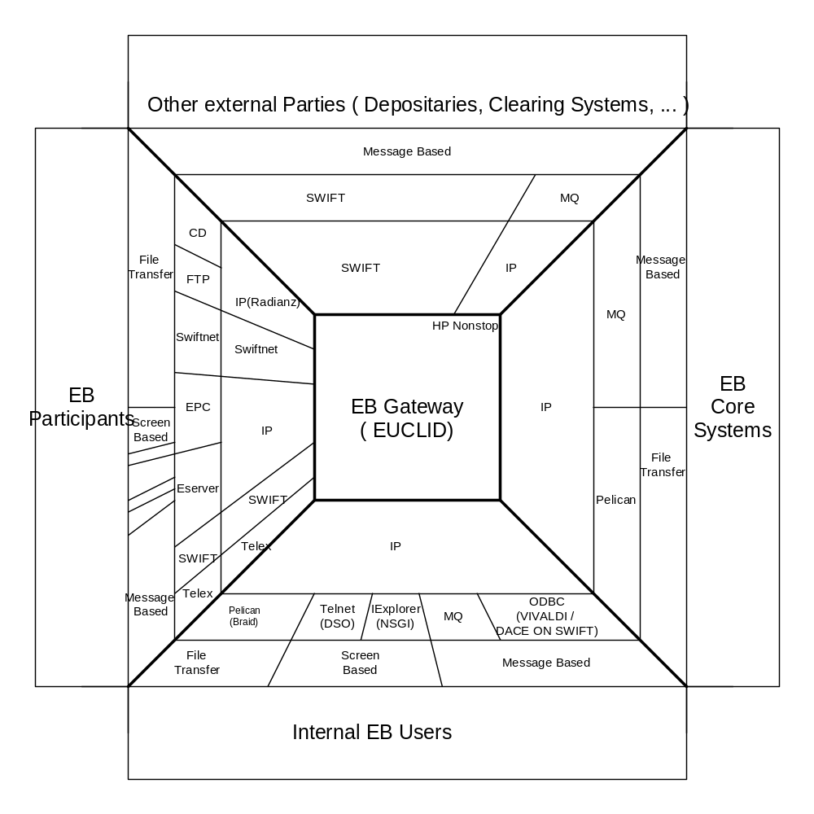

Background : definitions

Euroclear Participant

An EOC Participant concerns entity that holds cash & securities accounts with Euroclear.

Euroclear Participants can communicate with Euroclear using mainly either EUCLID or SWIFT channels (the other channels such as Telex or mail will not be detailed in this document).

Euclid users

Two User Numbers identify a Euclid user:
- The NETWORK number
- The EUCLID number (or P Number)
The EUCLID number is used to identify participants on the Euroclear Gateway (the HP NonStop system).
The NETWORK number is used to identify participants on the Network.
Both numbers are associated to a password.
Please note that the P-number is not the same one as the one used on IBM-side. A P-number is a typical ‘ Euclid ‘ term.

The link between the network number and the P-number can be found in table
=PT_USR_NWK_PWD

invoke =pt_usr_nwk_pwd;
-- Definition of table \EURBRU5.$DATA21.ETDATA.USRNWKP
-- Definition current at 10:03:02 - 06/29/06

(
EUT_USR_ID CHAR(8) DEFAULT SYSTEM NOT NULL
, EUT_NWK_TYP_ID CHAR(3) DEFAULT SYSTEM NOT NULL
, NWK_ID CHAR(8) DEFAULT SYSTEM NOT NULL
, CRR_NWK_PWD_ID CHAR(8) DEFAULT SYSTEM NOT NULL
, PVS_001_NWK_PWD_ID CHAR(8) DEFAULT SYSTEM NOT NULL
, PVS_002_NWK_PWD_ID CHAR(8) DEFAULT SYSTEM NOT NULL
, PVS_003_NWK_PWD_ID CHAR(8) DEFAULT SYSTEM NOT NULL
, PVS_004_NWK_PWD_ID CHAR(8) DEFAULT SYSTEM NOT NULL
, PVS_005_NWK_PWD_ID CHAR(8) DEFAULT SYSTEM NOT NULL
, PVS_006_NWK_PWD_ID CHAR(8) DEFAULT SYSTEM NOT NULL
, PVS_007_NWK_PWD_ID CHAR(8) DEFAULT SYSTEM NOT NULL
, CRT_TS DATETIME YEAR TO FRACTION(6) DEFAULT SYSTEM

NOT NULL
, LST_UPD_TS DATETIME YEAR TO FRACTION(6) DEFAULT SYSTEM

NOT NULL
)

User hierarchy and segregation of functions

A User hierarchy consists of an Administrator and one or several Operators.
The Euclid Administrator is an individual employee of the Participant that administrates the system from an authorization point of view. An administrator can create other EUCLID numbers called EUCLID operators. The administrator's profile can be changed only by Data Security (password reset, new accounts or privileges...).

A Euclid Operator is administered fully by the Administrator. Each Operator may access only the Euclid functions and accounts for which he has been granted authority. This enables the Administrator to establish the appropriate customized segregation of functions.

The following diagram illustrates the Participant User hierarchy:

Administrator (Pnumber0) Euclid PC

Operator 1 (Pnumber1)
Euclid PC
Operator 2 (Pnumber2)
File Transfer
Operator 3 (Pnumber3)
Euclid Server

Account 90001
Account 90001
Account 90002

CL
CL

R70
R30
580
…
R30

CU

R50
R58
553
…

What is BESS?

= Bank electronic support system

This is an application used to send, receive, route SWIFT and Telex messages

What is Swift?

= The Society for Worldwide Interbank Financial Transactions

This is a multi-national facility for the transfer of inter-bank funds, based in Belgium and the Netherlands

What is a SWIFT message?

A swift message is a bundle of ‘TAGS’ containing information about an instruction.

Example :

:16R:GENL
:20C::SEME//1061700022619
:23G:NEWM
:16R:LINK
:20C::RELA//PRIS3
:16S:LINK
:16S:GENL
:16R:TRADDET
:98A::SETT//20060619
:98A::TRAD//20060619
:35B:ISIN XS0177446076
:16S:TRADDET
:16R:FIAC
:36B::SETT//FAMT/1500000,
:97A::SAFE//23926
:16S:FIAC
:16R:SETDET
:22F::STCO//DLWM
:22F::SETR//TRAD
:22F::RTGS//YRTG
:16R:SETPRTY
:95R::REAG/CEDE/51467
:16S:SETPRTY
:16R:SETPRTY
:95P::PSET//CEDELULLXXX
:16S:SETPRTY
:16R:SETPRTY
:95Q::BUYR//UNKNOWN
:16S:SETPRTY
:16S:SETDET
-

More information about the tags, qualifiers and sequences etc. can be found in those documents :

\\PFILE002\ADSHARE\02.LRDS\05.Development\4.Tandem\Technical Documentation\Presentations\swift input validation.ppt

\\PFILE002\ADSHARE\02.LRDS\05.Development\4.Tandem\Technical Documentation\Presentations\TRAINING syntax ISO15022 . ppt.ppt

Input and reporting on tandem

In general, Tandem receives input from SWIFTS, EUCLID PC or SERVER, FTP, Connect direct, NSGI. This input is treated ( in most cases only SYNTACTICALLY checked ) , in some cases already logged at input and it is sent afterwards to another platform ( CTMS, IBM ). Over there the CONTEXTUAL validation is done, to see if business-wise everything is ok. Once this processing is done, TANDEM receives the feedback from these platforms and inserts or updates all received information in the TANDEM- databases. Based on these updates, TANDEM decides if reporting needs to be generated or not ( default reporting, or reporting via subscription, … )

This is the REAL-TIME treatment. This can be considered as DAYLIGHT processing.

In addition to this reporting, IBM also prepares large files during the day and during the night . These files are also sent to TANDEM on specific timings during the day. The largest number of these files ( BATCH files ) are sent during the night. These batches also generate updates on the TANDEM databases, and again : TANDEM decides if reporting needs to be generated or not .

This is the BATCH treatment. This can be considered as OVERNIGHT processing.

File Transfer

Introduction

The Euroclear Bank File Transfer access mode enables the Participant to establish direct computer-to-computer links with the Euroclear Gateway.

Three options are available when accessing Euclid in File Transfer mode:
- FTP (File Transfer Protocol), the ‘standard’ for IP file transfer.
- CONNECT:Direct, a product supported by Sterling Commerce. It is a powerful FTP software
- SWIFTNet, provided by SWIFT.

This access mode requires to the Participant to prepare off-line a file containing the Euclid commands requested and the instructions to validate.
Instructions are transmitted in the required ISO Format. (ISO15022 and/or ISO775).
Euclid commands have a generic structure.

More specific information about FTP and C:D can be found on :

\\PFILE002\ADSHARE\02.LRDS\05.Development\4.Tandem\Training\Getting Started\On boarding\FTP Tactical\

K:\02.LRDS\05.Development\4.Tandem\Technical Documentation\Presentations\Euclid IP File Transfer.pdf

Euclid commands

The figure below shows a typical command structure.

Euclid Service(s); Processing Selection; Parameter 1;Parameter 2 …

Value 1, Value 2 …
Subpar 1/Subpar 2/ …

Value 1, Value 2

These commands that include a list of parameters are interpreted by the programs and mapped into a sequence of atomic requests.
For instance, the reporting commands can include several accounts, which leads to the production of a separate report for each account (see example next page).

Euclid reports

The reports generated exist in 4 presentations:
- Formatted reports: These reports have a formatted, human readable layout.
- Computer readable reports: They consist of 80 character long, structured records. Each such record is characterized by a 2 characters header record code.
- ISO reports: These reports have an ISO format (tagged format based on ISO775 and ISO15022
- Tabular reports (only available for R34 & R20).

Furthermore, there exist mainly 2 different scopes:
- ‘A’ - report on all information available at the time of the report generation.
- ‘U’ - report that gives only the updates since the last time the report was asked for.
Finally a report can have a number of layouts such as (for the main ones):
- Basic information (e.g.: no narratives).
- Complete information.

Examples of commands

RF70AC; 90001,90002,90003

This command will be split in the following 18 atomic requests:
RF71AC;90001 RF71AC;;90002 RF71AC;;90003
RF72AC;;90001 RF72AC;;90002 RF72AC;;90003
…
RF76AC;;90001 RF76AC;;90002 RF76AC;;90003

Example of reports

An overview of the reporting commands + the possible values to be filled in, can be found on :

\\pfile002\eocdoc\ELECDOC\START.pdf

F-report: RF72AC;;90001

+--------------------------------------------+
| ACCOUNT: 90001 - USER #: D0005018 | LAST LOAD: 30/06/06
| URGENT UNSETTLED | MAT1
+--------------------------------------------+

TYP PC SE RE CH NOMINAL...AMOUNT CUR CASH......AMOUNT PRI CORR REFERENCE
S/N SECURITY.................DESCRIPTION CUR EUCL..ST (PR.EUCL.ST)
RR RELATED REFERENCE PAR.STAT
EC EUROCLEAR CURRENT INTERNAL STATUS NARRATIVE
CS CURRENT EXTERNAL STATUS NARRATIVE CODE
CSN CURRENT EXTERNAL STATUS NARRATIVE DETAIL
PS PREVIOUS EXTERNAL STATUS NARRATIVE CODE
PSN PREVIOUS EXTERNAL STATUS NARRATIVE DETAIL
--------------YOUR INFO----------------I--------------C/P INFO-----------------
NI TYP PC CH NOMINAL...AMOUNT I TYP PC CH NOMINAL...AMOUNT
CUR CASH......AMOUNT (E/C REF) SET.DT ICUR CASH......AMOUNT (E/C REF) SET.DT
TP TRADE.......PRICE DATE SP.COND AG I TRADE.......PRICE DATE SP.COND AG
TT TIME MKT.TYP I TIME MKT.TYP
PA CUR PRINCIPAL AMOUNT EXCHANGE RATE I CUR PRINCIPAL AMOUNT EXCHANGE RATE
AI CUR ACCR.INT.AMOUNT EXCHANGE RATE I CUR ACCR.INT.AMOUNT EXCHANGE RATE
DAYS RATE BASIS I DAYS RATE BASIS
FC CUR FEES.....AMOUNT EXCHANGE RATE I CUR FEES.....AMOUNT EXCHANGE RATE
NA NARRATIVES I NARRATIVES
AD ADDRESS OF RECEIVER OF SECURITIES I
DP DELIVERING PARTY I DELIVERING PARTY
RP RECEIVING PARTY I RECEIVING PARTY
IP INSTRUCTING PARTY I INSTRUCTING PARTY
RG REGISTRATION DETAILS I REGISTRATION DETAILS

C/P 92605 HSBC BK/IB CL SAFE CUSTODY,LDN
01 F Y 107000 3499776
S/N AU0000CBAHD4 COMMONWEALTH BANK O 6.00000 24/06/09 AUD CSEC (FUT )

NOT.MOD
---------------YOUR INFO---------------I---------------C/P INFO----------------
(5570916) 140606 I (5570919) =======
TP 0.000000 080606 N P I ================= ====== = =
DP MIDLGB22JAC I
IP I MIDLGB22JAC

C-report: RC72AC;;90001

013006061012MAT190001RC72AC URGENT UNSETTLED N
10557091601F 92605 0000000107000AUDAU0000CBAHD4 00000Y 000000810700000000000000
1155709163499776 000000000000000 140606 000000000000000080606NP0000
1555709193499777 000000000000000 140606 000000000000000080606NP
8955709160100000000107000,00000000107000,
...
99000769

I-report: RI70AC;;90001;548

548
:16R:GENL
:20C::SEME//5570916
:23G:INST
:98C::PREP//20060629090000
:16R:LINK
:20C::RELA//3499776
:16S:LINK
:16R:STAT
:25D::SETT//PENF
:16R:REAS
:24B::PENF//CLAC
:70D::REAS//CSEC
:16S:REAS
:16S:STAT
:16S:GENL
:16R:SETTRAN
:35B:ISIN AU0000CBAHD4
//COMMONWEALTH BANK O 6.00000 24/06
/09 AUD
:36B::SETT//FAMT/107000,
:97A::SAFE//90001
:22F::SETR//TRAD
:22H::REDE//RECE
:22H::PAYM//FREE
:98A::SETT//20060614
:98A::TRAD//20060608
:70E::SPRO///PREVSTAT/FUT/
:16R:SETPRTY
:95P::SELL//MIDLGB22JAC
:16S:SETPRTY
:16R:SETPRTY
:95R::DEAG/ECLR/92605
:16S:SETPRTY
:16R:SETPRTY
:95P::PSET//MGTCBEBE
:16S:SETPRTY
:16S:SETTRAN
-

File characteristics

Input and output files are linked through their names. The system will create output file names using the input file name as a root.
Participant can choose to use sequential or non-sequential file names. Sequential file names should follow a numeric sequence in the name. If a file is sent in a non-sequential order, the file out of the sequence is not processed.
The input file contains the logon statement, the instructions and the reporting requests that are sent to the Euroclear.
Several types of output files can be generated:
- A session file logging the report commands, the input results summary, the validation details and the formatted-reports (a request for report can be divided in a number of atomic requests generating a number of report files).
- A computer-readable report file (optional), containing the results of the computer-readable report requests (RCnn commands).
- An ISO report file (optional). As for the Computer-readable report file, all ISO reports are contained in one file.
- In case of problem with the input file (e.g.: naming, two files received with the same file name …), a specific error file is generated.

Testing connectivity

During the setup phase of a file transfer connection, the Participant is able to test the connectivity between his end and Euroclear by sending a file ending with an X (this is for connectivity testing only, and not for testing instruction formats).

Overview

A FTP session will follow this sequence :
- the system connects to Euroclear by entering the IP address of EOC FTP server.
- connection is authenticated using the network id (given by the reply to ‘PROFILM ;A’ command) and the password the participant has provided in the ‘PROFILM ;A’ command.
- as the connection is established, the participant is in his home directory. He can put input files in that directory (and only that one).
- FTP will trigger treatments upon file arrival. When the file starts to be written, first treatment consists in checking that file naming convention are respected (file ending with a “T”). Next check is that no other file with the same name is in processed and, if not, that no result file corresponding to this input filename is still in the home directory. If one of these conditions is met, an error file will be produced in home directory and the processing won’t go further. If the tests reveals no error, the processing of the file starts as soon as the file has been completely received.
- First step of processing is the move of the input file to a work directory inaccessible to the participant. Filename is changed in a way to be unique and allow saving of all inputs (useful for help desk, problem detection…). A table will store the correspondence between input filename and work filename.
- Inputs are treated by Euclid90 application and generated results are placed in the user work directory.
- Results of processing will be concatenated if needed and placed in home directory of the user, respecting file naming conventions defined for FTP tactical (c.f. TD).
- The participant can use a ftp get command to retrieve his results and can disconnect from FTP. He could also delete his results files, as he’s granted to do so. Otherwise, an ageing mechanism will delete the results files at a certain interval.

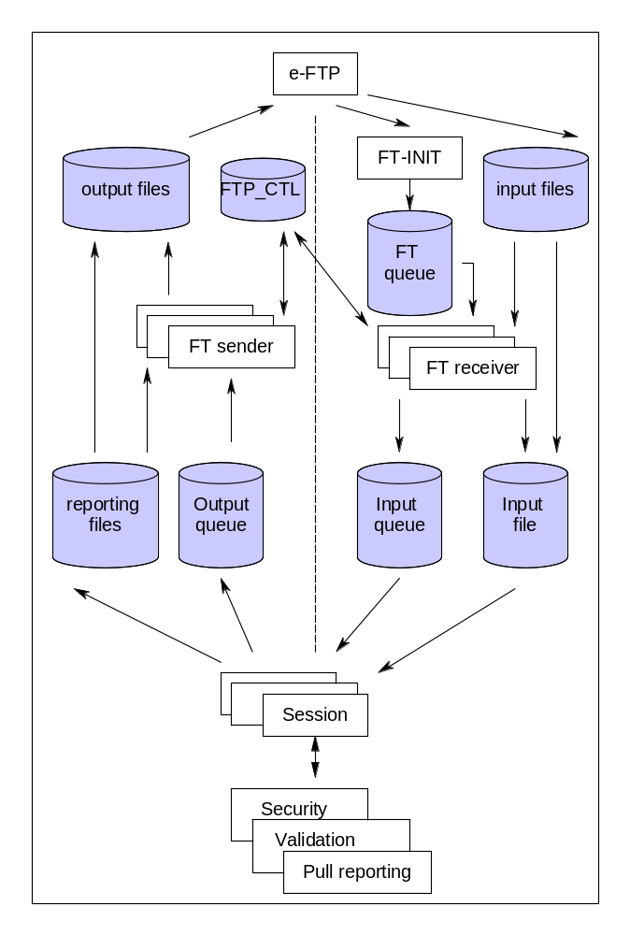

Component Description

Component Name: FT Init [$EFTPM/FTP-INIT/TDF004]

Responsibility:

- Triggering

Description:

The FT Init component manages all events received from the e-FTP product and triggers the processing of the input file by writing the name of the file received in a specific queue (SQL table). It is called by inter-process messages (event-driven).

Component Name: FT receiver [$EFTPM/FTP-RECEIVER/TDF005]

Responsibility:

- Security
- Session management
- Auditing/logging
- User access management
- Error handling

Description:

This component performs a number of controls on the file to be processed (naming convention, file sequencing, file already processed …), archives the file and triggers its processing. In case of error, it generated an ‘error’ file. Thanks to specific SQL control tables, the FT receiver component ensures that the Participant’s input files are processed in sequence.

Component Name: FT sender [$EFTPM/FTP-SENDER/TDF008]

Responsibility:

- Session management
- Auditing/logging

Description:

The role of the FT sender component is to concatenate the results of all report requests into specific files and to put them in the user’s directory. After completion of this operation, a specific control table is updated in order to inform an FT receiver component that it can process the next Participant’s input file (if present).

Component Name: FT session [$EETPM/PT4/TDE081]

Responsibility:

- Session management

Description:

The FT session component (also called pseudo terminal because it plays the role of a terminal vis-à-vis the FT router or requester) searches for unlocked record in the input queue, locks it and starts processing the associated file. When the file has been completely processed, it deletes the record from the queues and searches for another unlocked record or waits to be notified of the arrival of a new file. The FT session reads the input data file record by record and parses it in ‘self-contained’ transactions. Each transaction is sent for processing to the FT router (part of the application subsystems). It is the FT router that stores the context between transactions (the position in the input file). This avoids a transaction loss or duplicated processing in case of recovery.

CONNECT:Direct

Message Format

See File Transfer – Introduction chapter [3.1 ].

Client Interface

As for FTP, the set up of a CONNECT:Direct file transfer connection requires an IP connection through RadianzNet and the configuration of a Virtual Private Network.
It is also the Participant’s responsibility to do the setup of the firewall and the VPN at his end (with eventually the help of Radianz).
Each user has a single directory dedicated to both input files and output files.
An automatic pushback of the output files is implemented by default (only possible with a leased-line connection).

Security

Security is ensured through firewalls and VPNs.

The Participant has to authenticate himself on the local CONNECT:Direct server through a User ID and a password.
The Participant’s IP address, node and local user are communicated to Euroclear to set up the connection and these data are linked to the Euclid Network User ID.
There is a unique relationship between the Network user number and the Euclid User Number. As reminder, both numbers are associated to a password.
Network Intrusion Detection engines are in place at Euroclear side.

Overview

A C:D session will follow this sequence :
- participant’s system logs on local C:D server and is authenticated
- participant’s C:D server connects to Euroclear’s C:D server
- remote node and user are authenticated on Euroclear’s C:D server
- participant’s C:D server copies input file and submits the process (process will have to include the call to a Tandem program in order to detect the end of copy and fire the file treatment)
- connection is closed by participant’s C:D server
- some checks are performed before the input files are actually processed. The input file name can not be already in processing and must respect file naming conventions (ending by a “T”). The check on the presence of a corresponding result file is not necessary as C:D will send this file to the participant, and then no result file will stay in the participant’s home directory. If any of those check fails, an error file will be placed in participant’s home directory.
- input file is moved to participant’s work directory, using a unique file name, and the processing by Euclid 90 application is fired. Results are placed in work directory
- if needed results files are merged and then moved to the home directory
- Euroclear’s C:D server connects to participant’s C:D server
- the Euroclear’s remote node and user are authenticated on participant’s C:D server
- Euroclear’s C:D server sends results files and submit the process
- after a successful transmission, output files are deleted

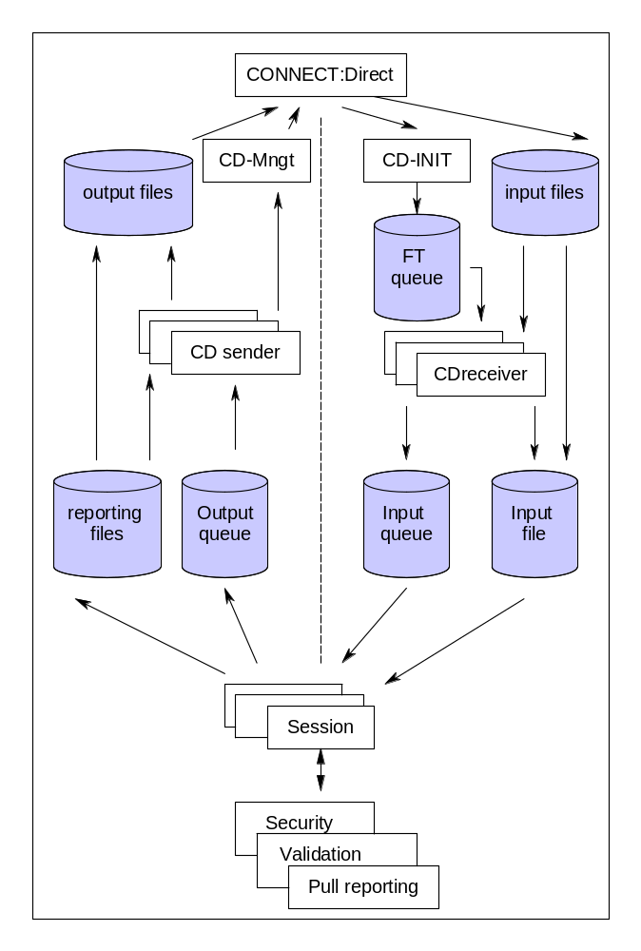

Component Description

Component Name: CD Init [N/A / N/A / TDF009]

Responsibility:

- Triggering

Description:

The CD Init (TDF009P0) is the initiator of a CONNECT:Direct session. Once a participant has successfully copied a file on our system, it triggers the CDINIT script (located in $DATA12.CDPROC). This script starts the TDF009P0 program.
It triggers (as the FTP Init component) the treatment of the input file by writing the name of the file transferred in the FT queue SQL table.

Component Name: CD Manager [ $EFTPM / CD-MNGT / TDF007 ]

Responsibility:

- Connect:Direct interface

Description:

The CD Manager component manages the requests to CONNECT:Direct. It is used for sending the files to the Participant (automatic pushback) and to administrate the users.

SWIFTNet

Message Format

See File Transfer – Introduction chapter [3.1 ]..

Client Interface

Specific hardware and software from SWIFT must be used to set up a SWIFTNet connection. It is up to the Participant to contact his local SWIFT office.
To set up the connection with Euroclear, a Euclid Network user ID is created. This user is part of the SWIFT DN (“Distinguished Name”) used for the SWIFTNet connection. This user will be used to identify the Participant on the EB Gateway.
Participant’s input files and resulting reports and session files are respectively sent and received in the correct input and output directory of the SWIFT Alliance Gateway (running on an UNIX machine).
The transfer of information between the UNIX machine and the HP NonStop system is done using connect direct.

Security

Security is achieved through SWIFT security and Euclid Network/User.

Overview
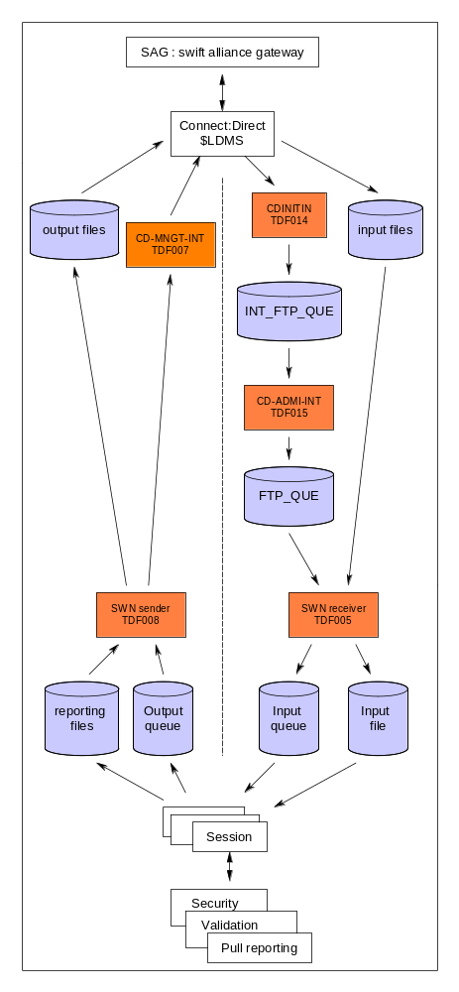

Component Description

Except the interaction with the SWIFT Alliance Gateway, the infrastructure used to process the Participant’s file is the same as this used for FTP and Connect:Direct.
SWIFT Alliance Gateway dialogs with the HP Nonstop system by file transfer using connect direct (previously pelican).

- From Connect:Direct a small object is called which initializes the further processing, CDINITIN.
- The full processing is done by serverclass CD-ADMI-INT ($CDPM ) running an object like that of the ADMI-PROCFIN which was migrated from the old Pelican version, prepared to process all kinds of transfers, SwiftNet, BRAID, loads, …
- The interface between CDINITIN and CD-ADMI-INT is a table called =PT_INT_FTP_QUE, filled in by the CDINITIN and read by the CD-ADMI-INT

the processing of files can be stopped without impacting the receipt of files. The information is stored in the above mentioned table and the processing will continue after restarting the server class.

SWIFT

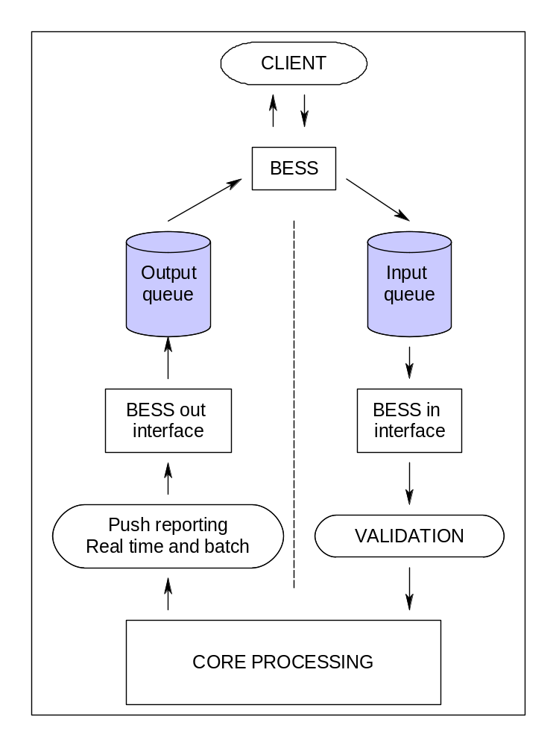

Component Description

Component Name: Bess In interface [ $ESPM / BESS-IN- *** / TDE839 ]

Responsibility:

- Routing

Description:

The Bess In component is responsible for unwrapping incoming requests and routing all of them to the appropriate ‘validation’ pool of processes (one pool by message type).
Messages are read from MQ queues.

Component Name: Bess Out interface [ $ESPM / BESS-OUT- *** or BESS-RPT-*** / N/A ]

Responsibility:

- Bess interface

Description:

The Bess Out component is responsible for the output dialog with the BESS application. It manages the sequencing of the messages and adds the required headers and trailers needed for BESS (and SWIFT).

EAA
EAA (Euroclear Access Application) is a Straight-Through Processing (STP) channel for all three ESES markets to accommodate ISO 15022-compliant messages, thereby accommodating all messages that were previously processed by CCI AutoFlow.

Note that the EAA interfaces are configured for ESES only. The HMI adaptor is relevant for Tandem.
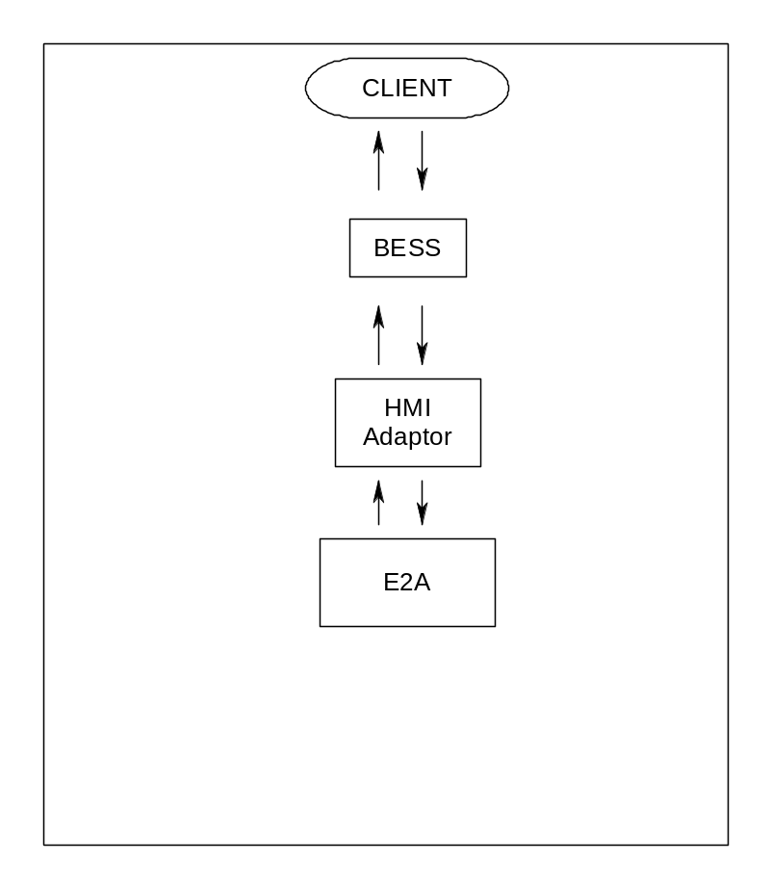

Component Description

Component name: HMI adaptor ESES [ $GIEF ]
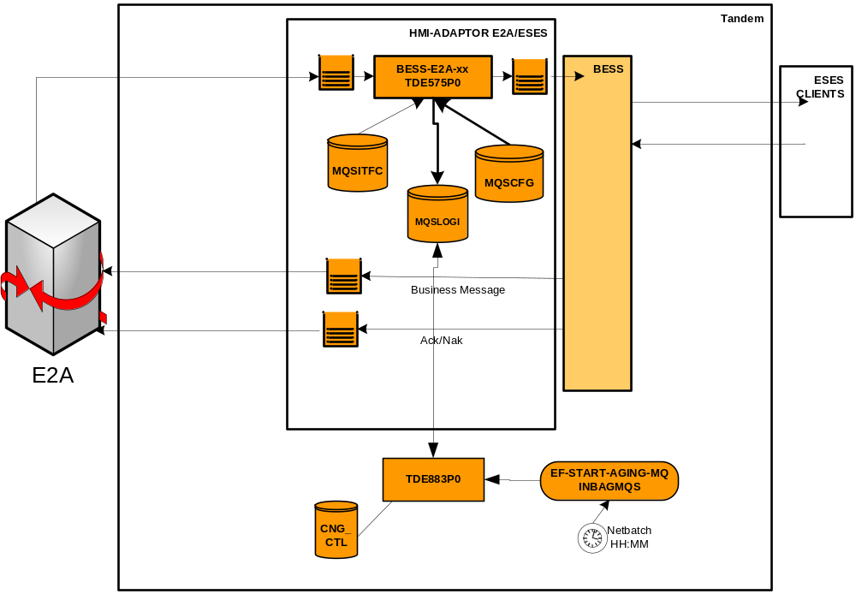

Description:

Messages sent between BESS and E2A for ESES will be handled by a HMI adaptor.
The adaptor will process outgoing messages.

The Outbound adapters, BESS-E2A-EB, -EF and -EN responsibility is to forward messages from E2A to BESS.
- The adaptor reads messages from a E2A queue using the signal option
The input message structure:
    - (optionally) a message timestamp block; the timestamps can be filled by E2A-platform
    - Input data
- Prepare the output message and puts it on the MQ queue off BESS
    - A sequence number is selected from the =PT_MQS_ITF_CTL table and used in the correlation ID of the MQ.
    - the message from the input data is moved to the structure WS-MQS-OUT-MES this structure is similar to the ISO-BESS-HMI-HDR structure in BESDDL
    - Host reference number is filled (concatenation of CPU number, PIN number and timestamp): all the other variables (like CIF Account ID, PRI-SRV-ADD and office, HMI-OFF) must be provided by E2A platform.
- Updates the next sequence number in the =PT_MQS_ITF_CTL table.
- Log the Outgoing Message in the =PT_MQS_LOG_INP table

- Incoming messages – both Business and Ack/Nak types – are treated by an Adapter and communication directly to E2A from BESS is facilitated by messages traversing the combined Alias/Remote Queue/Sender Channel MQ objects.

The logged incoming messages will be aged via Netbatch.

:

Interactive mode

NSGI

NSGI (the Non-Stop Gateway Interface) is a Web browser interface developed in-house for the internal users to monitor and manage the system:
- The Euclid Help Desk & Client support: To respond to external users questions. They mainly use inquiry and reporting functions (they are for instance able to look at or to produce the same report as the one requested by the Participant).
- Data Security: To monitor and manage the data security aspects of the application, including the addition of new users.
- Data admin.: To grant the appropriate privileges/subscriptions to the Participants.
- Production Follow-up: To monitor the good running of the application
- Tandem Hot Line & Watch Duty Teams: To support it from an applicative point of view.
- Development : to test applications and to monitor these tests

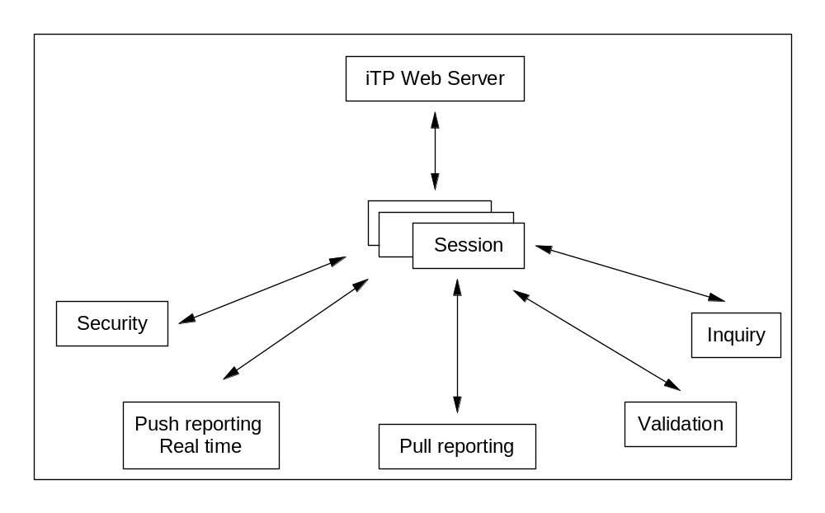

Euclid IP

The EUCLID IP project gives the participants the possibility to connect their EUCLID PC and EUCLID Server to Euroclear using the IP network. Several different kinds of providers are foreseen:
- The public internet
- Radianz Managed IP (MIP)
- SwiftNET (not in the scope of this document due to specific SWIFT development)
- For modems other providers are considered as well

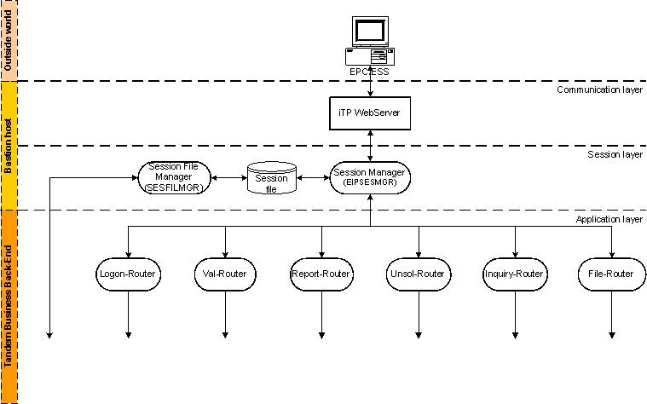

Session manager [ $EIPM / EIPSESMGR / N/A ]

- Combines different requests into a logical session
  - Each request is processed by a different process
  - Assigns a session-id at logon (MD5 hash – 32 hex character id)
  - Checks session status (logon/password/logoff)
  - Limits the number of concurrent requests
  - Session status is maintained in the session file (enscribe file called sesfil).
- Extracts message data from signed messages
- Forwards request to the appropriate router on the backend using ‘eiproute.cfg’ (oss text file)
- CGI serverclass (does not use NSGI framework)

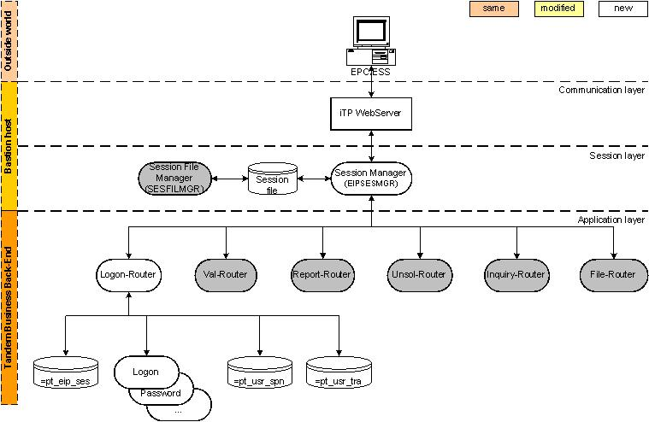

Logon-router [ $EIPM / LOGON-ROUTER / TDO003]

- LOGON, PASSWORD and LOGOFF (new command)
- Check SPN in =pt_usr_spn
  - Table contains link P-number – SPN
  - If SPN still is spaces, the link is created if the entry is created less than 24hrs ago (param)
  - If SPN is incorrect or window expired, S867 Unauthorized user
  - NSGI screen to initialize the link P-number - SPN
- Update =pt_eip_ses
  - Store sessions for bastion-host takeover
  - Insert at logon, delete at logoff
  - EIPSESMGR retrieves info using the ‘?GETSES? ’ technical command
- Checks =pt_usr_tra for tracing

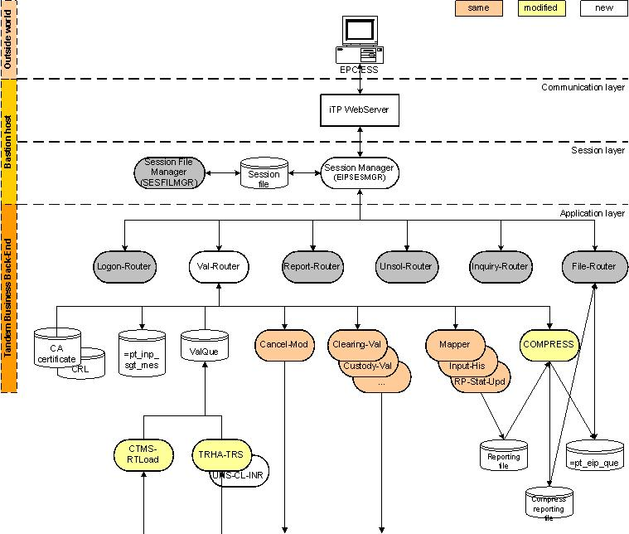

Val-router [ $EIPM / VAL-ROUTER / TDO004]

- Validation and cancel
- Feedback in enscribe queue file $EMAILx.ETQUEUE.VALQUE
  - Configured in =pt_que_cfg
  - Key is process name
  - Process name is passed as queue name to validation/cancel server
  - TRHA-TRS or UNS-CL-INR detect queue name is a process and use it to find the queue name in =pt_que_cfg
  - Automatic aging
- MT instructions are signed
  - Signature is checked using openSSL
  - The CA and CRL used to verify the signature are stored in the =pt_cer_aut table
  - Signature are archived in =pt_inp_sgt_mes as prove
  - SPN of signature must match SPN of certificate used for HTTPS connection

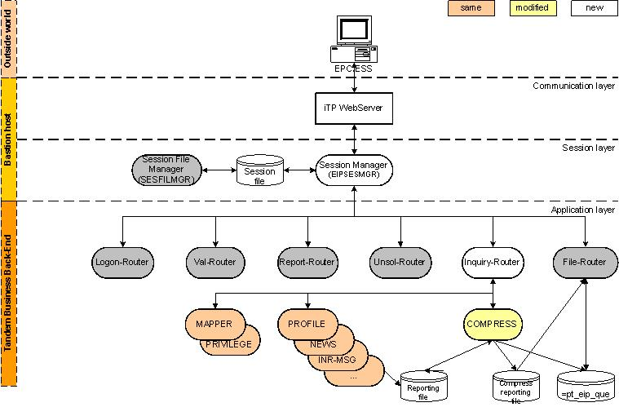

Inquiry-router [ $EIPM / INQUIRY-ROUTER / TDO005]

Handles reporting inquiries :

BANNER, NEWS, PROFILI, PROFILM, LA, LOGFAIL, PREPARE, SCHEDULI, SCHEDULM, MASTER, SIU, SIUCM, UPDNOTIF

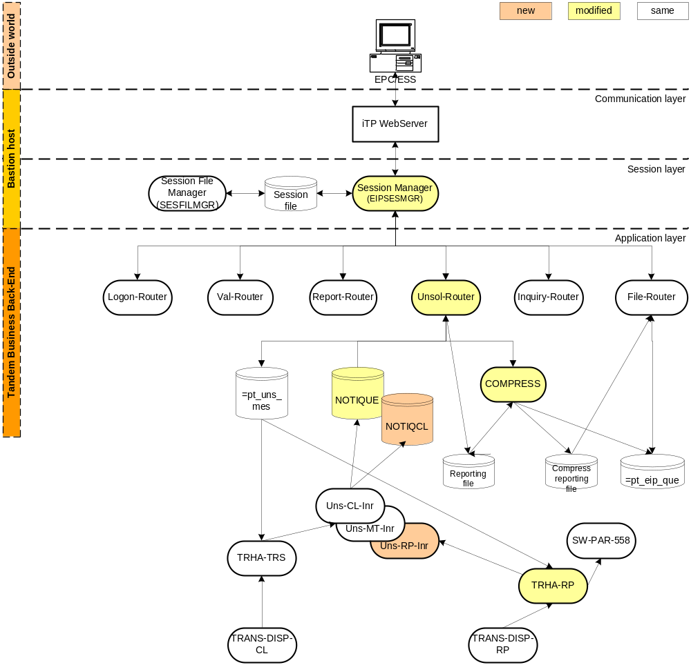

Unsol – router [ $EIPM / UNSOL-ROUTER / TDO006]

- SYSSTAT, UNSOLI, UNSOLU, UNSOLS, UNSOLICL, UNSOLUCL and UNSOLSCL
- Notique is created in user volume
  - Created at UNSOLI /UNSOLICL, each thread will have its own notique file. Up to 2 notique queues will be created for the same P number: one queue for settlement (NOTIQCL) and one queue for all other services (NOTIQUE).
  - Purgedata at UNSOLI /UNSOLICL and UNSOLS/UNSOLSCL
- Aging to avoid file-full, the check is done on file name NOT = “NOTIQU*”.

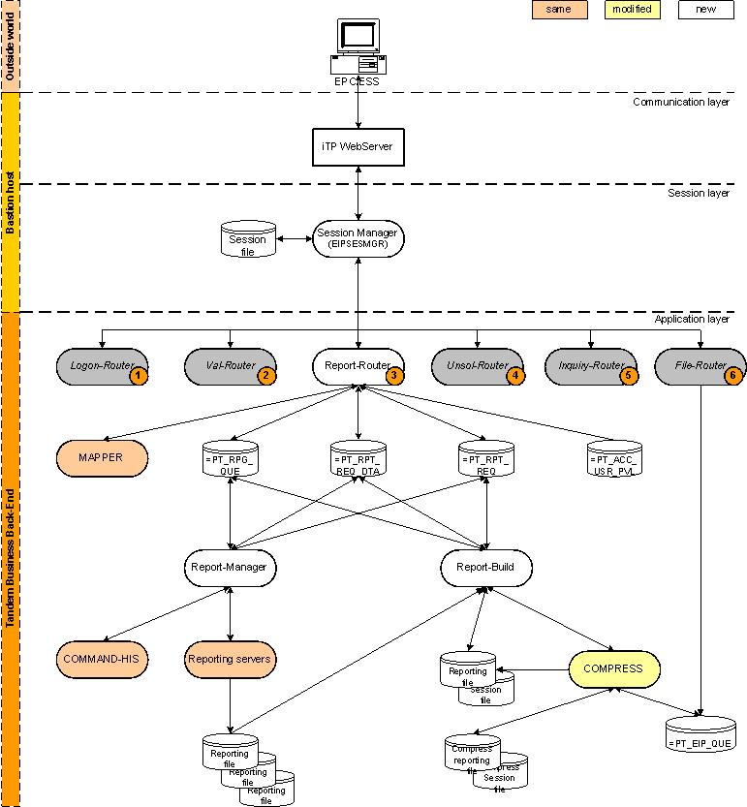

Report-router [ $EIPM / REPORT-ROUTER / TDO001]

- REPORT-ROUTER
  - Receives the request
  - Calls MAPPER and checks privilegies itself
  - Splits the request in atomic request
(R70 all account -> R71;acc1, R71;acc2, … R76;accn)
  - Waits for the request to be completed, taken over by another process or timeout
  - SQL/MX
- REPORT-MANAGER
  - Produces an atomic report
  - Calls command-his, reporting, command-his
  - Notifies report-build when all atomic reports are generated
  - Sequential or parallel mode
  - SQL/MX
  - Must be started manually
- REPORT-BUILD
  - Concatenates all atomic reports into a single file
  - Adds the (error) messages to the session file
  - Calls compress
  - Notifies report-router the report is produced
  - SQL/MX
  - Must be started manually

File-router [ $EIPM / FILE-ROUTER / TDE931]

- FDN (new command File DowNload)
  - Uses =pt_eip_que to find the filename
  - Pathsend with dialog to transfer the file in 32K blocks
- PDN (new command Package DowNload)
  - Uses =pt_atm_upd_fil to find the filename
  - Pathsend with dialog to transfer the file in 32K blocks
- EOS (End-Of-Session)
  - Deletes the row(s) in =pt_eip_que

Technical Applications on TANDEM

This chapter will focus on the main applicative sub-systems of the EB Gateway:

- Security (user access management)
- Database synchronization
- Transactions validation & conversion
- Push reporting
- Pull reporting

These sub-systems are included in a different chapter because most of them are common to all communication channels

Security/User access management

This chapter describes a number of components which are used whatever the session mode and which cover the security and user access management aspects.
All these components are written in COBOL. Their maintenance is easy and their scalability is achieved by increasing the number of processes.

Logon

The Logon component is called each time a user accesses the application or when a new user’s input file is processed. It mainly identifies the user as a valid Euclid user by checking his identification and password.

Logoff

The Logoff component is called at the end of a session or when a session is accidentally cleared mainly to remove the user from the logon table and to update the session table with the session end time.

Banner

The Banner is called each time a session is started (just after the logon validation) to create the ‘banner’ composed of:
- A welcome message
- The current EOC date and Brussels time
- Warning messages entered in the system by Production Follow-up to inform about important events (production delay …)
- Warning messages entered by the Euclid Help Desk informing about important events and inviting the user to read some News files.
- …

It is this server which will report specific messages when a launch is done ( to inform possible impact on the connectivity of the participants ).

Password

The role of the Password component is to process the ‘change password’ command entered by a user or the ‘reset password’ command entered by a master user (for one of his operators) or by Data Security.

Privilege

The Privilege checks that the user has the privilege to use a specific function.

User Profile

The User Profile component manages the user’s profiles (allows creating, modifying, deleting, and inquiring on Euclid users).

Logon inquiry

The Logon inquiry component is used to perform inquiries on the Access file, which contains the user’s access historic. This component is mainly called to retrieve the five last (logon) accesses of a user or to retrieve all access failures (invalid logon) that have been detected for the user.

Database Synchronization

Batch Replication

Process Diagram

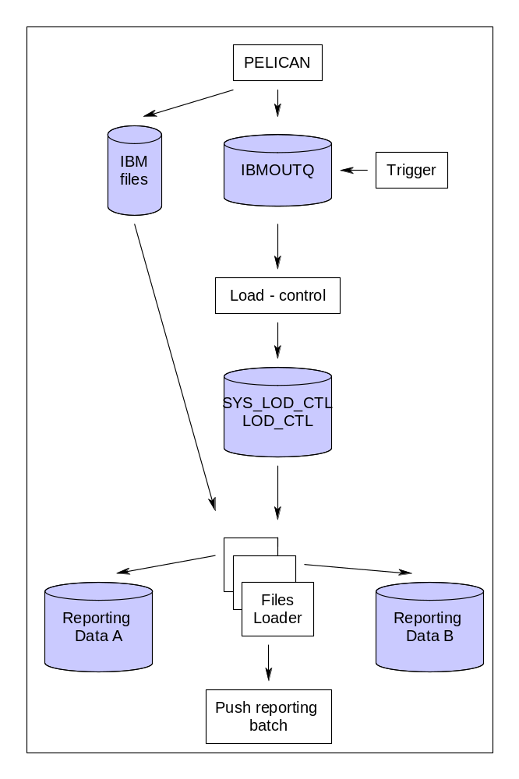

Component Description

Component Name: Load control [ $ELPM / LOAD-CONTROL / TDE163 ]

Responsibility:

- Routing

Description:

For each load received from the IBM system, an entry is written in the IBM input queue, which triggers the load control server. When triggered, the load control reads the record in the queue and performs a number of controls (e.g.: load authorization, pre-required loads executed, timing constraints …). When all conditions are met, it triggers the loaders.

Component Name: Loaders [ $ELPM / LOAD- *** / N/A ]

Responsibility:

- Database load

Description:

The ‘loader’ is triggered by means of a triggering message put in the ‘=PT_SYS_LOD_CTL’ table by the ‘load control’. When triggered, each loader searches in the ‘=PT_SYS_LOD_CTL’ table for an unprocessed batch file (corresponding to the load type it is dealing with) and starts to treat it.
Once the load is completed, the loader sends an IPM to the LOAD-CHECK server which is responsible to format and send a delimiter to Mainframe to tell them the load is processed on our side.
An overview of all batch – loads with the principal tables accessed ( updated ) , can be found in the annexes ( see [6.8] ).

Component Name: Load Check [ $ELPM / LOAD-CHECK / TDE009 ]

Responsibility:

- Format and send delimiter to mainframe

Description:

The LOAD-CHECK server receives IPM’s from the “loaders” once the processing of a load is finished. LOAD-CHECK then formats a delimiter and put it on the CL01 queue to Mainframe.

Real Time Replication

Process Diagram

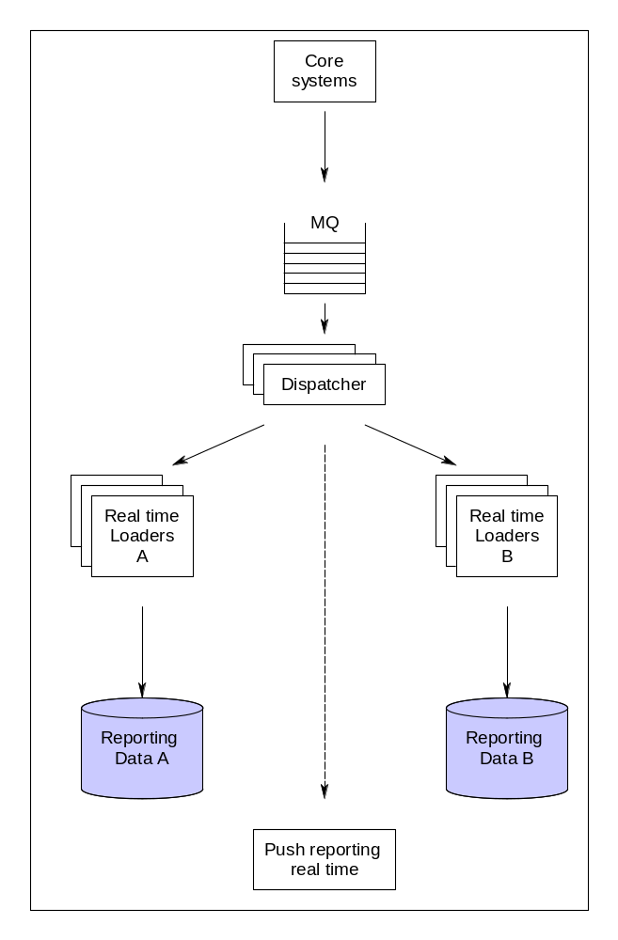

Component Description

Component Name: Dispatcher [ $EETPM / TRANS-DISP-** / TDE813 ]

Responsibility:

- Routing

Description:

The Dispatcher manages the routing of the information received to the different database updaters and to the ‘push reporting’ subsystem.
Please note that for this real-time feedback, IBM the ‘master ‘ system is, meaning that it is IBM who furnishes the info and the updates, which trigger afterwards reporting on TANDEM.
If the participants have the necessary subscription ( for SWIFT reporting )to report these updates, they are notified. For ESS, the participants are notified via the unsolicited link.

Transactions validation & conversion

Transactions validation & conversion

Process Diagram

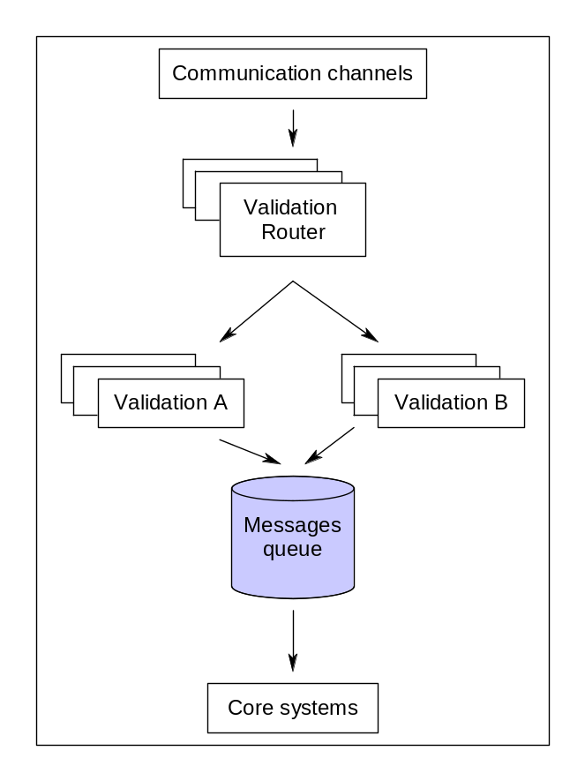

Component Description

Component Name: Validation [ $EETPM and $ESPM / **-VAL-** / N/A ]

Responsibility
- conversion
- validation
- security
- auditing/logging
- user access management

Description

This subsystem handles requests for the validation of new instructions as well as requests for instruction cancellation and modification. It mainly validates syntactically, converts and authorizes those requests and submits them to the EOC’s core systems.

Inter Process Message drives the process.

Remark:
In real time, the instructions are directly sent via MQ to the Core system by the TANDEM components of the application layers.
Batch transmission (to the IBM system) is still provided for very specific services. In that case, a ‘send batch’ component selects messages in the input queue and writes them in an extraction file. The extraction itself is triggered by a service message written into the input queue by the ‘extraction’ component (started at specific time by Netbatch, the HP Nonstop scheduler). When this message is encountered, the ‘send batch’ component writes the appropriate trailer in the current extraction file, closes it, requests Connect Direct to send it to IBM and opens a new one.
Let’s note that, when required (for instance, at the end of the Euclid day), the ‘extraction’ component can wait until all instructions received before the deadlines (as well as those included in the input files received in file transfer mode) are processed before sending the service message or the business delimiters.

Detailed Description + flow
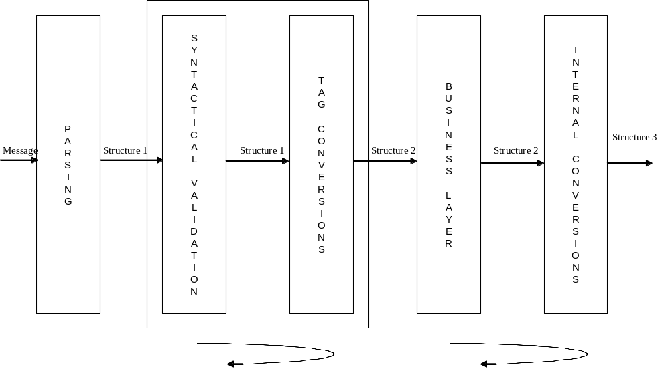

Split original message into tags to fill structure 1 (list of tags)
- Input – Validation – Parsing
  - Save tag offsets and lengths for future reporting purpose (copy from input)
  - Re-order tags to match EB’s order definition
  - Match tags to message tree definition
- Input – Validation – Syntactical validation
  - Check if every tag in structure 1 is syntactically correct according to its definition. If no error occurs, then the tag is converted. To do so, generic functions are used. Each generic function has its own parameters. E.g.:
    - TEXT function accepts a minimum and a maximum length
    - ACCOUNT function accepts a parameter to specify an account range
    - …
  - If no error occurs, then the tag is converted.
- Input – Validation – Tag conversions
  - Convert tag using conversion functions in a global module
    - Filling the structure 2 based on structure 1
    - Check cross-tag dependencies and conditions
      - Tags not allowed if other tag present (SWIFT rules…)
      - Tags allowed only for specific service (like FSA)
  - Remarks
    - There is one specific Structure 2 structure common to all non-statement messages
    - There is one specific Structure 2 structure common to all statement messages.
    - Conversion continues until the maximum number of errors is reached
    - Syntax check and conversion process occurs in 2 passes: in first pass, tags necessary for further processing (e.g.. Tags at the end of the message whose value is necessary to convert tags at beginning of the message)
- Input – Validation – Business layer
  - Participant messages
    - Check privileges
    - Save original message
    - Save tag pointers (offset and length)
  - Depositary messages without statement
    - Check privileges
    - Perform set of rules based on depositary id, swift message type and message content (decision tree)
    - Save original message
    - Save tag pointers
  - Depositary messages with statements
    - For each statement
      - Check privileges
      - Perform set of rules based on depositary id, swift message type and message content (decision tree)
    - Save original message
    - Save tag pointers
- Input – Validation – Internal conversion
  - Formats the information contained in structure 2 to send it to another platform (can contain business logic).
  - Remarks
    - Participant messages:
      - Type of structure 3 is always the same
      - Fills structure 3 from structure 2 data
    - Depositary messages:
      - Type of structure 3 is defined by the output of decision tree
      - Fills structure 3 from structure 2 data
      - For statements message, goes back to business layer to process next statement element

A Document exists, explaining the SWIFT validation mechanism in detail :

\\PFILE002\ADSHARE\02.LRDS\05.Development\4.Tandem\Technical Documentation\Frameworks\Swift Input Validation.doc

Example : Validation

An Invalid message ( valid on TANDEM, invalid on IBM )

540
:16R:GENL
:20C::SEME//TRACEBUL4
:23G:NEWM
:16S:GENL
:16R:TRADDET
:98A::SETT//19951001
:35B:ISIN DE0001141273
:16S:TRADDET
:16R:FIAC
:36B::SETT//FAMT/1000,
:97A::SAFE//90000
:16S:FIAC
:16R:SETDET
:22F::SETR//TRAD
:16R:SETPRTY
:95R::DEAG/ECLR/90001
:16S:SETPRTY
:16R:SETPRTY
:95P::PSET//MGTCBEBEECL
:16S:SETPRTY
:16S:SETDET
-

Errors/warnings
Code | Description
V058 | *** V058 SECURITY (:35B:) NOT OPERATIONAL

This is a valid message on TANDEM, so we have sent this structure to IBM :

MQ header
msg_type | : | CLAS | 434C4153
msg_head_version | : | 0001 | 30303031
CLAS header
msg_class | : | VALMATEUCLIDVI | 56414C4D41544555434C4944564920202020202020202020202020202020
msg_class_version | : | 0001 | 30303031
MAC header
mes_ts | : | 2006-06-29:15:21:36.531875 | 323030362D30362D32393A31353A32313A33362E353331383735
mes_ori_id | : | TAN | 54414E
dbg_fl | : | N | 4E
tra_fl | : | N | 4E
mes_rty_ct | : | 00 | 3030
mes_cxt_id | : |  | 202020202020202020202020202020
prv_prc_rsl_id | : |  | 2020
ori_pgm_id | : | $U720 | 2455373230202020
EXET 05
Pardepet | : | 90000 | 3930303030
Etws | : |  | 20202020202020
Reccd | : | 05 | 3035
Democd | : | 0 | 30
Etparnr | : | 90000 | 3930303030
Typ | : | 01 | 3031
Etsecnr | : |  | 202020202020
Etcpnr | : | 90001 | 3930303031
Etnam | : | 000000000100000 | 303030303030303030313030303030
Ncur | : |  | 202020
Operref | : | TRACEBUL4 | 545241434542554C3420202020202020
Etcam | : |  | 202020202020202020202020202020
Cacc | : |  | 202020
Etsetdate | : | 00951001 | 3030393531303031
Payc | : | F | 46
Clhc | : |  | 20
Pric | : |  | 20
Etcpndate | : |  | 2020202020202020
Etpredep | : |  | 20
Etsrvcd | : | CL | 434C
etcod1 | : |  | 2020202020
etcod3 | : |  | 2020202020
Etcodgc | : |  | 20
Lminst | : |  | 20
Glce | : |  | 20
ettradpr_sign | : |  | 20
Ettradpr | : | 000000000000000 | 303030303030303030303030303030
Ettradat | : |  | 2020202020202020
Etspecin | : |  | 20
Etflpri | : | 0 | 30
Etflacr | : | 0 | 30
Etflfee | : | 0 | 30
Etflnar | : | 0 | 30
Etfladd | : | 0 | 30
Etagent | : |  | 20
Etcncode | : |  | 20
Etsettlcd | : | Y | 59
Etmatchcd | : |  | 20
Etcpnbcedel | : | 000000 | 303030303030
Etcommon | : |  | 202020202020202020
Etisin | : | DE0001141273 | 444530303031313431323733
Etvalidate | : | 20060629 | 3230303630363239
Etvalitime | : | 1321 | 31333231
Ettradtim | : |  | 20202020
Etsecinput | : | IS | 4953
Etusnr | : | S0104531 | 5330313034353331
pro_idc_flag | : |  | 20
selection_dt | : | 00060207 | 3030303630323037
resend_cd | : |  | 20
ettrd_pr_cur | : |  | 202020
etnomamtyp | : | FMT | 464D5420
Etcortyp | : |  | 20
Etcpttyp | : | E | 45
Etcantsa | : |  | 20
csh_amt_sgn_cd | : |  | 20
nat_dcl | : |  | 2020
filler_0 | : |  | 2020202020202020202020202020202020202020
EXET 12
Pardepet | : | 90000 | 3930303030
Etws | : |  | 20202020202020
Reccd | : | 12 | 3132
Democd | : | 0 | 30
input_mode | : | SW | 535720
message_id | : | \ISO5SR5$U7202006-06-29:15:21:36.531875 | 5C49534F355352352455373230323030362D30362D32393A31353A32313A33362E353331383735
session_ts | : | 2006-06-29:13:21:36.542827 | 323030362D30362D32393A31333A32313A33362E353432383237
inr_ref | : |  | 202020202020202020202020202020202020
reply_queue_nm | : |  | 2020202020202020202020202020202020202020202020202020202020202020202020
eut_usr_id | : | S0104531 | 5330313034353331
eup_usr_sht_nm | : |  | 202020
swi_add_id | : | MGTCBEBEECL | 4D4754434245424545434C20
bic_clr_sys | : | MGTCBEBE | 4D47544342454245202020
mes_typ | : | 540 | 353430
user_type | : | L | 4C
sync_reply | : |  | 20
order_nbr | : |  | 202020202020
total_nbr | : |  | 202020202020
Language | : |  | 2020
web_screen_type | : |  | 20202020
PC version | : |  | 2020202020
filler_3 | : |  | 2020202020
EXET 13
par_acc | : | 90000 | 3930303030
wsh_id | : |  | 20202020202020
rec_cd | : | 13 | 3133
trs_rpt_mkr_cd | : |  | 20
trd_ref_tx | : |  | 20202020202020202020202020202020
mkt_cli_id | : |  | 20
exh_cmo_ref_tx | : |  | 20202020202020202020202020202020
tdl_opt_cd | : |  | 2020
cli_mkt_lnk_tx | : |  | 20202020202020202020202020202020
cli_ref_tx | : |  | 202020202020202020202020202020202020202020202020202020202020
sry_trs_inf_cd | : |  | 2020
bgn_cdt[1].bgn_cdt_cd | : |  | 2020
bgn_cdt[2].bgn_cdt_cd | : |  | 2020
bgn_cdt[3].bgn_cdt_cd | : |  | 2020
bgn_cdt[4].bgn_cdt_cd | : |  | 2020
bgn_cdt[5].bgn_cdt_cd | : |  | 2020
bgn_cdt[6].bgn_cdt_cd | : |  | 2020
bgn_cdt[7].bgn_cdt_cd | : |  | 2020
bgn_cdt[8].bgn_cdt_cd | : |  | 2020
bgn_cdt[9].bgn_cdt_cd | : |  | 2020
dea_cpa_cd | : | P | 50
clr_mbr_id | : |  | 2020202020
stl_net_fl | : |  | 20
net_trs_id | : |  | 20202020202020202020202020202020
vat_amt | : |  | 202020202020202020202020202020
vat_cur | : |  | 202020
vat_sgn | : |  | 20
loc_amt | : |  | 202020202020202020202020202020
loc_cur | : |  | 202020
loc_sgn | : |  | 20
lcl_amt | : |  | 202020202020202020202020202020
lcl_cur | : |  | 202020
lcl_sgn | : |  | 20
filler_0 | :

Feedback to the participant ( push reporting after having received the feedback from IBM , see next chapter ) :

16R:GENL
:20C::SEME//2650450
:23G:INST
:98C::PREP//20060629035524
:16R:LINK
:20C::RELA//TRACEBUL4
:16S:LINK
:16R:STAT
:25D::IPRC//REJT
:16R:REAS
:24B::REJT//DSEC
:70D::REAS//V058 SECURITY (:35B:) NOT OPERATION
AL
:16S:REAS
:16S:STAT
:16S:GENL
:16R:SETTRAN
:35B:ISIN DE0001141273
:36B::SETT//FAMT/1000,
:97A::SAFE//90000
:22F::SETR//TRAD
:22H::REDE//RECE
:22H::PAYM//FREE
:98A::SETT//19951001
:16R:SETPRTY
:95R::DEAG/ECLR/90001
:16S:SETPRTY
:16R:SETPRTY
:95P::PSET//MGTCBEBEECL
:16S:SETPRTY
:16S:SETTRAN
-

Reporting

Push Reporting - Real Time

‘Push’ reporting means, that we send reporting to the participants without request from their side. This means that we will send feedback and updates to them at each time we get an update for a certain instruction.

Process Diagram
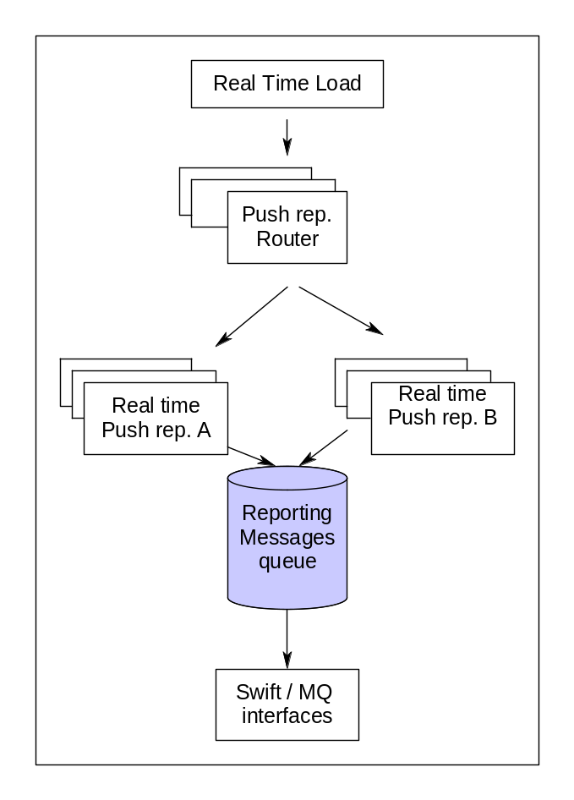

Component Description

Component Name: Push Reporting Router [ $EETPM / TRHA-TRS / TDE798 ]

Responsibility:

- Routing
- User access management

Description:

The role of this component is to route all incoming messages to the appropriate ‘generate’ components based not only on the type of information received but also function of the subscriptions database.

Extra info for the TRHA-TRS can be found in this document :

\\PFILE002\ADSHARE\02.LRDS\05.Development\4.Tandem\Training\KISS\TRHA-TRS.ppt

Push Reporting – Batch ( new infra )

Process Diagram ( general )

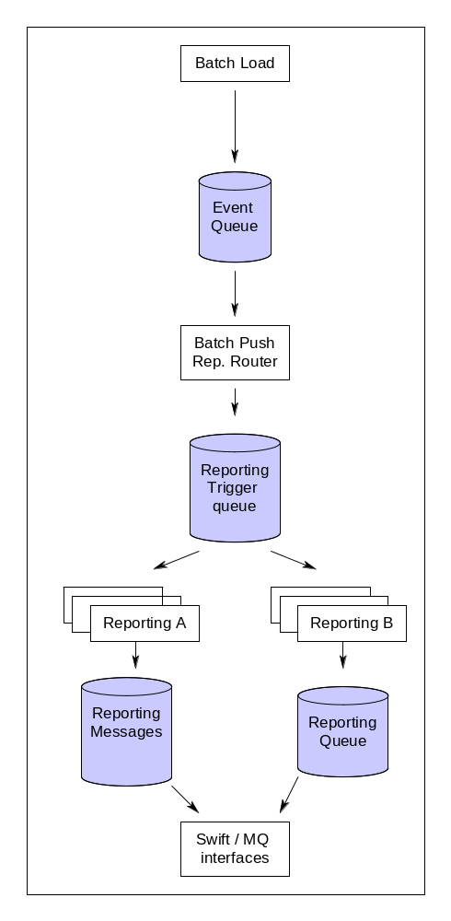

More specific

Connect Direct load
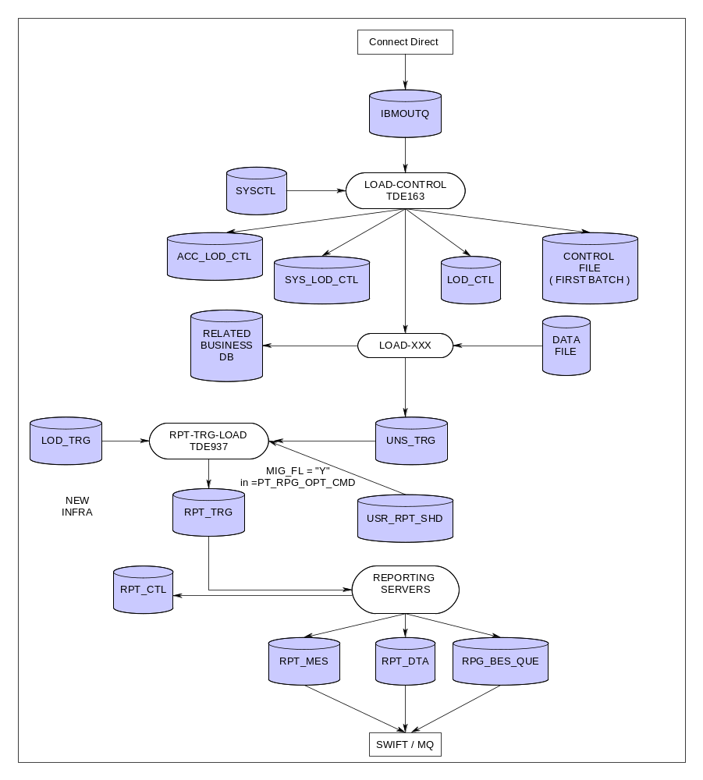

Business delimiter
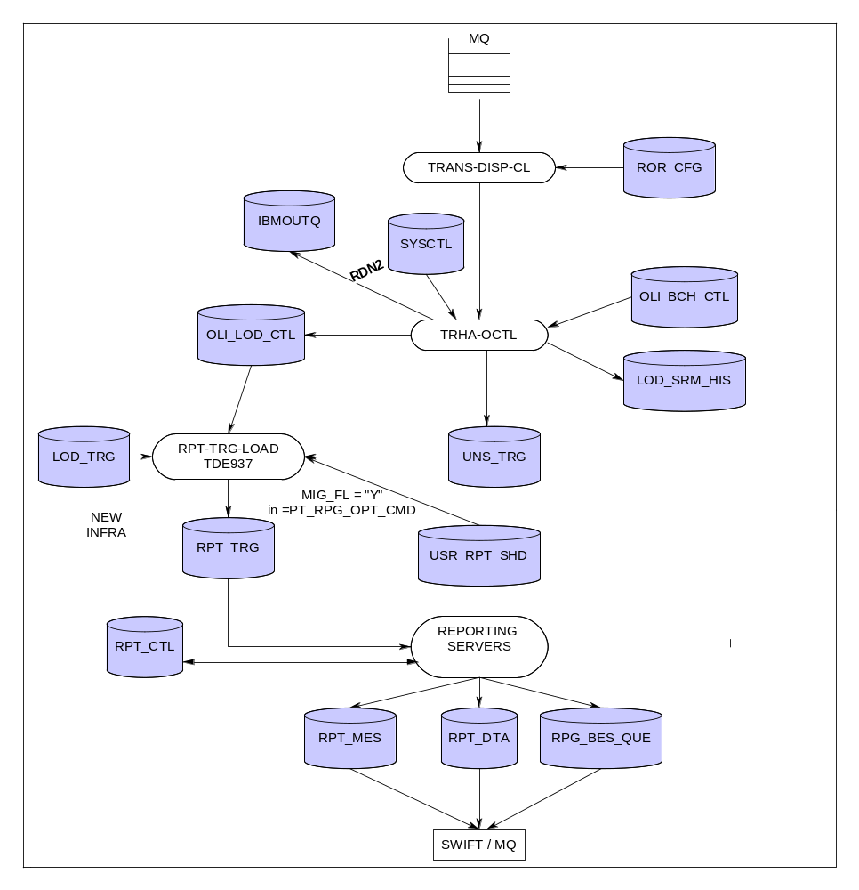

Component Description

Component Name: Batch Push Reporting Router [ $ESPM / RPT-TRG-LOAD / TDE937 ]

Responsibility:

- Routing
- User access management

Description :

This component is triggered by the writing of a record in the ‘event queue’ table (e.g. end of a specific batch load, reception of a business delimiter…).
When triggered, it reads the subscriptions table and writes a record in the ‘report trigger queue’ for each report that must be generated.
Reporting requests are read from the ‘report trigger queue’ by a set of reporting components that generates the appropriate reports.

Component Name: Generate

Responsibility:

- Reporting
- Auditing/logging

Description:

The ‘Generate’ component generates the outgoing SWIFT and Telex messages following either the load of data in batch mode or the reception/creation of a specific business delimiter.

Example Connect Direct load

A Connect Direct load is sent by IBM.

We receive the batch files ( $data9.peletprd.* ) and once they are transmitted via Connect Direct, the records in the IBMOUTQ are written.

The LOAD-CONTROL checks on a regular basis if it has received something in the IBMOUTQ.
If yes, it will check if the data contained in that record is correct ( the system date, the name of the batch files ). If everything is correct AND the files are on TANDEM, the LOAD-CONTROL starts its processing.

!!!! Some loads need, in addition to these records in the IBMOUTQ ( which we call ‘01’ records ) also a ‘trigger’ record ( which we call a ‘02’ record ). Very often, this trigger is done by a netbatch job, which runs every day at the same time.
If, for one reason or another, this processing does not work, we can also do a manual intervention and modify the records in the IBMOUTQ ( often done in testing, sometimes in production if we need to do manual processing ).

The IBMOUTQ can be browsed and updated via DSO :

Pathcom $PTST; run logon-1
F15 - Enable Menu
F14 - IBMOUTQ file

IBMOUTQ FILE MAINTENANCE Page 1 / 1
==============================================================================
* IBMOUTQ-KEY
CMD-CODE
LOAD-ID
BATCH-NBR 0
REPORTING-DT 0
FILE-NAME
BYPASS-FLAG
RERUN-RELOAD-FLAG

The info which needs to be filled in ( rarely done ) :

Normal record for the 3rd batch file of the load-MATX

COMMAND CODE : 01
LOAD-ID : MAT1
BATCH-NUMBER : 03
REPORTING-DATE : 060527 ( FOR UMF LOADS USE EOC-DATE OF SYSCTL
ALL OTHERS USE REPORTING DATE OF SYSCTL )
FILE-NAME : $DATA9.PELETPRD.MR0103
RERUN-FLAG : N
BYPASS-FLAG : N

Load triggering ( here for load-bops ):

COMMAND CODE : 02
LOAD-ID : BOPS
BATCH-NUMBER :
REPORTING-DATE : 060527
FILE-NAME :
RERUN-FLAG : N
BYPASS-FLAG : N

EOD triggering :

COMMAND CODE : 03
LOAD-ID : UMFA
BATCH-NUMBER :
REPORTING-DATE : 060527
FILE-NAME :
RERUN-FLAG : N
BYPASS-FLAG : N

Wake up load control ( force to read the IBMOUTQ ):

COMMAND CODE : 08
LOAD-ID :
BATCH-NUMBER :
REPORTING-DATE :
FILE-NAME :
RERUN-FLAG :
BYPASS-FLAG :

Lines are written in =PT_LOD_CTL and in =PT_SYS_LOD_CTL.
In this last table, you can follow the actual ‘load’ of information ( there is a pointer indicating how far the information has already been loaded on TANDEM ).

invoke =PT_SYS_LOD_CTL;
-- Definition of table \EURBRU5.$DATA19.ETDATA.SYSLODC
-- Definition current at 14:26:04 - 07/04/06

(
EUT_LOD_CD CHAR(5) DEFAULT SYSTEM NOT NULL
, EUT_LOD_DT NUMERIC( 8, 0) UNSIGNED DEFAULT

SYSTEM

NOT NULL
, BCH_NB SMALLINT DEFAULT SYSTEM NOT NULL
, CEN_FL CHAR(1) DEFAULT SYSTEM NOT NULL
, REC_PTR_NB INT DEFAULT SYSTEM NOT NULL
, LOD_END_TS LARGEINT DEFAULT SYSTEM NOT NULL
, BCH_NM CHAR(24) DEFAULT SYSTEM NOT NULL
, PRC_ID CHAR(6) DEFAULT SYSTEM NOT NULL
, BCH_TYP_CD CHAR(1) DEFAULT SYSTEM NOT NULL
, BCH_PES_CD CHAR(1) DEFAULT SYSTEM NOT NULL
, RPT_GEN_TYP_CD CHAR(1) DEFAULT SYSTEM NOT NULL
)

With :

BCH_NB sequence number of the batch

CEN_FL - Not triggered
S startable (set by batchcom)
R running (set by LOADER)
C completed

REC_PTR_NB records present in file

LOD_END_TS

BCH_NM name of the actual loadfile

PRC_ID name of treating process

Once the load finished ( the TANDEM business database is completely updated ), the batches treated are deleted ( not the control batch ). Please keep that in mind when doing unit testing ( save them before treating ).

In production, we NEVER accept to delete manually information in the batches; we NEVER accept changing data either ( sometimes a date is not correct ).
It is common procedure to rename the batches in case of problems and to ask IBM to resend new ( corrected ) batches via Connect Direct .

When the load is done, a line is written in =PT_UNS_TRG ( for each load ).

Once we have a line in =PT_UNS_TRG, the server RPT-TRG-LOAD detects this. It will continue its processing ONLY IF the MIG_FL = “Y”.

If this is the case, the server will read the table of subscriptions ( =PT_USR_RPT_SHD ) and it will create a line in =PT_RPT_TRG FOR EACH account having a subscription, independent of the fact that information has been updated for this account or not.
It is the table =PT_LOD_TRG which decides if several kinds of reporting needs to be done for 1 load ( uses technical load codes, which all refer to 1 kind of swift reporting ).

As from there, it is the reporting server which takes over :

When started, it first checks if there are still swifts that need to be generated ( if for one reason or another the server abended or was stopped manually ) : the reporting server scans through =PT_RPT_CTL for its own reporting AND STU_ID = “P” ( to be processed ).
Only if the reporting for all lines remaining in this table have been put to “C” ( completed ), the server starts reading =PT_RPT_TRG.
For each line, he tries to select data from it’s business table ( with update timestamp somewhere in between of the start of the load and the end of the load + additional where – clauses ) and IF it retrieves information, the reporting server goes on with the generation of the SWIFT.

The way of SWIFT generation is the same for all swift reporting servers in this new infrastructure and it is the same way of working as the swift reporting in real time. A nice document to explain this swift reporting ( ERM-ERS and ERT modules … ) can be found on :

\\PFILE002\ADSHARE\02.LRDS\05.Development\4.Tandem\Technical Documentation\Frameworks\Framework 548 v001.doc

It is specific for the MT548 reporting, but the way of working is the same as for the other swift reporting.

Pull Reporting - Synchronous

Process Diagram

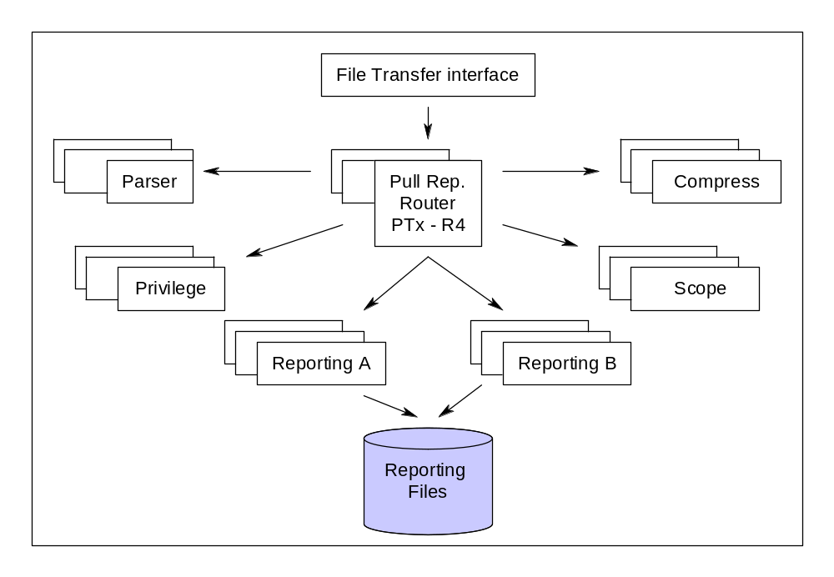

Component Description

Component Name: Parser [ $EETPM / MAPPER / TDE145 ]

Responsibility:

- Conversion
- Validation

Description:

The Parser is responsible for checking the correctness of the parameters of a request. If all the parameters are correct, it will split the request in atomic requests (the rest of the application being built to handle simple request). An atomic request in our case is a request that can be handled by the ‘reporting’ component.
Example: If the request contains more than one account, we must have one atomic request per account. If the request itself is the result of an aggregation of multiple requests (like R70 for instance), we have also to split it.

Component Name: Privilege [ $EETPM / PRIVILEGE / TDE212 ]

Responsibility:

- User access management

Description:

The role of the Privilege component consists to check the rights of the user for each atomic Request by accessing the ‘Privileges’ database.

Component Name: Scope [ $EETPM/ COMMAND-HIS / TDE215 ]

Responsibility:

- Auditing/logging
- Session management
- Reporting

Description:

The Scope component is in charge of determining the availability and the boundaries of each atomic request. The Scope manages also the Command History table that mainly contains statistics about the reporting commands sent by the user.

Component Name: Generate

Responsibility:

- Reporting

Description:

The Generate component generates the requested report. The production of the report is composed of three major steps:
- Selection: one or several queries on the relevant table(s) in order to get the data matching the selection criteria implied by the reporting request.
- Sort: when the report requires a sorting step.
- Formatting: the data selected and (possibly) sorted must be formatted according a number of rules function of the type of report generated.

Pull Reporting - Asynchronous

Process Diagram

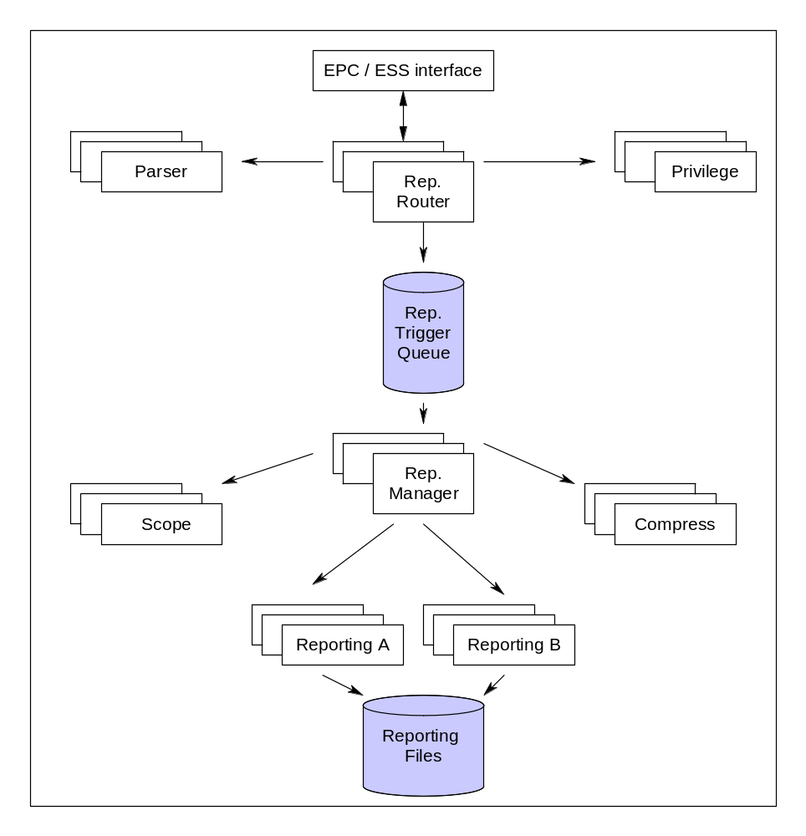

Component Description

Component Name: Reporting Manager

Responsibility:

- Routing

Description:

The Reporting Manager will receive reporting command via an inter-process message from the session manager.
It will handle the report requests, validate and translate them (by calling the Parser component), see if the privilege is granted to the user, and finally queue atomic requests in a queue table (NonStop SQL/MX table).
Privilege functionalities has been integrated to the Reporting Manager in order to save on pathsend operations and IOs.
It will directly reply to the session manager, mentioning either the produced file names, either the error code produced.

Component Name: Reporting Router

Responsibility:

- Routing

Description:

The reporting manager is responsible of the report generation chain. It treats all atomic requests queued. The treatment of the request involves to call the ‘scope’, the ‘generate’ and the ‘compress’ components. All of them are briefly described in the previous chapter.

Remark: The asynchronous mechanism allows us (if enough processes are configured) to treat the atomic requests of a reporting request in parallel. In the synchronous mode described above, they are processed in sequence.

Business applications on TANDEM

CUSTODY

Custody is the safekeeping and administration of securities and financial instruments on behalf of others
It is a Euroclear service, providing custody services for securities held in the Euroclear System – including tax services

Custody instruction and cancel: MT565 input

The custody MT565 input can be divided in 2 parts :

- Messages which are sent to NT – CTMS application
- Messages which are sent to IBM – USTAX application

MT565 can be:
  - New instruction when message contains :23G:NEWM
  - Cancel of instruction when message contains :23G:CANC

A distinction may also be made on the MT565 sent to CTMS for Certification and other Custody events.

How to make the difference ?
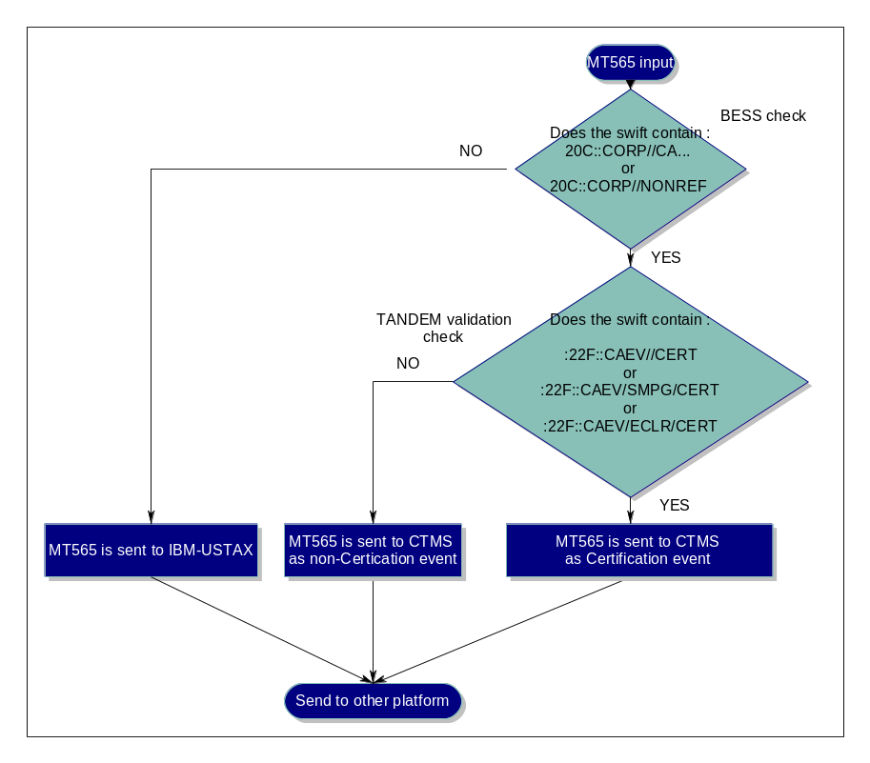

Custody cancel: MT592 input – Inline command

The custody MT592 input is proprietary format inputed thru Euclid PC/Server. Those Custody instructions are used to cancel previously sent instruction and are sent to CTMS application. There are 3 types of MT592 related to the service i.e. Clearing, Custody and Lending Borrowing.
N.B.: It is also possible to cancel of instruction thru special inline commands entered in Euclid PC/Server (CANCEL-MOD server) e.g. “CU;C;E;[worksheet]

USTAX instructions

Business overview

Participants use the ISO 15022 message MT 565 (Corporate Action Instruction) to send Euroclear beneficial owner breakdowns or pooled asset allocation. This input will generally be received from QIs ( qualified-intermediary ) or NQIs (non qualified-intermediary ) that have not taken withholding responsibility, or that are holding securities in an account for which not unique tax treatment has been identified. The allocation information received will be used to derive the correct tax rates to be applied, on a per payment basis.

Tandem implementation

When we talk about USTAX instructions, we talk about SWIFT input. The message type used for this is the MT565.
Reporting towards the clients is done via the MT567.

The routing ( to decide wether it is a USTAX message or not ) is done in BESS itself. When BESS detects that it is a USTAX message, then the message is put in the MQ which is read by the BESS-IN-TX server. This server then forwards the message to the USTAX-validation server : SWF-TX-VAL.
The validation, done on the MT565, is purely syntactical, no real ‘business’ is behind the processing.
If the message appears to be syntactically invalid, there is no need to send it on to IBM, so we report an error towards the participant via a MT567 – message ( VTX subscription – is free ). This message contains the error which was found in the message ( up to 3 errors are reported ) and the MT567 is sent to the address from where the MT565 came.

If the message is valid, we send it via MQ towards IBM-USTAX. IBM analyses the input and validates all fields contextually ( ‘business wise’ ). When all checks are done, TANDEM receives the feedback ( valid or invalid ) and logs it in the table =PT_BRD_FDB. This table contains all fields which will be reported to the participant.
This reporting is not free, the participant needs to pay for it. In return, he gets the subscription : 567XL or 567XF.

There is no overnight batch load for USTAX, only processing and feedback via the real-time links.

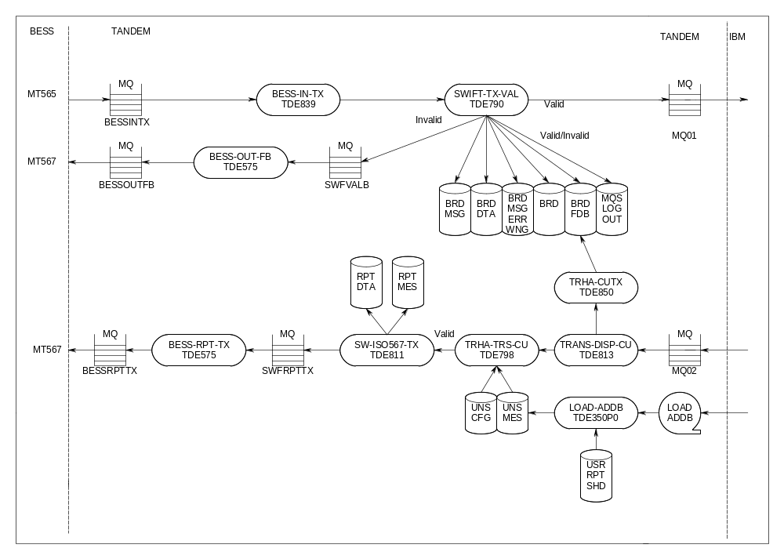

Example

A valid MT565 enters the system and is sent towards IBM :

IBM does the contextual checks and send all business data back to TANDEM. The TRANS-DISP-CU reads the input from the MQ, sends the structure towards the TRHA-TRS-CU and TRHA-CUTX. This last server enters all received information in the reporting feedback database ( =PT_BRD_FDB ). This table contains ALL info necessary to generate the MT567 message.

The TRHA-TRS-CU server checks the subscriptions in =PT_UNS_MES and if the participant has subscribed ( eut_fct_id = 567XF or 567XL ).
TRHA-TRS-CU does an "instruction based" pathsend (if subscribed) depending on the configuration in =PT_UNS_CFG table to the reporting server.Pathsend is done only if there exists an entry in =PT_UNS_CFG.
>>SELECT * FROM =PT_UNS_CFG WHERE EUT_FCT_ID LIKE "%567X%" BROWSE ACCESS;

EUT_FCT_ID PTH_SND_FL EUT_PTM_PRC_NM EUT_SRV_NM TIM_LMT_CT
---------- ---------- --------------- -------------- -----------

567XF Y $EETPM SW-ISO567-TX 60000
567XL Y $EETPM SW-ISO567-TX 60000

--- 2 row(s) selected.

The reporting server SW-ISO-567-TX generates the MT567 swift-report and places it on an MQ-queue SWFRPTTX. It also updates the =PT_EUT_CMD_HIS table.
Server BESS-RP-TX will read the message from the input queue SWFRPTTX and write the message into BESSRPTTX to be able to sent out to the SWIFT network.

!!! The FDB_FL in =PT_BRD_FDB indicated if the feedback from IBM was the answer on a MT565 which just entered the system ( fdb_fl = M ). If it is update info from IBM about ste status of a breakdown ( a lot of these are sent at 8 PM ), the the fdb_fl = B .

PT_BRD_FDB

PT_BRD_FDB.PAR_ACC_ID = 92564
PT_BRD_FDB.FDB_FL = M
PT_BRD_FDB.CRT_TS_567 = 2006-06-30:17:11:58.739399
PT_BRD_FDB.BRD_ID = 87042
PT_BRD_FDB.SEQ_CT_567 = 1
PT_BRD_FDB.MAX_SEQ_CT_567 = 1
PT_BRD_FDB.CRT_TS = 2006-06-30:17:11:59.108486
PT_BRD_FDB.CEV_CT = 6236046
PT_BRD_FDB.CEV_IDC_CD = INTR
PT_BRD_FDB.RLT_CEV_CT = 6220014
PT_BRD_FDB.FCT_CD = INST
PT_BRD_FDB.LNK_CT = 0
PT_BRD_FDB.LNK_TMN_NB_1 =
PT_BRD_FDB.LNK_TMN_NB_2 =
PT_BRD_FDB.LNK_TMN_NB_3 =
PT_BRD_FDB.LNK_TMN_NB_4 =
PT_BRD_FDB.LNK_TMN_NB_5 =
PT_BRD_FDB.LNK_TMN_NB_6 =
PT_BRD_FDB.LNK_TMN_NB_7 =
PT_BRD_FDB.LNK_TMN_NB_8 =
PT_BRD_FDB.LNK_TMN_NB_9 =
PT_BRD_FDB.LNK_TMN_NB_10 =
PT_BRD_FDB.TMN_NB_565 = BESV.GOLDMAN
PT_BRD_FDB.CRT_TS_565 = 2006-06-30:17:11:56.724590
PT_BRD_FDB.STU_CT = 1
PT_BRD_FDB.STU_QUA_1 = IPRC
PT_BRD_FDB.STU_CD_1 = PACK
PT_BRD_FDB.REA_CT_1 = 1
PT_BRD_FDB.REA_QUA_11 = PEND
PT_BRD_FDB.REA_CD_11 = NARR
PT_BRD_FDB.REA_NAR_TX_11 = EOC WARNING : NO ENTITLED POSITION VAL
PT_BRD_FDB.REA_NAR_TX_11 = IDATED (YET)
PT_BRD_FDB.REA_NAR_TX_11 =
PT_BRD_FDB.REA_QUA_12 =
PT_BRD_FDB.REA_CD_12 =
PT_BRD_FDB.REA_NAR_TX_12 =
PT_BRD_FDB.REA_NAR_TX_12 =
PT_BRD_FDB.REA_NAR_TX_12 =
PT_BRD_FDB.REA_QUA_13 =
PT_BRD_FDB.REA_CD_13 =
PT_BRD_FDB.REA_NAR_TX_13 =
PT_BRD_FDB.REA_NAR_TX_13 =
PT_BRD_FDB.REA_NAR_TX_13 =
PT_BRD_FDB.STU_QUA_2 =
PT_BRD_FDB.STU_CD_2 =
PT_BRD_FDB.REA_CT_2 = 0
PT_BRD_FDB.REA_QUA_21 =
PT_BRD_FDB.REA_CD_21 =
PT_BRD_FDB.REA_NAR_TX_21 =
PT_BRD_FDB.REA_NAR_TX_21 =
PT_BRD_FDB.REA_NAR_TX_21 =
PT_BRD_FDB.REA_QUA_22 =
PT_BRD_FDB.REA_CD_22 =
PT_BRD_FDB.REA_NAR_TX_22 =
PT_BRD_FDB.REA_NAR_TX_22 =
PT_BRD_FDB.REA_NAR_TX_22 =
PT_BRD_FDB.REA_QUA_23 =
PT_BRD_FDB.REA_CD_23 =
PT_BRD_FDB.REA_NAR_TX_23 =
PT_BRD_FDB.REA_NAR_TX_23 =
PT_BRD_FDB.REA_NAR_TX_23 =

MT567 sent

16R:GENL
:20C::CORP//000006236046
:20C::SEME//TAX0000000087042
:23G:INST
:22F::CAEV//INTR
:98C::PREP//20060630171158
:16R:LINK
:20C::CORP//000006220014
:16S:LINK
:16R:LINK
:13A::LINK//565
:20C::RELA//BESV.GOLDMAN
:16S:LINK
:16R:STAT
:25D::IPRC//PACK
:16R:REAS
:24B::PEND//NARR
:70D::REAS//EOC WARNING : NO ENTITLED POSITION
VALIDATED (YET)
:16S:REAS
:16S:STAT
:16S:GENL
-

CTMS instructions

Business overview

= Custody Transaction Management System.

Processes voluntary corporate actions instructions, using events from DACE (corporate events database) or participants or depositaries instructions and SECDB (securities database). Reports to participants and local markets (agents, depositaries)

e.g. : companies merging, splitting, issuer's currency options, capital gains, rights distribution, drawing announcement, fungibility

The CTMS system - Custody Transaction Management System - was developed in 1988 to manage the bulk of custody instructions. In 1999 the development of a new CTMS platform started. This new CTMS platform was launched in Feb 2001. In 2003 a new project focused on optimization of some o-line processes on NT, improving the DB accesses. In 2011, a project was launch to include the processing of Certification events so KIN application may be decommissioned. With this project, Euroclear is ISO compliant with the tax regulations and laws in several countries.
'CTMS' refers to the current CTMS system which is made of 3 different platforms (NT - Tandem - Mainframe) ; for TANDEM, CTMS refers to the NT part of the CTMS system.
The majority of custody instructions require manual intervention and has to be viewed in the broader context of the specific risks associated to the processing of corporate actions instructions. Indeed, unlike settlement instructions where the risk is rather a 'funding risk', the misprocessing or delay of a corporate action instruction exposes EOC to a 'principal risk', i.e. the maximum loss equal the total asset value.
With the worldwide trend towards consolidation through mergers and alliances, the financial sector is facing a considerable increase in the number and complexity of corporate actions, especially on equities and corporate bonds. More than ever, this emphasizes the need for a low-risk, highly efficient environment for executing corporate action instructions.
To limit the risks that are inherent in the execution of corporate action instructions, Euroclear has developed a real-time custody service for corporate action instructions (further referred to as “the instructions”).
The business objectives of the CTMS platform can be summarized as follows:
- Offer more competitive corporate actions deadlines, closer to the local market deadlines by interfacing in real-time with NEXT;
- Reduce operational sensitivity to volumes by increasing straight through processing;
- Reduce operational risk by automating securities and cash movements and messages to external parties.
- Calculate the uncertified amount on the certification deadline when client sent several instructions with certified positions.

The processing of the corporate actions within Euroclear includes the processing of
  - the voluntary corporate actions:
    - options: these are published in the prospectus of the security and require actions by the holders of the security. Examples of options: conversion option of a convertible bond, put option, etc.
    - offers: these do not exist when the security is created. They are announced by the issuing corporation and they require actions by the holders of the security. Examples are choice dividend, subscription for new shares.
  - mandatory corporate actions (also called non-voluntary corporate actions or non-elective events): these do not exist when the security is issued and they do not require actions from the holders of the security (except in a few cases where the participant needs to provide some information e.g. when a non-US residence certificate is required or when delivery details are required as proceeds might not be eligible within the EOC system). They are reported for information only. On event date or record date EOC automatically applies the execution of the corporate action on all the holdings of the participant
  - certification events: Euroclear Bank offers the facility for its clients to certify electronically the eligibility to hold the securities. EB sends the certification of its position to the depositary for onward sending to the fiscal agent.

Tandem implementation

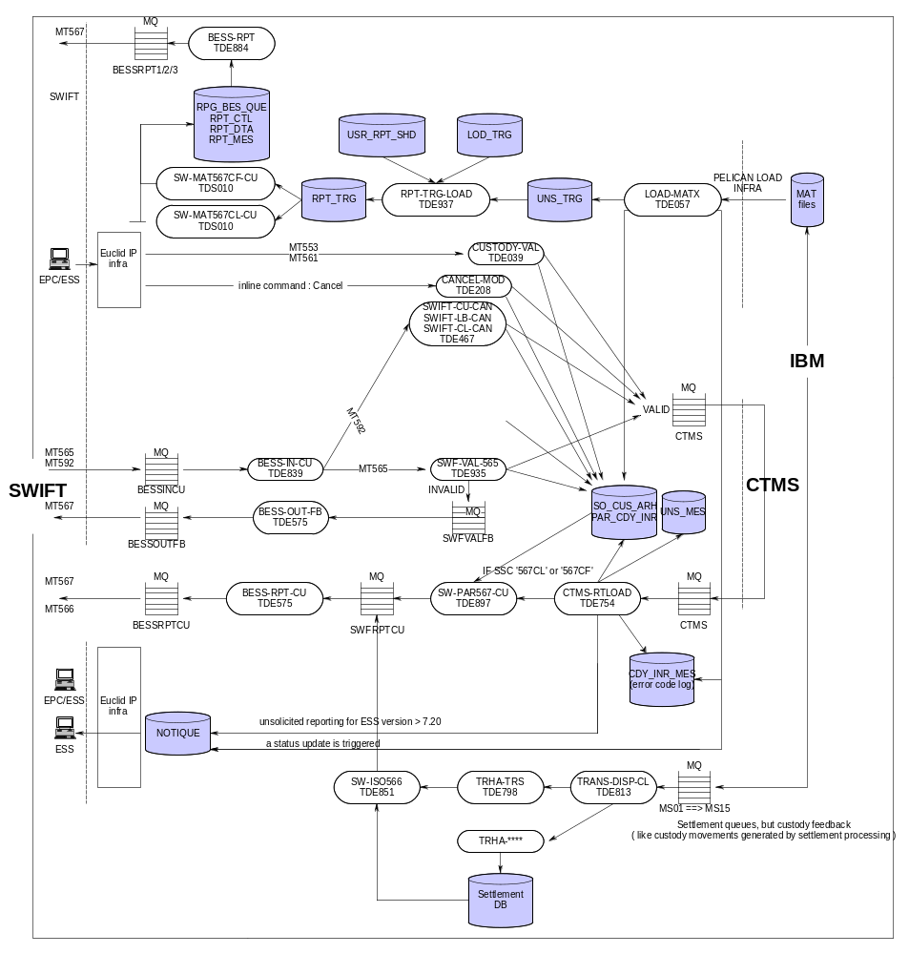
Custody instructions can enter our system via Euclid server and PC ( MT553/MT561 ), and also via SWIFT. Only syntax validation is applied. When the swift message is invalid, reporting is done towards the participant with the error message. When the message is valid, the data is sent towards CTMS.

The contextual validation is done on CTMS.
Overnight feedback from IBM comes back via the LOAD_MATX. This load updates the custody tables and generates swift reporting for the participants which have subscribed. A status update is triggered for the ESS which are connected in unsolicited mode.

Real-time feedback from CTMS comes back via the MQ and this information is read by the CTMS-RTLOAD. This server does a pathsend to the swift reporting server for participants which have subscribed. For the ESS connected in unsolicited, unsolicited reporting is being generated for the specific instruction update which came back. CTMS-RTLOAD will also log the error codes received from CTMS into =PT_CDY_INR_MES. That table will be used in the Custody Euclid reporting, such as R50, combined with the decode table = PT_EUT_CDY_INR_MES.

Swift reporting uses the format MT567.

Example

A MT565 enters the system. It is validated by the SWF-VAL-565. This server updates the custody databases before sending the message to CTMS.

565
:16R:GENL
:20C::CORP//CA000006431042
:20C::SEME//63646395/COA/BVC
:23G:NEWM
:22F::CAEV//EXRI
:16S:GENL
:16R:USECU
:35B:ISIN FR0010342816
EURALTECH RIGHT 06/06
:16R:ACCTINFO
:97A::SAFE//90013
:93B::ELIG//UNIT/12200,
:16S:ACCTINFO
:16S:USECU
:16R:CAINST
:13A::CAON//004
:22F::CAOP//SLLE
:36B::QINS//UNIT/10700,
:16S:CAINST
-

Feedback comes back from CTMS :

If the feedback comes back, the CTMS-RTLOAD will update the custody tables with additional business information .
It also checks if the participant has subscriptions ( =PT_UNS_MES ) to receive feedback on his instruction ( via SWIFT or Euclid unsolicited ). If yes, the reporting is generated by the CTMS-RTLOAD itself for the unsolicited reporting, and by the SW-PAR567-CU in case of swift reporting ( eut_fct_id = 567CF or 567CL ).

Swift MT567

16R:GENL
:20C::CORP//CA000006431042
:20C::SEME//4904789
:23G:INST
:22F::CAEV//OTHR
:98C::PREP//20060703134918
:16R:LINK
:20C::RELA//63646395/COA/BVC
:16S:LINK
:16R:STAT
:25D::IPRC//PACK
:16S:STAT
:16S:GENL
:16R:CADETL
:13A::CAON//004
:22F::CAOP//SLLE
:97A::SAFE//90013
:35B:ISIN FR0010342816
//EURALTECH RIGHT 06/06

EUR
:36B::STAQ//UNIT/10700,
:16S:CADETL
-

Table =PT_PAR_CDY_INR

PT_PAR_CDY_INR.PAR_ACC_ID = 90013
PT_PAR_CDY_INR.SEC_INR_PAR_WSH_ID = 4904789
PT_PAR_CDY_INR.ECL_USR_ID =
PT_PAR_CDY_INR.CRT_TS = 212018694558726332
PT_PAR_CDY_INR.SEC_INR_ENR_DT = 60703
PT_PAR_CDY_INR.CDY_OPN_TYP_CD = 61
PT_PAR_CDY_INR.SEC_TYP_GRP_CD =
PT_PAR_CDY_INR.CDY_INR_STL_DT = 20060703
PT_PAR_CDY_INR.SEC_ID = 708744
PT_PAR_CDY_INR.SEC_AB = EURALTECH RIGHT 06/06
PT_PAR_CDY_INR.SEC_NOM_CUR_ID = EUR
PT_PAR_CDY_INR.SEC_INR_NOM_AM = 10700,00
PT_PAR_CDY_INR.CMO_SEC_ID = 025884701
PT_PAR_CDY_INR.ISN_ID = FR0010342816
PT_PAR_CDY_INR.SEC_IDF_TYP_CD =
PT_PAR_CDY_INR.SWI_SEC_TYP_DS =
PT_PAR_CDY_INR.INR_CAN_ORI_FL =
PT_PAR_CDY_INR.EUT_SEC_INR_STU_CD = 03
PT_PAR_CDY_INR.SEC_INR_STU_UPD_TS = 212018694730671544
PT_PAR_CDY_INR.INR_STU_UPD_EOC_DT = 60703
PT_PAR_CDY_INR.SEC_INR_STU_LOD_CD =
PT_PAR_CDY_INR.SEC_INR_PVS_STU_CD = 04
PT_PAR_CDY_INR.SEC_INR_CAN_TS = 212018694558726332
PT_PAR_CDY_INR.INR_CAN_EOC_DT = 0
PT_PAR_CDY_INR.CDY_PCD_SEC_ID = 708744
PT_PAR_CDY_INR.CDY_OPN_SUB_TYP_CD = SELL
PT_PAR_CDY_INR.CSH_PCD_CUR_ID =
PT_PAR_CDY_INR.SEC_INR_PAR_REF_ID = 63646395/COA/BVC
PT_PAR_CDY_INR.PAR_INP_NOM_CUR_ID =
PT_PAR_CDY_INR.SEC_INR_CPN_CD =
PT_PAR_CDY_INR.INR_ORI_CD =
PT_PAR_CDY_INR.INP_CMN_CHL_CD =
PT_PAR_CDY_INR.SEC_INR_CAN_CD = 0
PT_PAR_CDY_INR.INR_CAN_USR_ID =
PT_PAR_CDY_INR.INR_CAN_INP_CHL_CD =
PT_PAR_CDY_INR.STD_CER_CD =
PT_PAR_CDY_INR.SEC_RGS_ID =
PT_PAR_CDY_INR.SEC_RGS_ID =
PT_PAR_CDY_INR.SEC_RGS_ID =
PT_PAR_CDY_INR.SEC_RGS_ID =
PT_PAR_CDY_INR.CDY_PCD_RCP_ID =
PT_PAR_CDY_INR.CDY_PCD_RCP_ID =
PT_PAR_CDY_INR.CDY_PCD_RCP_ID =
PT_PAR_CDY_INR.CDY_PCD_RCP_ID =
PT_PAR_CDY_INR.CDY_PCD_BNF_ID =
PT_PAR_CDY_INR.CDY_PCD_BNF_ID =
PT_PAR_CDY_INR.CDY_PCD_BNF_ID =
PT_PAR_CDY_INR.CDY_PCD_BNF_ID =
PT_PAR_CDY_INR.CDY_PCD_RCP_MES_TX =
PT_PAR_CDY_INR.CDY_PCD_RCP_MES_TX =
PT_PAR_CDY_INR.CDY_EOC_MES_TX =
PT_PAR_CDY_INR.CDY_EOC_MES_TX =
PT_PAR_CDY_INR.CDY_EOC_MES_TX =
. . .
PT_PAR_CDY_INR.EUT_INP_MDE_BEG_TS = 0
PT_PAR_CDY_INR.CDY_INR_NTF_DT = 0
PT_PAR_CDY_INR.CDY_INR_PRI_DT = 0
PT_PAR_CDY_INR.CDY_INR_CER_DT = 0
PT_PAR_CDY_INR.SHR_HLD_MET_DT = 0
PT_PAR_CDY_INR.BXL_CRT_TS = 6515993861955616
PT_PAR_CDY_INR.EUT_INR_WNG_001_CD =
PT_PAR_CDY_INR.EUT_INR_WNG_002_CD =
PT_PAR_CDY_INR.INR_CFM_FL = Y
PT_PAR_CDY_INR.INR_REF_ID =
PT_PAR_CDY_INR.CEV_CT = 6431042
PT_PAR_CDY_INR.SEN_TS = 2006-07-03:13:49:18.700835
PT_PAR_CDY_INR.RCV_TS = 2006-07-03:13:49:18.700835
PT_PAR_CDY_INR.EOL_INP_USR_ID =
PT_PAR_CDY_INR.EOL_INP_USR_ID =
PT_PAR_CDY_INR.EOL_CAN_USR_ID =
PT_PAR_CDY_INR.EOL_CAN_USR_ID =
PT_PAR_CDY_INR.MES_ID =
PT_PAR_CDY_INR.MES_ID =
PT_PAR_CDY_INR.COR_ACT_EVT_ID = OTHR
PT_PAR_CDY_INR.COR_ACT_OPT_EVT_NB = 004
PT_PAR_CDY_INR.COR_ACT_OPT_ID = SLLE
PT_PAR_CDY_INR.RMK_MES_TX =
PT_PAR_CDY_INR.RMK_MES_TX =
PT_PAR_CDY_INR.RMK_MES_TX =
PT_PAR_CDY_INR.RMK_MES_TX =
PT_PAR_CDY_INR.RMK_MES_TX =
PT_PAR_CDY_INR.RMK_MES_TX =
PT_PAR_CDY_INR.ECL_DEF_USR_ID =
PT_PAR_CDY_INR.CTT_PSO_TX =
PT_PAR_CDY_INR.CTT_PSO_TX =
PT_PAR_CDY_INR.MES_TYP_ID =
PT_PAR_CDY_INR.VLN_EUP_USR_SHT_NM =
PT_PAR_CDY_INR.CAN_EUP_USR_SHT_NM =

Custody output specific for Credit Suisse; income payable

For each daylight cash payment, an MT566 will be created and sent to the client.
To be able to create the MT566 on Tandem, a mini income load will be sent through an MQ message. Tandem will read the messages, feed the income database that is used to create the R59 report and generate the MT566 MKC cash message.

Tandem implementation

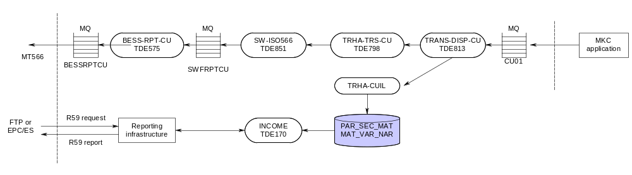
The above shows the real-time custody link to create MT566 MKC cash (market claim cash) reports specifically for Credit Suisse. MT566 MKC cash reports for other clients are normally created via batch reporting which is triggered via LOAD-INCO.

Other specific Custody output

IPR: MT566/MT567/R59

Custody income and movements: MT566‘s are being generated after LOAD-INCO and LOAD-SETx (see =PT_LOD_TRG ) + also in real time.
The reporting server which does this generation after LOAD-INCO and LOAD-SETx is the SW-ISO56N – TDS013.
The reporting server which does this generation in real time is the SW-ISO566 – TDE851.

This is the reporting of income + cash and securities movements related to custody activity

LOAD-INCO and the real-time custody link (introduced for Credit Suisse) will produce MT566 income (INC) messages (cash and/or security) or MT566 market claim (MKC) messages (cash only).
Custody movements via LOAD-SETx and the real-time settlement link will produce MT566 subtypes based on the below selection criteria:

- Mandatory corporate actions / Manual input (MCA):
- mvt_rlt_ent_id in (“CM”, “CR”)
- sec_inr_typ_cd in (“01”, “02”, “03”, “07”)
- sec_inr_opr_ref_id < > “MARKET CLAIM”
- Market claims securities (MKC):
- mvt_rlt_ent_id = “CM”
- sec_inr_typ_cd in (“01”, “02”, “03”, “07”)
- sec_inr_opr_ref_id = “MARKET CLAIM”

- Coupon compensations (CCO):
- mvt_rlt_ent_id < > “CM” ( !!! “CI ” is included in this case )
- sec_inr_typ_cd in (“01”, “02”)
- cpn_cmp_typ_cd = “2”
- Coupon compensations - instruction linked to biparty Repo (BPI) :
- mvt_rlt_ent_id = “CM”
- sec_inr_typ_cd = (“02”)
- sec_inr_opr_ref_id = “COMPENSATION”
- Coupon compensations - advise linked to biparty Repo (BPA) :
- mvt_rlt_ent_id = “CN”
- sec_inr_typ_cd in (“01”)
- sec_inr_opr_ref_id = “COMPENSATION”

Both BPI as BPA will be generated with sub-type CCO.

Corporate Action Status and Processing Advice; MT567’s are being generated after LOAD-INCO and also in real time.

In real time we produce a ‘Cash status Advice’ via MT567 to confirm that:
- funds previously advanced have been received and reconciled
- funds have been received and reconciled for a deferred payment
The reporting server which does this generation is the SW-PAR567 – TDE002.
After LOAD-INCO we produce a ‘Deferred Payment Advice’ via MT567 to indicate that:
- cash proceeds have not been paid due to lack of certification from clients
- a payment has been deferred (including when price is unknown and reversals not yet rebooked)
The reporting server which does this generation is the SW-BCH567 – TDS028.

Tandem implementation
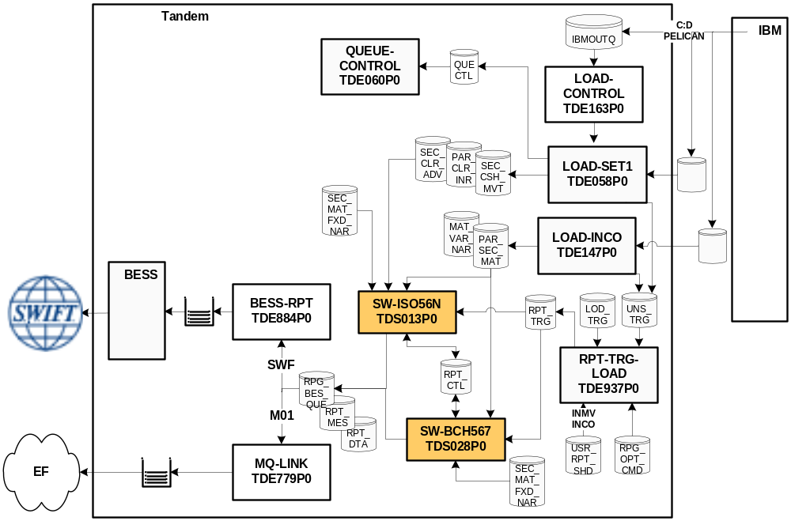 Figure ‎5-1 INCO/SETn Batch Custody reporting

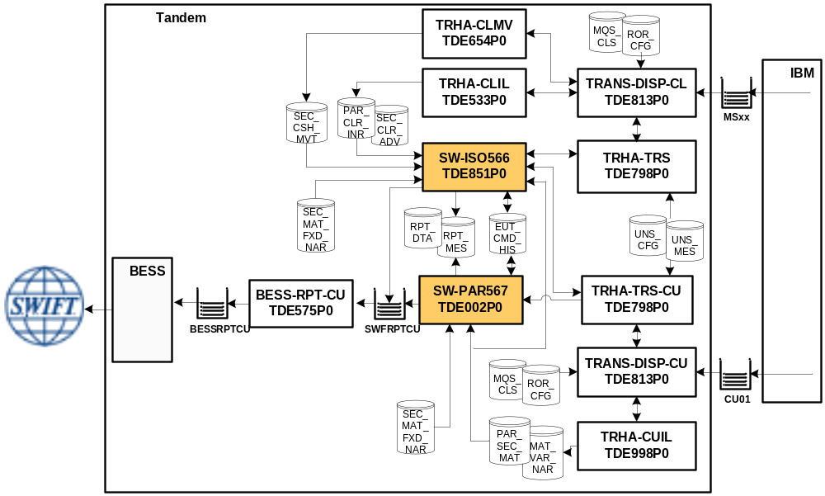 Figure ‎5-2 Income + Cash & Security Real-time custody reporting

Note that:
- The real-time link to create the MT567 CSA is re-using the link for Credit Suisse which creates the MT566 MKC cash(via TRANS-DISP-CU).
- The real-time link to create the MT566 <> MKC cash is re-using the link for settlement activity (via TRAN-DISP-CL).
- The reports generated in real time can not be sent to Euroclear France using the MQ-link (the ‘M01’ subscriptions).

Tandem will base its reporting on the TOL code (stored in =PT_PAR_SEC_MAT.SEC_MAT_RPT_CD) according to the table below:

TOL | SWIFT |  | Comment
1,2 | 566 | 56N | Income reporting:  1 - Advanced payment: reporting of booking  2 - Deferred payment: reporting of booking/reconciliation
3 | n/a | n/a | Reconciliation of advanced payment; not reported (as it’s already done in real-time via 567CSA).
O | 567 | 567CSA | Real time reporting of reconciliation step
C,D | 567 | 567DPA | PEND//MCER
F | 567 | 567DPA | PEND//NPAY
E | 567 | 567DPA | PEND/EGSP/UKWN
H,I | 567 | 567DPA | PEND//MCER, PEND//NPAY& PEND/EGSP/UKWN
J,K | 567 | 567DPA | PEND//MCER & PEND/EGSP/UKWN
N | 567 | 567DPA | PEND//NPAY & PEND/EGSP/UKWN
L,M | 567 | 567DPA | PEND//MCER & PEND//NPAY

The IPR Euclid Report (R59) – the equivalent of the SWIFT MT566 and MT567 - is generated from the business tables filled by LOAD-INCO and the real-time custody link (=PT_PAR_SEC_MAT & =PT_MAT_VAR_NAR). This report is divided in sub-parts also depending on the TOL code:

TOL | Euclid |  | Comment
1 | Income | Part 1 | Items posted today - Funds advanced by Euroclear
2 | Income | Part 2 | Items posted today - Funds received and reconciled by Euroclear
3 | Income | Part 3 | Items previously posted - Funds received and reconciled by Euroclear
6 | Income | Part 4 | Items delayed (will become obsolete)
F, H, I, L, M, N | Income | Part 4.1 | Funds not received
C, J | Income | Part 4.2 | Missing certification for non-US Beneficial Ownership
D, K | Income | Part 4.3 | Missing affidavit for non-Belgian residence
E | Income | Part 4.4 | Gross amount is unknown
G | Income | Part 4.5 | Funds received and reconciled by Euroclear
7 | Income | Part 5 | Items Referred for follow-up by Custody Services
O | Income | Part 6 | Items reconciled intra-day
A | Corporate actions

MT564

There are multiple types of MT564. The original (ANIR) version has been (SPQW 2.1) renamed to CMA and (November 2011 release) an additional PAR version has been generated for the pre-advice of reversal.
Both reports require the same 564 subscription, so they (had to) share the same function id. The Pre-Advice of Reversal will be conditional to client’s subscription on CMA service i.e. clients having subscribed to the CMA (in whatever format) will automatically receive the PAR. All reporting options on the CMA will not apply to the PAR (e.g. opt-out for NILP, unknown payment, full/delta for ISO). Clients not having subscribed to the CMA will not receive a PAR. Option to opt-out zero payment and/or price/rate or Full/Delta is not applicable to PAR message generated via MT564. Subscriptions for CMA are currently only available for ISIN format so this will (currently) also apply for PAR (even though ISIN/common code is already implemented, due to the restriction in subscriptions they will not yet apply).

564 CMA is triggered after the INPR load, the 564 PAR is triggered after the PARV load. For both reports the same SW-BCH564 server (TDS029) is called. The main module distinguished both types using the REPORT-PRESENTATION : CMA has the default code S (calling report generator S02901) while the PAR has P (calling S02902).

MT564 CMA

The 564 CMA report (in a previous version known as Anir) provides information on forthcoming interests, dividends, redemptions and corporate actions payments made in cash. This reporting is generated after the LOAD-INPR.
The reporting server is the SW-BCH564 (TDS029 – dedicated module S02901C1). Main tables where the data is stored are :

- PT_ICO_PRE_INF (main table)
- PT_ICO_PRE_POS (positions)
- PT_ICO_PRE_NAR (narratives)

There is one INPR overnight load (INPR0) that is triggered by Batchcom (around 0.30) and during the day there are 6 intraday loads (INPR1->6) that process on arrival (without trigger).

- intra-day load INPR1 processed on arrival around 06:30
- intra-day load INPR2 processed on arrival around 09:00
- intra-day load INPR3 processed on arrival around 12:00
- intra-day load INPR4 processed on arrival around 15:00
- intra-day load INPR5 processed on arrival around 17:15
- intra-day load INPR6 processed on arrival around 19:00

INPR loads can be skipped on mainframe side with no impact on tandem. The only rule on tandem is that the previous INPR load arrived has processed (therefore the number has to be sequential but can be skipped from INPR2 to INPR4)

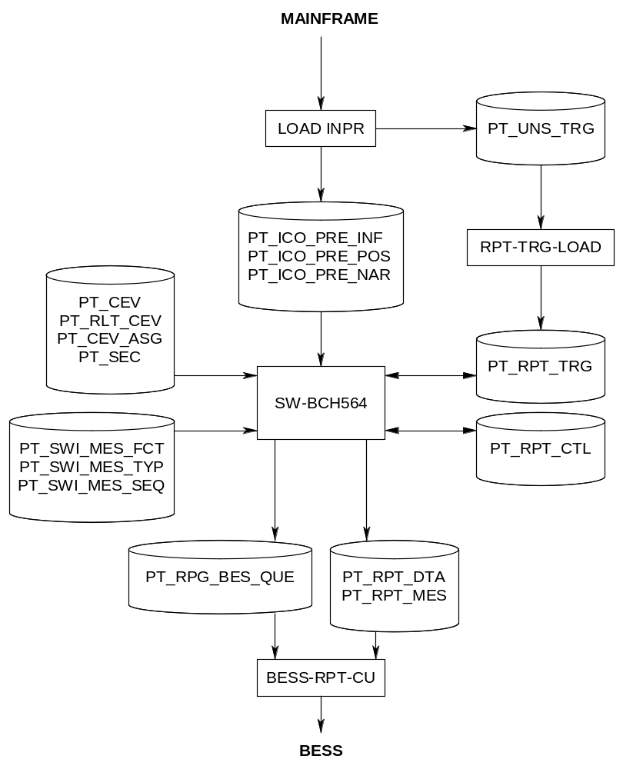

There are some exceptions on the report triggering / subscriptions, e.g :

- cancels are only to be reported once (even for full subscription)
- overnight loads will generate full/delta reports depending on the subscription but intraday load will always generate delta (regardless the subscription)
- there are multiple opt-out options to which users can subscribe in order (not) to reveice zero payments and/or unknown price/rate. For this the filtering is done based on the coupon code (CPN-CD) being :
- 'C' : coupon pays zero
- 'U' : unknown price
- 'N' : default
- 'D' : Coupon Pays zero - previously Non Zero. Reported once more even for an opt-out on pays zero
- 'V' : Unknown Price - Previously known. Reported once more even for an opt-out on unknown price-rate
- There are also some cases where the function of the message reported is not the same as the one send over by mainframe :
First CMA (no previous swift ref. found)
> when NEWM or REPE, reports NEWM
> when CANC, reports CANC with corp.id in previous reference
Not First CMA (previous swift ref. found)
> when NEWM or REPE, reports REPE with previous reference
> when CANC, reports CANC with previous reference
when CPN-CD = "D" or "V, reports REPE with prev reference (if not CANC)

The Euclid equivalent of the MT564 CMA is the R58

MT564 PAR

The 564 PAR is as Pre-advice of Reversal (PAR) on Income and Corporate actions events with cash proceeds processed in MM/REM.
The purpose of this message is to notify account owners that:
- a forthcoming reversal of cash and possibly of underlying securities will be made to its account.
- new cash amount will be credited to its account (only if details of new payment are known at the time of the reversal notification)

In case of new and replacement the report must contain all the information available (as detailed in the mapping) and not just the updated data.
In case of cancellation the report must only contain the mandatory Swift fields of an MT564, i.e. all the optional fields and sequences should not be reported. Except the optional field ‘Additional Business Process indicator’ identifying that the message is a Pre-advice of reversal must be present even in case of cancellation.
One MT564 PAR must be generated per event number/account id but it can have multiple balances and multiple cash movements with no aggregation of amounts i.e. the PAR must contain repetition of all credited or debited amounts that need to be reversed / rebooked.
An MT564 update must refer to the previous PAR generated while a NEW PAR should refer to the original MT566. As one MT564 PAR can be linked to several MT566 having as function of message ‘NEWM’, in case of multiple balances (e.g. one MT566 sent for a borrowed/lent balance and one MT566 sent for the clearance balance).
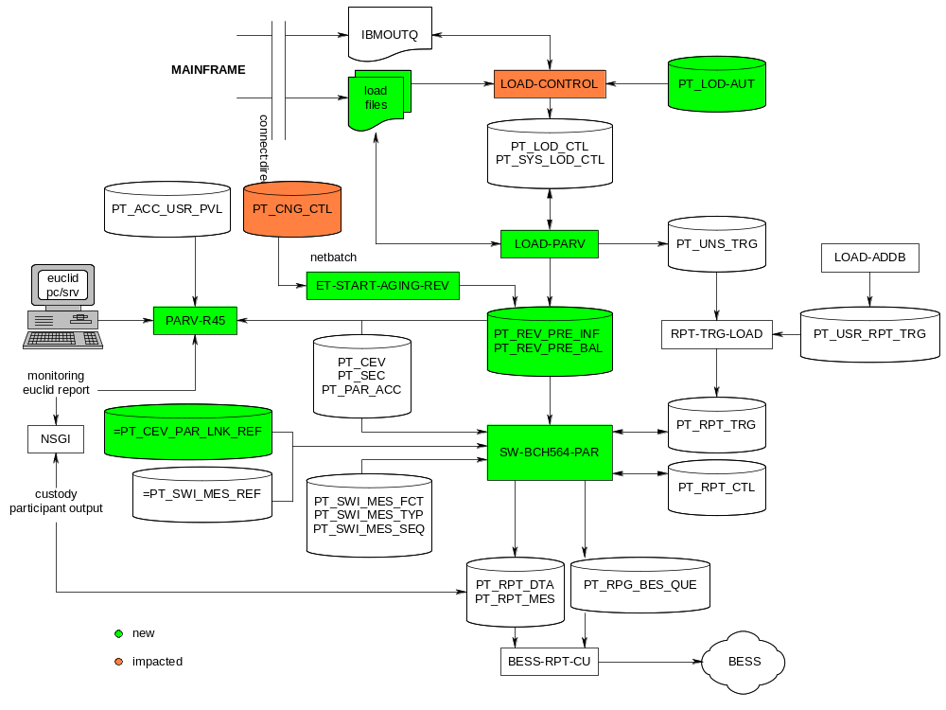
There is an exception on the Retention period for PAR reports for which the aging has been extended to 10 days (dedicated entry in PT_CNG_CTL PT_RPT_DTA_564PAR).

The data of the reversal (and potentially rebooking) is manually inputted on mainframe via an on-line PAR Operational tool. The data is transferred to tandem and stored in the PAR tables
- PT_ICO_PRE_INF
- PT_ICO_PRE_BAL
during the LOAD-PARV, which is generated (on MF) along with the next DACE intraday following the validation of the PARV preparation in the Ops Tool. If DACE intraday is blocked/delayed, PARV will wait for DACE intraday, if DACE intraday is skipped, the PARV must not be sent, so also for tandem, the loads are skippable, except for the last PARV6.
Intraday timing (aligned on the main currencies’ treasury deadlines):
- PARV1 6:30 (skippable)
- PARV2 9:30 (timings to meet Asian clients’ needs – skippable)
- PARV3 12:00 (skippable)
- PARV4 15:00 (skippable)
- PARV5 17:15 (skippable)
- PARV6 19:00 (around the closure of business – MANDATORY)

Unlike the INPR load (INPR0, triggered by netbatch) there is no overnight load for the PARV. All batches process on arrival. The only dependency that is checked on tandem side is that if the previous PARV has completed. All batches can be skipped, the only one mandatory is the PARV6, so if no batches for the current day are found, the PARV6 of the previous day should be completed.

The Euclid equivalent of the MT564 PAR is the R45 :

Ra45A;date;currency;income type;account
a : F or X (formatted or excel)

A : U or A (update of all)
UPDATE reports are to be restricted on the UPDATE-EOC-DATE (against RPT_SEL_DT) and the START and END-TIMESTAMP (against LST_UPD_TS) while the ALL version is only restricted on the date passed (if provided). Please note that if a date is inserted in the R45U, the command will be rejected.

date : In the command for the R45A, it must be possible to specify up to five reversal processing dates in the future. If no date is specified, all future reversal dates must be the default value (five business days).
The reversal processing date can be specified in two ways:
by typing dates in the format ddmmyy or
by selecting codes (+1 up to +5) indicating a number of days in the future.
Note: Date +1 is the date of the next overnight process.

Currency : In the command for the R45A, it must be possible to specify up to five reversal cash currencies or the value ‘A’ to obtain the report
for all reversal cash currencies. If nothing is specified, A must be the default value.

Income type : In the command for the R45A, it must be possible to specify up to three types of income categories of entries by using the value:
• C for coupons only;
• D for dividends only; or
• P for principal only, including drawings, partial, early and final redemptions and all other event categories not included in ‘C’ or ‘D’.
Account: In the command for the R45A it must be possible to specify up to 10 Securities Clearance Account numbers or the value A to obtain the balances for all the Securities Clearance Accounts to which the user has access. Thus, one report can contain several accounts. If nothing is specified, the default account specified for that client (in Tandem) will be the default value.

MT536

The generation of MT536, Statement of Transactions, will be triggered upon receipt of the BALDN, ARTSE and/or ARTS2 delimiter. The period for reporting depends on the delimiter received:
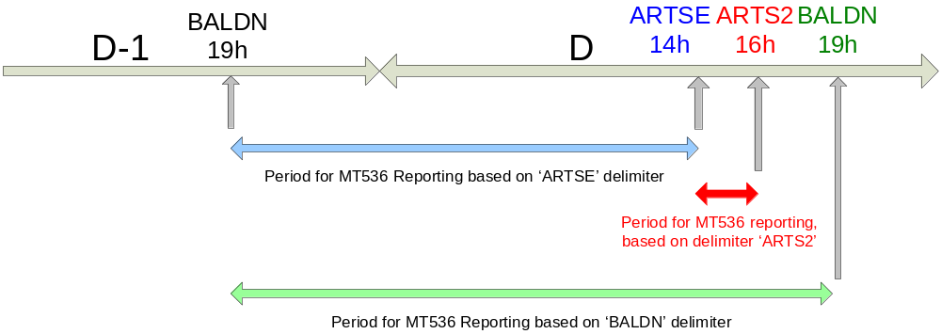
The delimiter ‘ARTS2’ is linked to the ARTSE delimiter so messages will be generated using the same ‘ARTSE’ subscriptions, a separate ‘BALDN’ subscription is required for the MT536 report based on the ‘BALDN’ delimiter.
The reporting server is SW-ISO536 (TDE818P0).

MarkiT

MarkiT is an external data provider who has got a cotract with Euroclear to receive corporate event information on a daily base. MarkiT will forward the information got from Euroclear to their own clients.

Tandem gets the updates on the corporate event information 8 times per business day via a load UMFD. Triggered by the receipt of the UMFD, Tandem will generate reports on all the updated events in the same MT564 format like in the client reports used for Dace on Swift. Only balance and account information is excluded. MT568 messages will not be generated.

A filter has been put in place to select the events reported according to the following rules:

- The following rules must apply apply to underlying (= exercised) securities

  - Euroclear Bank eligible (eligibility flag= Y)
  - non confidential (confidential flag=N)
  - deposited with a common depository or
  - deposited with specialised depository ('00012','00018','00030') and after exchange physical form equals 'N'
  - for which the instrument nature is ‘debt’ = D or for which the instrument category is hybrid warrant OR cumwarrant OR convertible
  - securities without ISIN will not be selected
  - regardless whether Euroclear Bank has a holding or not in that security
  - whatever its status (DEF, BKD, CMP, AUT) excluding security status equal to ‘CAN’

- event types 5xx and 4xx will not be selected (Tax events or certification events)
- Events for which the reporting flag = C (confidential) will not be selected. This is already provided on Mainframe. We don’t receive confidential events via UMFD.

The reporting to the client is done via a Secure File Transfer (SFTP) which is performed on a Windows system. Tandem concatenates all the MT564 messages received via a specific UMFD into a single text file, and transfers this file to Windows via Connect:Direct. A triggering mechanism is in place (using Mainframe) to start the sending process on the Windows system.

Implementation details

Two server classes are responsible for the generation of the MarkiT feed reports:

- SW-BCH564-MKT (TDS030P0) in $ESPM
- MKT-SENDER (TDF016P0) in $EFTPM

SW-BCH564-MKT is a clone of the DoS and UIR servers. It is using a third message sub type for the MT564, sub type “MKT” in addition to the sub types UIR and DOS. It generates the 564 messages as usual and stores them into =PT_RPT_DTA and =PT_RPT_MES. A trigger is written into the =PT_RPG_BES_QUE with the channel code “MKT”, so that it can be picked up by the special MKT-SENDER server.

The MKT-SENDER is a server with a functionality in the middle between a BESS reporting server and a FTP sender server:

- Input is similar to the input of a BESS reporting server, via =PT_RPG_BES_QUE
- Output is similar to the output of a FTP sender; file transfer via Connect:Direct, and use of the =PT_FTP_CTL table and =PT_FTP_OUT table to store the results of the transfer.

MKT-SENDER concatenates all the MT564 messages found in the =PT_RPT_DTA table into a single text file. Naming of the file: DACE<dd><bb>, where dd is the day of the month and bb is the number of the file produced on that day.

When the generation of the file is finished, it is transferred to Windows via the internal Connect:Direct channel. A second file (trigger file) is sent to Mainframe. Additionally a job is started on Mainframe which will start the file transfer from Windows to the MarkiT client via SFTP. This is done using an XPS trigger from Mainframe to Windows.

The generated files can be shown via the NSGI file transfer application (NSGI -> Monitoring -> File transfer -> Files). They are stored for 1 month on the data base, until they will be overwritten again (e.g. DACE0101 of the 01/09 will be overwritten by the DACE0101 of the 01/10).
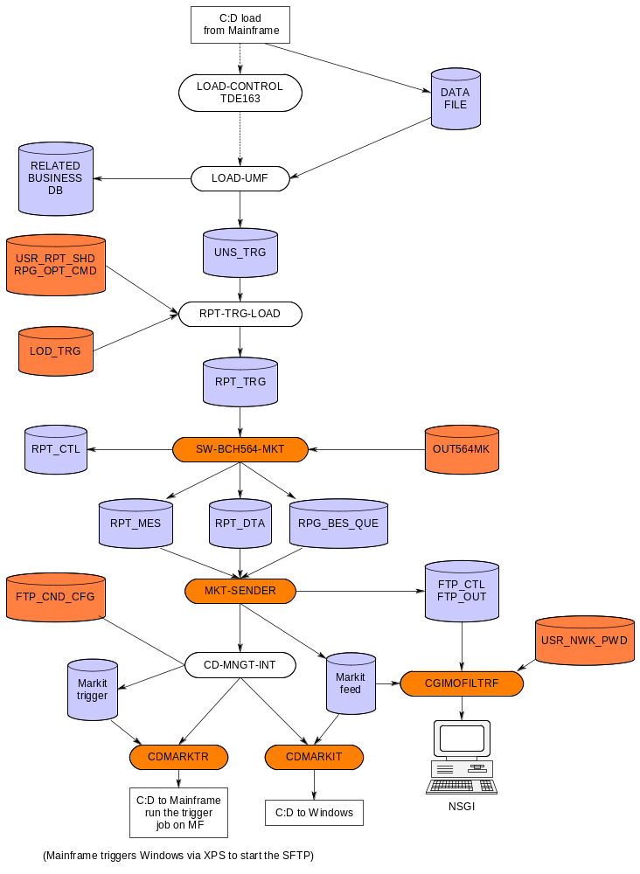

Figure 5-6: Markit reporting and file transfer

DACE instructions

Business overview

= Deadlines and Corporate Events.

Creates and manages custody's events and notices. The application identifies events (payment of coupons, distribution of dividend, tax reduction or exemption at source, call option ...), creates (using exercise conditions, prices, ratios, deadlines) and stores these events.
Once these events reach their reporting period, a notice is created to be sent to participants.

The service DACE offers the participants the ability to receive DACE notices either via SWIFT, EUCLID or Telex. A DACE notice informs the participant about upcoming Deadlines and Corporate Events on securities held in the participant’s portfolio (based on his balances) or for which the participant has pending custody instructions. The rules used to determine whether a participant should receive a particular notice are called triggering rules.

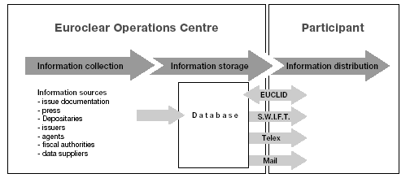

DACE serves both as a repository of Corporate Actions information (Events database) and as a reporting tool to notify clients of such corporate actions (via DACE Notices). The notices are generated based on the data extracted from the events database.

Providing information is the main target of the DACE service, therefore we start the discussion with a brief explanation of the different types of information used for the service.
First of all we have to make a distinction between static information and dynamic information. Examples of static information are the security name and the issuer of the security. This static information about securities is stored in the Securities Database (or SecDb). Dynamic information, on the contrary, is stored on the Dace database since they relate to special events that occur during the lifetime of a security. Examples of dynamic information are: the coupon amount, the date the coupon will be paid, etc.
Furthermore, a distinction has to be made between first notices and notices. A first notice provides the participant with general information about an upcoming event for a certain security. Hence, no information on the Participant’s balances and instructions is used. A first notice is send to the participants prior to a notice. A notice contains all kinds of useful information that is specific for the participant: the participant’s balance, whether instructions have been processed or not, what the participant has to do to react to the event, etc.
Events and notices management as well as their reporting to external parties (participants, agents, etc) is the main target of Dace.
Next to DACE notifications there are the Confirmed interest rate event notifications generated thru MT564 FRN (Floating Rate Notes).

Platform overview :
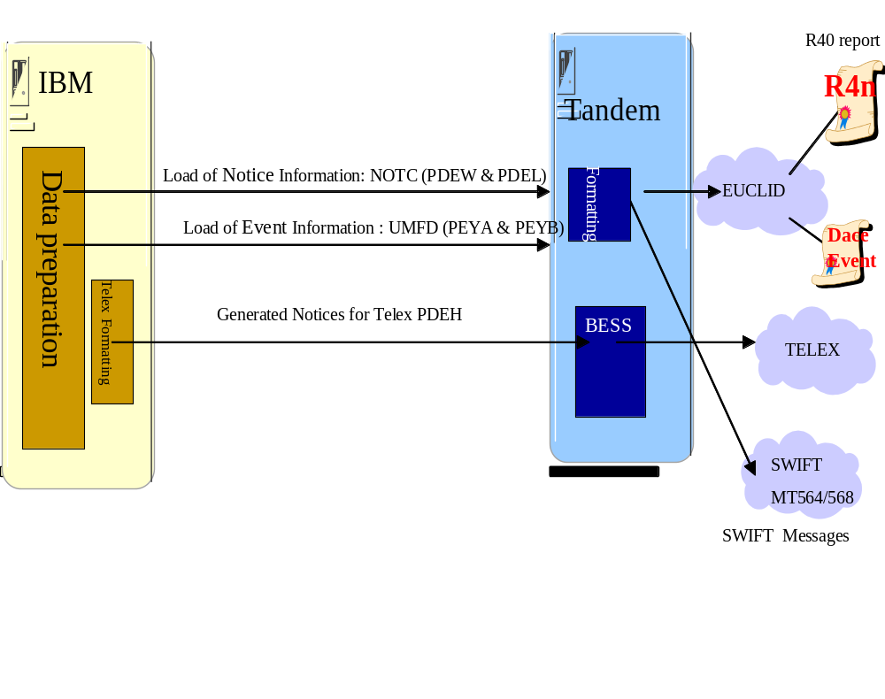
In the DACE service, and more specifically the reporting of notices, three platforms are involved :

- IBM Mainframe: this is the platform where all DACE related information is stored and managed, as well as where the decisions are taken whether a notice needs to be sent or not, and via which channel. Thereafter and still on the mainframe, the data is prepared for each channel: Telex, Swift and Euclid. For notices sent via telex, the formatting of the telex notices is also managed on the IBM mainframe platform. These Telex notices are entirely generated on the IBM Mainframe. After preparation they are sent onto the telex channel via Tandem. The NOTC load, on the other hand, is used to load new notices onto Tandem. (Remark: reminders are automatically sent to the tandem therefore only new notices are loaded). The notices have already been triggered, but they will be generated on the Tandem. The UMFD load is used to load the event information on Tandem.
- Tandem gateway: This platform manages the connections to the outside world. For notices reported via Euclid, the needed information is made available (via UMFD and NOTC loads) on the Tandem platform to enable the R4n processes to format the report. For notices reported via telex, the Tandem platform only manages the physical sending since the notices have been generated on the mainframe. For notices via SWIFT, the BESS connection also manages the sending of the generated SWIFT messages. From Euclid, the client can also perform inquiries on any events; therefore, the event database is also stored on Tandem. This is done via the UMFD load, this loads the new/modified events onto the Tandem for inquiry purposes.
The Dace on SWIFT messages (MT564/MT568) which were produced by the Distributed platform within Euroclear are rewritten on the Tandem platform to allow the integration of the DoS message with other types of MT564 message – and allow the linking between them.

Tandem implementation

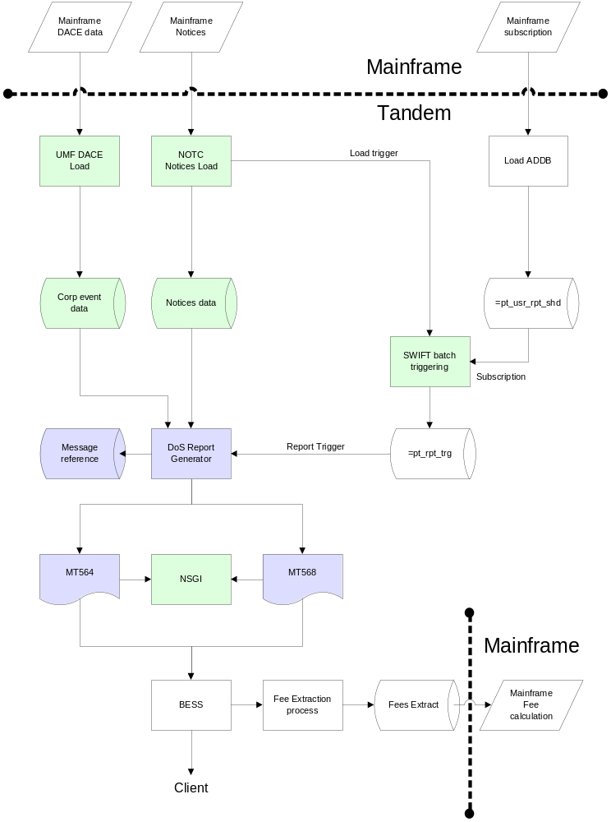

For DACE instructions the information are received via NOTC/UMFD loads and saved on Tandem to allow the triggering of the messages.

The processing is generated automatically after the load-notc. Once this load is treated correctly, the reporting will be generated (see Push Reporting - Batch (new infra).

DACE Swift Reporting with 564 and 568 messages
- MT564 Corporate Action Notification
- MT568 Corporate Action Narrative

MT564 FRN

The 564 FRN report (re-write from Mainframe) provides information about confirmed Interest Rates.
There are 2 types of subscription:
- Daily FRN
- Weekly FRN
As far as FRN are concerned, CA notifications for SWIFT and Telex messages are handled in two ways:
- Confirmed FRN Interest Rate notifications via the FRN programs (565 FRN)
- FRN Classical notifications via DaceOnSwift (564 DOS)
The Telex version of 564 FRN are generated on Mainframe.
When there is FRN interest rate event but the interest rate is unknown, Mainframe FRN programs will not send any information to Tandem. However, the FRN interest rate notification is automatically sent to EB clients based on their subscription profile via Dace Intraday. The Dace Intraday will start generating the required information to be able to produce either the ISO report (MT564 DACE).
Once the interest rate is known or when there is an updated interest rate, EB clients who subscribe to the service, need to receive FRN Interest rate notification. The FRN interest rate information is sent to Tandem to be able to produce either the ISO report (MT564 FRN). Note that Mainframe FRN programs send information to Tandem only when there is an update of the interest rate in Dace. The interest rate sent from Mainframe for SWIFT messages to Tandem is the interest rate taken from DACE table.
For FRN the information are received via FRN loads and saved on Tandem to allow the triggering of the messages thru reporting server SW-BCH564-FRN (TDS008)
Table where the data is stored is :
- PT_ACC_FRN

Twice a day the FRN load are received on tandem.and processed on arrival.
- Load FRNT1
  - On Saturday around 01:30 AM
  - From Tuesday to Friday around 01:00 AM
- Load FRNT2 around 12:00 AM (noon) from Monday to Friday
It is important to understand that the load received on Saturday (that is in fact the Monday morning load) will contain the Daily AND Weekly FRN information. At that time, a Netbatch Job, i.e. ET-TRIGGER-FRN-WEEKLY planned each Saturday at 01:45AM, will triger the generation of 564 FRN for client having the weekly FRN subscription. If FRN data related to client having a weekly subscription are received outside this load, they WILL not be reported to client. Moreover, clients having both subscriptions will receive twice the message (one message by subscription present).
FRN loads can be skipped on mainframe side with no impact on tandem except to add the entry in the Load Control table. The only rule on tandem is that the previous FRN load on same day or the previous day has been processed.

Custody Euclid reports

R00 : gives overview valid / invalid instructions / modifications and cancellations ( not only for custody )
R44 : Alarm bell reporting
R56 : Tax reclaims
R55 : Tax certificates
R40 : DACE
R25 : Executed corporate actions instructions
R50 : Unexecuted corporate actions instructions
R59 : Income Payable

Triparty instructions

Business overview

What is collateral ?

Something of value (securities, money ), which is used to secure a loan

- Collateral giver :

This is the party that commits to deliver securities and/or cash from its Account (the seller)

- Collateral taker :

This is the party that receives the collateral securities and/or cash in its Account (the purchaser)

TSL within triparty :

Triparty Securities Lending (TSL) is a product designed for Participants who want to use securities as collateral in securities lending transactions.
A securities lending transaction takes place when a LENDER lends securities to a BORROWER. This is called the LOAN. The loan exposes the Lender to a risk given by the fact that the Borrower might fail to return the securities he borrowed. Therefore, the Lender requires the Borrower to cover this risk with other securities (mostly debt instruments) as collateral.

Securities Borrowers are typically large investment banks who want to borrow specific securities for investment or speculation purposes. Securities Lenders have large portfolios of securities available and are interested in low-risk opportunities of revenue. Typically, they serve institutional investors such as mutual and pension funds.

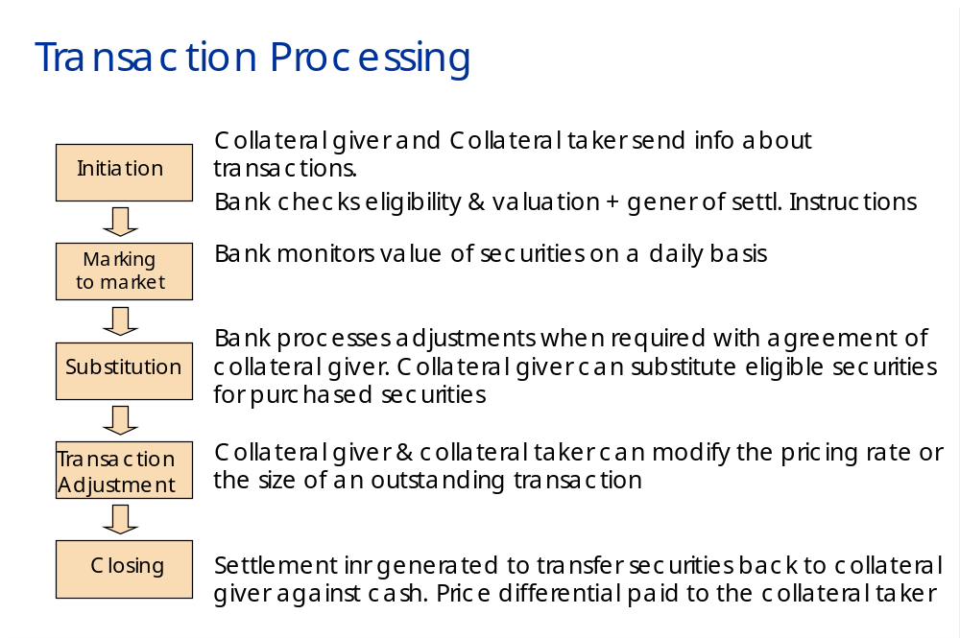

Tandem implementation

- Validation of Triparty messages (syntactical, contextual)
- Matching of Triparty messages
- Input via SWIFT or Euclid Pc
- Synchro with IBM via RT link (no batch upload)

Triparty
Input
Converter
Validation
Matching
Output
Converter
EPC/ES
MT587
Swift
MT527
EPC/ESS
ProprietaryFormat
Swift
MT558
Triparty db
Other databases
Only on Tandem:
User Access Mngt
(User Profile, …)
Priv. / Subscription
Triparty Deadlines
(in)valid messages …

Loaded from IBM:
Cty Holidays
Currency
Security
RSA
Basket
&
Feedback on Triparty Messages
Internal
users
Managed Triparty input messages and deadlines.
Sent to IBM:
Triparty messages
IBM
Load

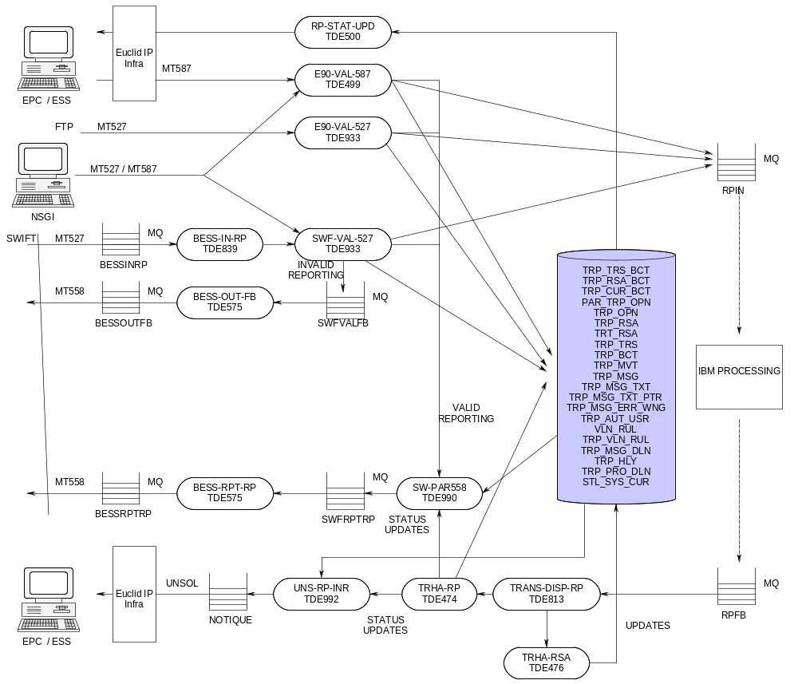

For triparty, we can have 2 types of message input: MT587 and MT527. The MT527 is used in the swift context ( and FTP ), the MT587 is used by EPC and ESS. Additional manual input can be done via NSGI, this concerns new input or updates.
A feedback message ( MT558 ) is send back to the swift participant in the case of a valid MT527 and in the case of an invalid MT527. Validation is done on syntax and context.
If the message is valid ( matched or not ), it’s sent to IBM via MQ. When IBM sends the feedback TRHA-RP (repository) and RSA update the database for PT_TRP_OPN and =PT_TRP_RSA.
Unsolicited reporting can be triggered by ESS. It is done via the server class UNS-RP-INR on updates of the triparty database after receiving feedback messages from IBM. Other reporting is done via the Euclid reports ( R00 and R80 ) or when a EPC/ESS asks for a status update.

Creation of MT558 responses to the participant(s)
We have to create MT558 messages to a participant on any status update, if he has subscribed to this service. No difference is made, if he has sent his messages via Swift or not. These status update messages are always generated by the new server class SW-PAR558.
If the input channel is Swift, we have to generate in addition the invalidation replies, just in the same way, as it is done in the current application.

Invalidation replies from SWF-VAL-527
If an incoming MT527 message is invalid in any way, then a reply is sent back from the SWF-VAL-527 to the participant to inform them of the validation failure. This feedback takes the form of an MT558 message, which will only be generated as a result of an invalid input.

Directly sent status updates by the validation servers
If we receive a valid Tri-party message in the validation servers (E90-VAL-587, E90-VAL-527, SWF-VAL-527), in many cases we are able to calculate a status already on Tandem, which will be stable for a certain time period (e.g. UNM, MAT, FUTU, or IPRO). In these cases, we can not rely on a direct response from IBM.
So we have to generate a MT558 status update initiated by the validation servers. We have to check for each participant, if there was a status change, and if he has subscribed for the MT558. In this case we have to call SW-PAR558 to generate the message (possibly twice, one for each participant).
We must not generate a message, if there are still some intermediate statuses on the operation, (that is LIMB), on either the operation itself or on any of the included movements.
Every time, when we make a decision to send - or not to send - a direct response to a user, who has subscribed to MT558, we have to log this decision in =PT_EUT_SYS_ATY (depending on a logging PARAM).

Status updates after feedback from IBM
Once the database has been updated by the TRHA-RP with the results of the feedback to an operation, processing will check to see for each of the two participants, whether the participant has a subscription for MT558 messages, and whether a status update for him has been processed (either on the operation itself, or on any of the included movements). If a subscription does exist for the participant (subscription is sent to Tandem as part of the existing LOAD-ADDB processing), and a status has been updated, processing will call the SW-PAR558 server to generate the MT558 status update to the participant.
Every time, when we make a decision to send - or not to send - a status update to a user, who has subscribed to MT558, we have to log this decision in =PT_EUT_SYS_ATY (depending on a logging PARAM).
The SW-PAR558 will receive details of the participant account, the Tri-party message id and the operation id. The message ID has to be taken from the operations table =PT_TRP_OPN; either the PCH_LST_MSG_ID, or the SLL_LST_MSG_ID (depending on the role of the participant). These will be used to read the Tri-party tables, and the associated MT558 status update message will be generated.
The resulting MT558 feedback message is then written to a MQ, and processed through BESS and sent out to the participant over the SWIFT network.

Unilateral Matching
Normally all Triparty instructions need to be matched between seller and purchaser. Exceptions are the collataeral adjustment and the allocation mode change, which are sent by the seller only. In this cases it is checked by Euroclear, if the instructions fit to the agreement between purchaser and seller (RSA).
But some purchasers have asked for a special type of RSA, in which no matching at all will be done by Euroclear. This behavior is called unilateral matching. Depending on the unilateral matching flag in the RSA,
- Incoming seller instructions will be matched automatically, when valid
- Purchaser instructions on that type of RSA will be rejected..

Deadline / Holiday / Currency Check :
Triparty Notice Validation:
The holidays were checked on Mainframe and Tandem; the holiday check (for interoperability notices and non-interoperability notices) will only be done on Tandem after June 2013.
Check for transaction currencies (for interoperability notices and non-interoperability notices) will be done on Tandem.

Triparty Deadline:
Impact on the real-time load of RSA data from Mainframe to Tandem (TRHA-RSA). This application will also process the receipt of the deadlines, and maintenance of the new deadline table.
Previous situation (before June 2013) for deadline is such that we have only one deadline time in the deadline table (values from mainframe) and this deadline is selected based on the Function message id, operation type allocation mode, currency, input communication channel and settlement process id.
On EB-ESES interoperability the deadline will apply based on Autoselect DVP, Autoselect FOP, Manual DVP, Manual FOP, settlement option id on the RSA. For overnight, Autoselect DVP deadline will apply.
Impact on the validation:
i. The old deadline check is removed. A new check on =PT_TRP_PRO_DLN value is developed
ii. The decision for overnight / daylight processing of instructions for the next day has to be based on the new table structure (=PT_TRP_PRO_DLN)
Currency:
For settlement systems different from EB (for now only ESES but maybe in the near future HongKong and others) a new static table (=PT_STL_SYS_CUR table) is checked for allowed settlement system currencies (only EUR is allowed for ESES).

GIV_STL_SYS_ID and TAK_STL_SYS_ID values from =PT_TRP_PRO_DLN is checked, even if one is different from EB then the static table (=PT_STL_SYS_CUR) needs to referred for the corresponding currency.

This static table will need to be maintained manually (no automatic process will be developed).

Triparty Euclid reports

R00 : gives overview valid / invalid instructions / modifications and cancellations ( not
only for triparty )
R80 : Triparty operations report

Settlement instructions

Business overview

Settlement is the process whereby the transaction between a buyer and a seller is finalized.

In Euroclear Bank, an instruction can only settle once it has gone through the process of input, validation, matching and positioning.

Once all these stages have successfully been completed , the instruction will settle against the counterparty’s instruction in one of the Euroclear processings ( called : clear ) - or in the local market, if it is an external instruction ( called : X-border ).

Input :

TANDEM receives the input ( Euclid or SWIFT or FTP or … ) and validates this syntactically.
Logging is done in the TANDEM input tables ( =PT_INP_DTA/MES ) but not in the business tables !!!
If the input appears to be valid, the deformatted message is sent to IBM.

On IBM, there are several phases to process this input :

Format :

  - It sends the incoming message to the logging kernel
  - It reformats the messages received from Tandem:
    - New instructions
    - Cancel
    - Modification of Backlog
  - It sets the worksheet
  - It sends the formatted message to the logging kernel and to the target

To make sure a wsh. is unique in the system, each application has dedicated range(s) of wsh (cfr batch application)
  - When a range is full, another range is used.
  - If all the ranges are full, the last wsh. of the first range is reset to the lower bound of the range

Validation :

context validation ( does the security exist, can that participant or depositary insert such an instruction ? ).
  - It checks that the instruction is valid :
    - Primary rules (mandatory fields)
    - Master rules (fields found on EB DB)
    - Dependant rules (contextual check)
  - If it is valid, it attributes the link-id and then sends it to the Matching kernel

Matching (Euroclear Bank)

Certain data in an instruction is compared, item by item, to the data in the couterparty’s instruction.
Matching in Euroclear Bank takes place before positioning and according to Euroclear rules. The rules for external instructions vary depending on the local market.

  - Search a matching candidate for the settlement instructions
  - Forward all received messages to MUS input queue.
  - The selection of candidates for Matching is based on specific criteria
    - Selection criteria
    - If several candidates matches the selection criteria the best one is chosen
    - Preference criteria

What is MUS ( market update stidb )

  - Updates the STIDB
  - Calculate some fields of the instruction/transaction
  - Calculate next actions of the instructions/transaction (in RT & batch)
  - Distributes ‘actions’ to other kernels

Positioning

Process of verifying whether sufficient assets are available to cover the outflow of cash or securities from a specific account.

When is this done ?

Positioning takes place prior to making the commitment on behalf of Participant
  - either prior to settlement (internal clearance, book transfer, ...)
  - or prior to transmission of the instruction to the local market in view of settlement or execution (cross-border instruction for matching or for settlement, wire transfer, ...)

When all this IBM processing is done, feedback is given towards TANDEM. Tandem processes the feedback ( updates the business tables ) and generates the appropriate reporting.

ETCMS instructions

Business overview

ETCMS stands for Euroclear Trade Capture and Matching System

Also called : MRN = Multilateral Repo Netting

This processing is part of the settlement processing : there is validation and matching. Only big difference is, that the matching is done on TANDEM and not on IBM.
The ETCMS infrastructure is also re-used for Biparty Repo, as the input messages for this business are MT515’s , MT541’s and MT543’s.
The swift reporting for Biparty Repo uses also the MT509, which was an additional feature to re-use the ETCMS infra.

It aims at :

- Accepting BPR instructions
- Deformatting, validating and matching these instructions (NL: NearLeg)
- Generating the 2nd leg of the repo (FL: FarLeg)
- Maintaining the information of the full repo trade
- Allowing updates and cancellations of Repo trade
- Managing substitution and Coupon Compensation

Definition of Repo :

A Repo ( repurchase agreement ) is a transaction whereby securities ( bonds or equities ) are sold against or exchanged for cash and wherein, at the same time, the parties agree that the seller will repurchase equivalent securities at a specific date in the future for a specific price rate.

Purpose of a Repo :

For the seller ( doing a repo ), it is a financing tool enabling him to value the securities he holds and at the same time obtain the cash he needs to support other activities.
For the purchaser ( doing a reverse repo ), it is a way to borrow securities he needs for his own business.

Tandem implementation

The MRN swift messages are received via the BESS-IN-RN ( TDE839 ). After this, the message is validated in the SWIFT-RN-VAL ( for messages MT515 / 518 ), object TDE735 .
Please note that input could also be done via EUCLID. These messages are thus validated by the RN-VAL ( same program TDE735 )

For MRN, the business logic is also based on the TANDEM side. At first, a syntax validation is done and all data is written into a certain structure. When the syntax is valid, the contextual validation is done to treat the information received correctly.

After validation, reporting is done for the invalid cases, but also for the valid cases IF they have a subscription VRN ( Repo netting confirmation result ). These messages are sent on BESS via the BESS-OUT-FB ( TDE575 ).
For valid input, after the syntax and context validation, the ‘MATCHING’ is done between 2 trades. Every matched trade is sent – using a MT518 – to LCH /CLEARNET to perform the NETTING.
As a reply LCH/CLEARNET sends a MT509 to indicate the new status of the trade : registered or rejected or XREG (only CLEARNET).
The BESS-IN-RN routes these records to the server SWIFT-RN-509 ( TDE735 ).
This server SWF-RN-509 performs a syntax + context validation on the MT509 – instruction. For a valid instruction the status of the corresponding trade in PT_MRN_TRD should be updated.

ETCMS (& Biparty Repo)
Input
Converter
Validation
Matching
Output
Converter
EPC/ES
MT515
Swift/CCI
MT515 MT509
EPC/ESS
ProprietaryFormat
Swift/CCI
MT518 MT509
MRN db
Other databases
Only on Tandem:
User Access Mngt
(User Profile, …)
Priv.
MRN Deadlines
(in)valid messages
Fees …

Loaded from IBM:
Cty Holidays
Security
Participant
Subscription
Internal
users
Trade, part. eligibility management. Statistics …
Biparty trades are converted in MT54x and sent to the settlement validation.
MT54x
Load
IBM
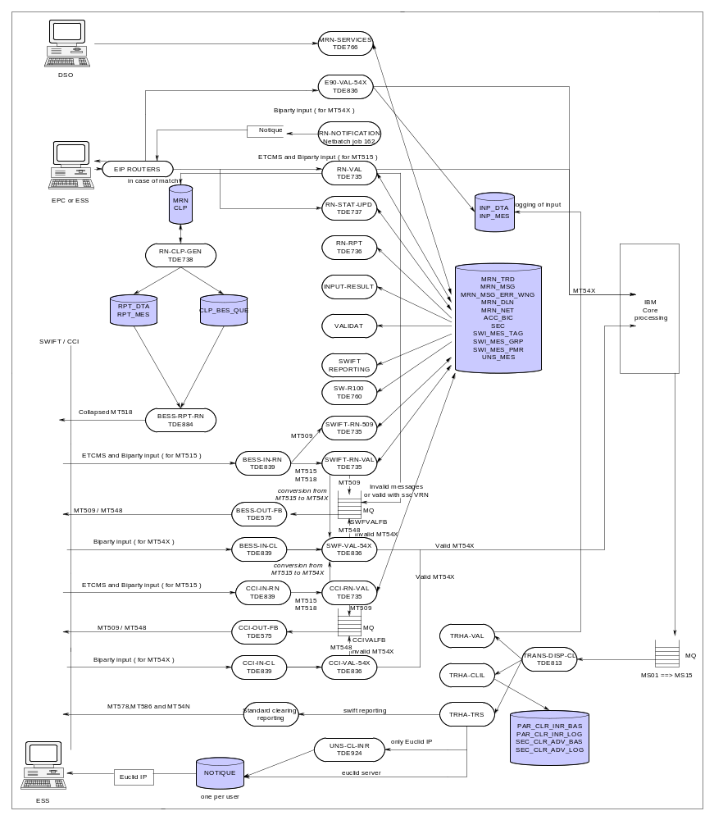

ISOPART

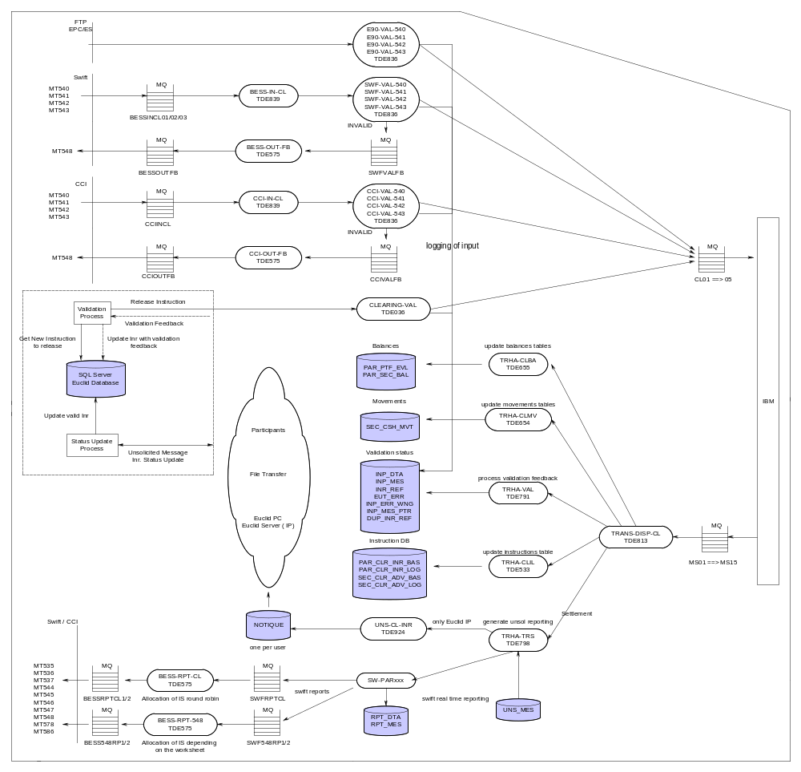

ISODEP
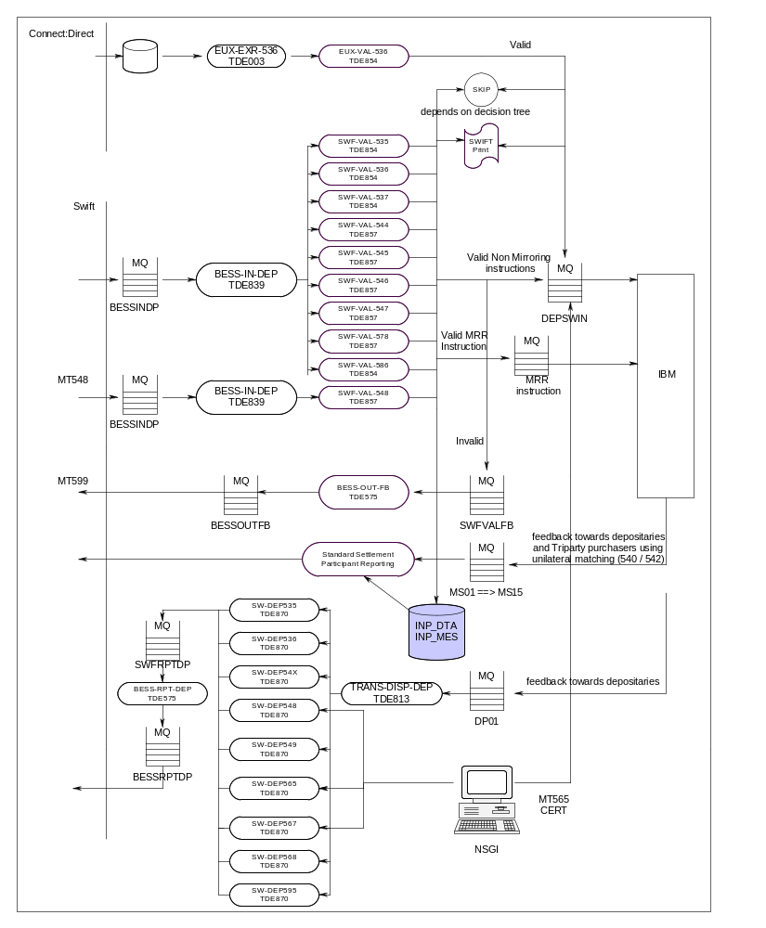
SESG project introduced a new way to receive Depository MT536 messages: via Connect:Direct. This aims to provide new services for trading members on the XETRA segment of Deutsche Börse and which are direct clearing member of EUREX and for trading members of other German exchanges using the XONTRO trading platform.
The incoming file is parsed and individual messages are extracted and sent to the validation server.
Those messages are also visible in NSGI; the only difference with Swift messages it that no MT599 is generated in case of syntactically invalid incoming message.

Dynamic MQ:
Triparty open inventory sourcing provides a Dynamic MQ approach (based on the ISIN code in the messaged) for mirroring instruction to IBM for Depository input messages.

Swift Reporting – SW-PAR534

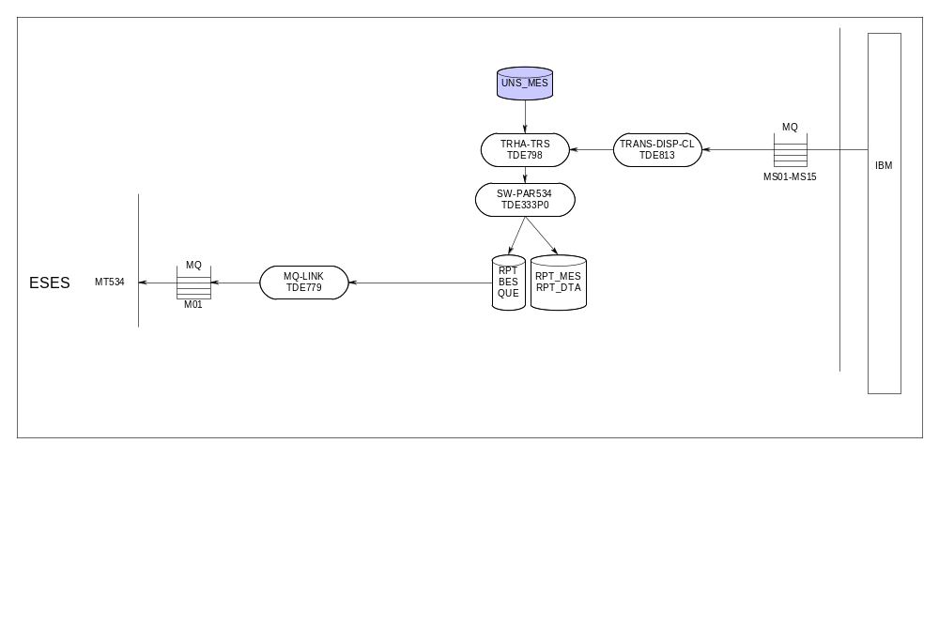
Settlement messages(MT 534) are received from IBM through the dispatcher and transactional handler TRANS-DISP-CL and TRHA-TRS.Transactional handler will call the new server SW-PAR534 based on the subscription and the entry in the table =PT_UNS_CFG which will write the message into RPT_MES and RPT_DTA along with the table =PT_RPG_BES_QUE.

>>SELECT * FROM =PT_UNS_CFG WHERE EUT_FCT_ID LIKE "%534%" BROWSE ACCESS;

EUT_FCT_ID PTH_SND_FL EUT_PTM_PRC_NM EUT_SRV_NM TIM_LMT_CT
---------- ---------- --------------- -------------- -----------

534 Y $EESPM SW-PAR534 60000

Settlement euclid reports

R00 : gives overview valid / invalid instructions / modifications and cancellations ( not
only for triparty )

R20 : securities movements - Batch
R23 : securities movement – real time
R30 : Securities balances
R70 : unexecuted settlement instructions

Link / Reference

\\PFILE002\ADSHARE\02.LRDS\05.Development\4.Tandem\Technical Documentation\Presentations\etcms-domain.ppt

\\PFILE002\ADSHARE\02.LRDS\05.Development\4.Tandem\Technical Documentation\Presentations\etcms-functional.ppt

Money transfer instructions

Business overview

Money transfer is a Euroclear service, whereby a Participant can manage its cash flow.

Upon the opening of a Securities Clearance Account in Euroclear Bank, a related Cash Account is also opened.

The Money Transfer System allows Participants to manage their cash in Euroclear, so that they can settle their securities transactions with the maximum efficiency.

To link this System with the outside world, Euroclear has established a network of Cash Correspondents, which is very similar to the Securities Depositories network. Euroclear has opened an account with each of these Correspondents. For reconciliation purposes, to each of these accounts corresponds a Nostro account opened internally (mirror account) which reflects all the movements on the Euroclear’s account with the Correspondent. Movements on the Euroclear accounts will be accordingly mirrored in the Euroclear Participant accounts. Such movements are processed based on the exchange of instructions between Euroclear, Participants and Correspondents.
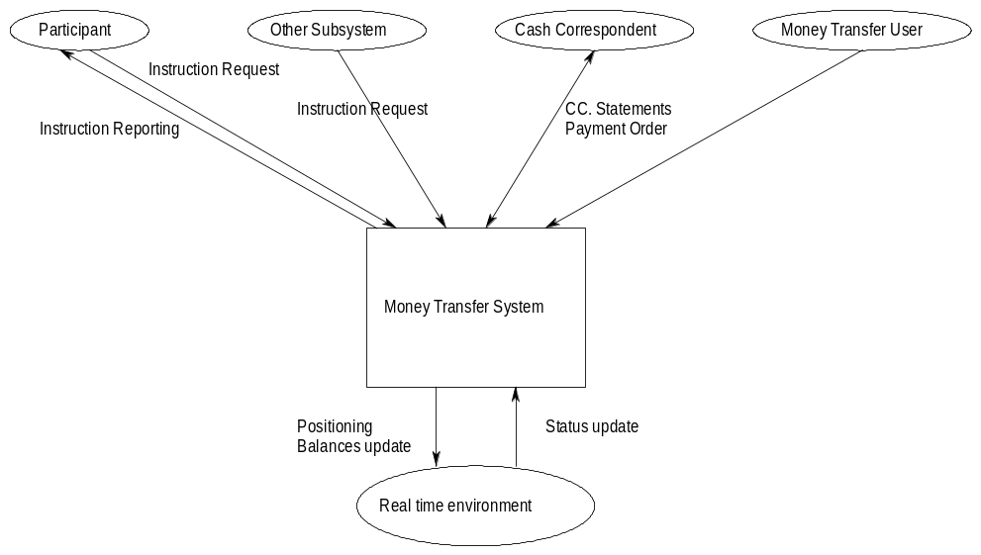
As shown in the context diagram here above, the main parties of the MT System are:

Participants | They send their instructions to the MT System for processing or cancellation.  They communicate with EOC via Swift, Euclid or Telex.  EOC provides them with reports.
Correspondents | Bank where EOC has a cash account. Correspondents advise the MT System that funds have been received in their EOC account (Nostro).  They also send daily statements of the Nostro account.
MT User | The MT Users control the instructions lifecycle. They repair, verify, update or cancel them.
EOC Subsystems | EOC Subsystems (other than the MT itself) also require to create MT instructions, for internal purpose.
R/T | This system positions the instructions, updates the Participant and Nostro balances, in real-time from 03:00 to 21:45.  R/T also updates the instructions status.

There a six different types of MT instructions:

Book Transfer | Transfer of funds from one Participant account in a specific currency, to another Participant account in the same currency.
Conversion | Transfer of funds from one Participant account in one specific currency, to the same Participant account in another currency.
Wire Transfer | Transfer of funds from a Euroclear account to an external account.
Preadvice of Funds | Notification sent by a Participant to advise EOC of incoming funds.
Bank Order | Confirmation of funds transfer to the Correspondent. It is sent by the bank crediting the Correspondent in favour of a EOC account, for further credit to a Participant account..
Credit Confirmation | Confirmation from the Correspondent that a EOC account has been credited.

Tandem implementation

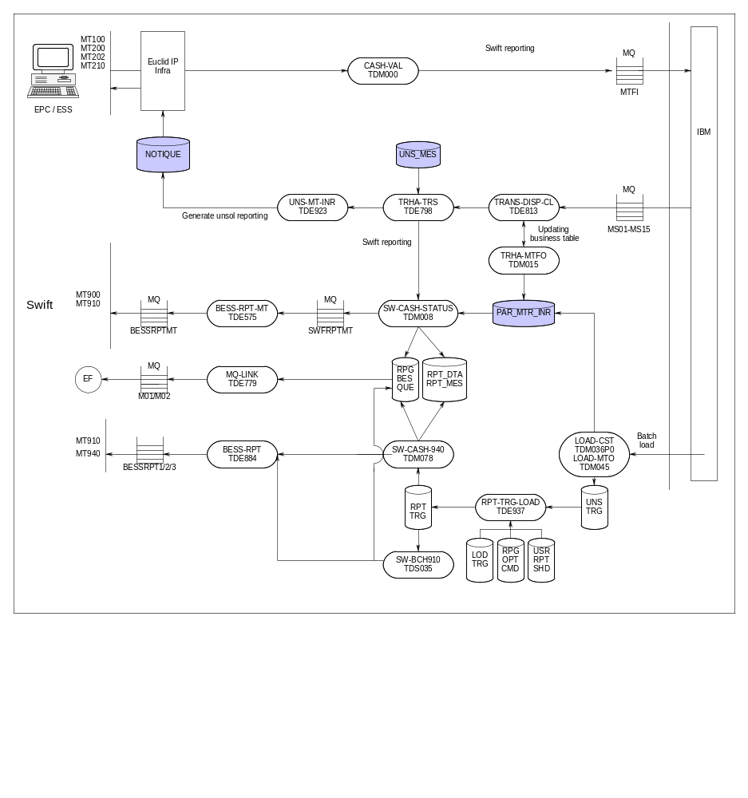

Messages received from IBM will be read by TRANS-DISP-CL which will then be forwarded to TRHA-TRS. TRHA-TRS does an "instruction based" pathsend (if subscribed) depending on the configuration in =PT_UNS_CFG table to the new reporting server.Pathsend is done only if there exists an entry in =PT_UNS_CFG.
>>SELECT * FROM =PT_UNS_CFG WHERE EUT_FCT_ID LIKE "%9%" BROWSE ACCESS;

EUT_FCT_ID PTH_SND_FL EUT_PTM_PRC_NM EUT_SRV_NM TIM_LMT_CT
---------- ---------- --------------- -------------- -----------

900 Y $EESPM SW-CASH-9XX 60000
910 Y $EESPM SW-CASH-9XX 60000

--- 2 row(s) selected.

TRHA-TRS will call the appropriate swift reporting server ie SW-CASH-9XX to generate the MT900 and MT910 which will be write the message in the queue SWFRPTMT.
Messages from the queue SWFRPTMT will be read by the new serverclass BESS-RPT-MT which will send the message to swift world via BESS.Table =PT_EUT_CMD_HIS is also updated by server SW-CASH-9XX. Messages bound for EF will be written into the table =PT_RPG_BES_QUE which will be sent to EF via the MQ-LINK.

Money transfer euclid reports

Instructions reporting :

Reports showing the evolution of an instruction in its lifecycle are:
- R29/R90: Executed/Unexecuted MT Instructions (Euclid reports),
R29 and R90 are similar, the only difference being that settled instructions appear in R29, and pending or cancelled instructions appear in R90.

Balances reporting

1/ Online

During the online, the R34 (R/T Balances) reports balance updates in real-time. This report is built on Tandem, on basis of the R33 (Opening Cash Position) that gives the position at the start of R/T, and R29/R90 that gives in real-time the executed/unexecuted instructions, hence the related movements.
There is no real-time reporting of balances as such.
2/ Batch

During the overnight, daily balance and movements reports are produced. The main ones are:
- R35: Cash Statement on Euclid
- R36: Cash Balances (summary of R35)

Lending and Borrowing

Business overview

It is one of the Euroclear services, whereby a Participant can lend and/or borrow securities

The Securities Lending and Borrowing Programme improves the efficiency of
securities settlement and, consequently, liquidity in the market. The Programme
matches the lendable supply of securities in Euroclear with borrowing demand,
enabling a Participant to meet its settlement needs or to support its trading activity
by borrowing securities.

A Participant may borrow securities to avoid failed delivery instructions, to cover
certain corporate action instructions, or to increase the efficiency of cross-border
trading activity. Securities borrowing thus reduces financing costs related to failed
settlement. It also gives Borrowers an opportunity to make extra profits by
reinvesting the proceeds of a settled delivery transaction at the money market rate.

A Lender increases the yield on its portfolio without losing ownership benefits and
all related entitlements on lent securities.

Through the Programme, Borrowings are generated whenever there are insufficient
securities available in a Borrower’s account to execute a delivery instruction. The
direct link between securities settlement and securities lending and borrowing
activity ensures that Borrowings correspond exactly to a Borrower’s actual
borrowing needs.

Most Lenders and Borrowers participate in the Programme on an automatic basis.
Automatic participation reduces Lenders’ and Borrowers’ efforts in monitoring
lending opportunities and borrowing needs. Lenders and Borrowers can also
participate in the Programme on an opportunity basis. In addition, participation in
the Programme is flexible as a result of a number of options available to Lenders
and Borrowers.

Euroclear Bank S.A./N.V. guarantees Lenders the return of lent securities (or their
cash equivalent), related entitlements (or their cash countervalue) paid by issuers,
as well as payment of lending fees.

Comprehensive reports available through EUCLID, SWIFT, telex and mail inform
Participants on their securities lending and borrowing activity.

Tandem implementation

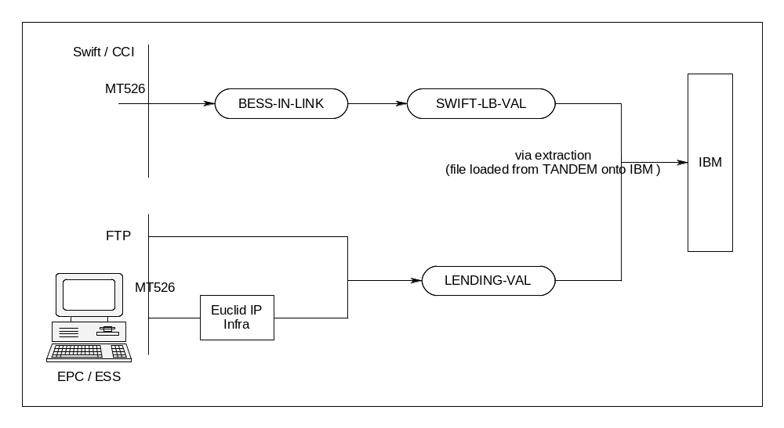

Database updates are done via the load-BOPS ➔ no real-time feedback.

Swift reporting :

Lending and borrowing has no real time swift reporting. There is swift reporting after the LOAD-BOPS. The messages which are sent, are MT599’s ( free format swifts ) – to be retrieved in the tables using eut_fct_id = “S31”. The reporting server is the ISO-LDGPOS ( TDS011 )

Lending and borrowing euclid reports

R31 : Securities lending and borrowing balances
R60 : Securities lending and borrowing execution report

Annexes

Big general overview

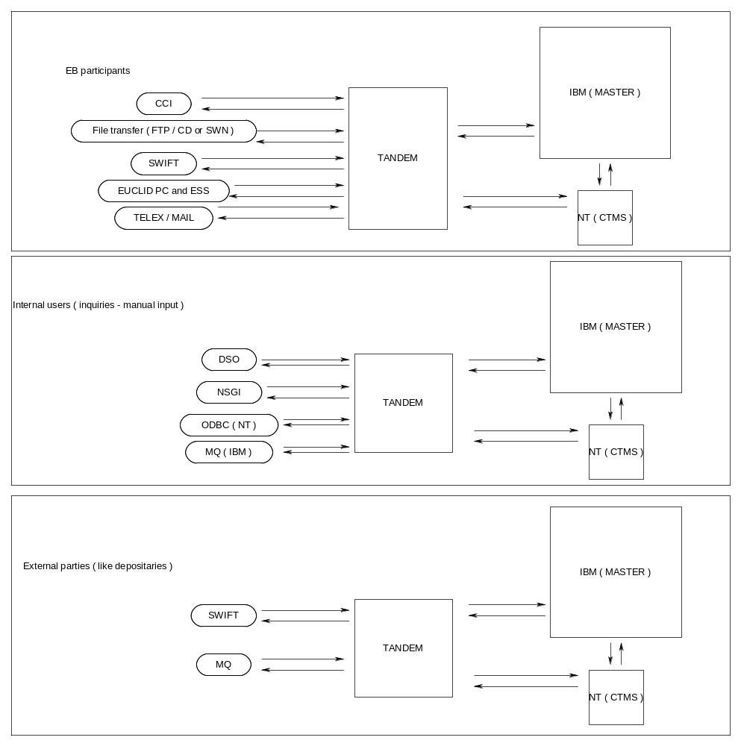

Overview of pathways

DSPM : contains servers which are used by DSO screens ( old inquiry screens equivalent to NSGI ).
EIPM : pathway with servers for Euclid IP - connection
ELPM : contains all LOAD – related servers ( BATCH PROCESSING )
ESPM : contains mainly all swift related servers : swift validation and reporting
EETPM : contains all Euclid – linked servers : euclid validation reporting + some old swift reporting + logon / password / privilege … servers + servers which do the real time updates of our tables ( TRHA-*** servers )
EEWPM : pathway with servers for X25 – connection – lots of them are frozen – not used anymore. The ones that remain running are also used for EIP.
EFTPM : for FT – related servers ( FT, CD and SWN )
EGIPM : all NSGI – related servers
EPTST : used to access PTST screens ( run logon-1 ) : have access to the system control file, IBMOUTQ file , DATES file etc .

Main input – output ( mainly swift )

Custody part. input

2 kinds of MT565 ( USTAX / CTMS )

Custody part. output

MT564

MT566
MT567
MT599

Custody dep. Output ( goes throught settlement dep. reporting Queues )

535
565
567
568

Settlement input ( non depositary )

MT515

MT509
MT518
MT540
MT541
MT542
MT543

Settlement output ( non depositary )

MT509

MT518
MT544
MT545
MT546
MT547
MT548
MT549
MT578
MT535
MT536
MT537
MT586

Settlement Depositary input

MT544

MT545
MT546
MT547
MT548
MT578
MT535
MT536
MT537
MT586

Settlement Depositary output

MT540

MT541
MT542
MT543
MT536
MT595

Triparty input

MT527

MT587

Triparty output

MT558

Lending and borrowing input

MT526

Lending and borrowing output

MT599

Money transfer input

MT100

MT200
MT202
MT210

Money transfer output

MT900

MT910
MT940

DACE

MT564

MT568

Important tables

MQ – tables

=PT_MQS_CFG
=PT_MQS_LOG_INP
=PT_MQS_LOG_OUT

Input / output tables

=PT_INP_DTA
=PT_INP_ERR_WNG
=PT_INP_MES
=PT_INP_MES_EUP
=PT_INP_MES_PTR

=PT_RPT_DTA
=PT_RPT_MES

Subscription tables

=PT_UNS_MES
=PT_USR_RPT_SHD
=PT_RPG_OPT_CMD

Custody tables

USTAX
=PT_BRD
=PT_BRD_DTA
=PT_BRD_FDB
=PT_BRD_MSG
=PT_BRD_MSG_ERR_WNG

CTMS

=PT_CDY_INR_MES
=PT_PAR_CDY_INR
=PT_ISO_CUS_ARH
=PT_ISO_ARH_ERR_WNG

DACE

=PT_CEV
=PT_CEV_ACR_ITR
=PT_CEV_ASG
=PT_CEV_CER
=PT_CEV_CER_NAR
=PT_CEV_CSH_FIX
=PT_CEV_CSH_PYM_NET
=PT_CEV_DEF_DCS
=PT_CEV_EXE_CSH
=PT_CEV_EXE_OPT
=PT_CEV_EXE_SEC
=PT_CEV_FLD_SPS
=PT_CEV_IPM
=PT_CEV_MAR_TYP
=PT_CEV_MIN_PCD_CSH
=PT_CEV_NAR
=PT_CEV_NAR_HTM
=PT_CEV_NON_RES_RQM
=PT_CEV_OTH_DOC_RQM
=PT_CEV_PCD_CMY
=PT_CEV_PCD_CSH
=PT_CEV_PCD_OPT
=PT_CEV_PCD_RND
=PT_CEV_PCD_SEC
=PT_CEV_PCD_SEC_RND
=PT_CEV_RGH_PCH
=PT_CEV_RGH_SLL
=PT_CEV_SEC_TYP
=PT_CEV_TYP
=PT_CEV_TYP_INR

Triparty tables

=PT_AUD_TRP_DLN
=PT_PAR_TRP_OPN
=PT_TRP_ALC_MDE
=PT_TRP_AUT_USR
=PT_TRP_BCT
=PT_TRP_CUR_BCT
=PT_TRP_FCT_MSG
=PT_TRP_MSG
=PT_TRP_MSG_DLN
=PT_TRP_MSG_ERR_WNG
=PT_TRP_MSG_TXT
=PT_TRP_MVT
=PT_TRP_MVT_SGN
=PT_TRP_OPN
=PT_TRP_OPR_PRI
=PT_TRP_PAR_ROL
=PT_TRP_RSA
=PT_TRP_RSA_BCT
=PT_TRP_SEC_STU
=PT_TRP_STL_PRO
=PT_TRP_TRS
=PT_TRP_TRS_BCT
=PT_TRP_TYP_OPN
=PT_TRP_VLN_RUL
=PT_WEB_TRP_INP
=PT_TRP_HLY
=PT_STL_SYS_CUR
=PT_TRP_PRO_DLN

Settlement tables

ETCMS

=PT_MRN_CLP
=PT_MRN_DLN
=PT_MRN_MSG
=PT_MRN_MSG_ERR_WNG
=PT_MRN_NET
=PT_MRN_TRD
=PT_MRN_TRD_TRS_TYP

SETTLEMENT

=PT_PAR_CLR_INR_BAS
=PT_PAR_CLR_INR_LOG
=PT_SEC_CLR_ADV_BAS
=PT_SEC_CLR_ADV_LOG

Money transfer tables

=PT_MTR_BNK_VRL
=PT_MTR_CUR_CTY
=PT_MTR_INR_DLN

=PT_MTR_SWI_MVT
=PT_PAR_MTR_INR

Lending and borrowing tables

=PT_SLG_BAL
=PT_SLG_FEE_COM

Aging mechanisms

A number of ‘aging’ programs have been implemented to delete old data from the reporting database (the retention period is variable by table – see table =PT_CNG_CTL where this timing is mentioned ). Of course, we do not only check timestamps, the other checks depend on the table to be aged ( statuses, reasons ).
The ‘aging’ processing runs in general in two steps (to improve performances and avoid records/table locking). The first one selects all the key of the rows to delete in the second step.

Euclid reports and swift reports

A great document to find some usefull information :

\\pfile002\eocdoc\Electronic Documentation\INTROEOC\INTREOC2.EXE

\\pfile002\eocdoc\ELECDOC\START.pdf

\\PFILE002\ADSHARE\06.Hot Line\Contingency\Documentation\09. Custody\Com\eu90\

BATCHCOM / NETBATCH jobs

Jobs which have to be ran a certain specific timings, are often defined in NETBATCH. To each job, we can attribute a specific calendar. This means that each job can have its own timing.
Some jobs run once a day, some once a month, …

Agings often use NETBATCH to do their cleaning ( overnight ). Also, some loads need a ‘trigger’ to start them and in some cases, that triggering is done on specific moments ( as example, you can take the LOAD-MATx ).

Also programs which have to check certain queues or files or tables often use a job to start them.

This way of triggering certain processing is not the common way to do it, but it can be an easy way to implement processing which has to be done once in a while.

BATCH LOADS + Corresponding tables

LOAD-ADDB [ $ELPM / LOAD-ADDB / TDE350 ] - Subscriptions
=PT_USR_RPT_SHD
=PT_EUT_PAR_SSC
=PT_SSC_SRV_FCT
=PT_AUD_PAR_SSC

LOAD-BKMF [ $ELPM / LOAD-BKMF / TDM007 ] – Bank Master file update
=PT_CLR_SYS_BNK

LOAD-BOPS[ $ELPM / LOAD-BOPS / TDE136 ] - Bondlending load ( Lending and
Borrowing )
=PT_SLG_BAL
=PT_SLG_FEE_COM

LOAD-CPO [ $ELPM / LOAD-CPO / TDM054 ] – Cash Positions Load
=PT_CSH_BAL_OVR
=PT_ITD_CSH_BAL
=PT_CSH_PAR_PLG
=PT_CSH_PNG_TRS
=PT_CSH_BAL_CTL

LOAD-CST [ $ELPM / LOAD-CST / TDM036 ] – Cash statements load
=PT_CSH_STM_BAL
=PT_CSH_PAR_PLG
=PT_PAR_CSH_MVT

LOAD-ENCO [ $ELPM / LOAD-ENCO / TDE524 ] – Entitlement Compensation load =PT_INR_CEC_SIT

LOAD-EQUO [ $ELPM / LOAD-EQUO / TDE289 ] – Security Quotations
=PT_SEC_QUO

LOAD-FRN [ $ELPM / LOAD-FRN / TDE135 ] – Floating Rate Notes load
=PT_ACC_FRN

LOAD-INCO [ $ELPM / LOAD-INCO / TDE147 ] – Income payable load
=PT_PAR_SEC_MAT

LOAD-INPR [ $ELPM / LOAD-INPR / TDE292 ] – Income Preadvices Load =PT_ICO_PRE_INF
=PT_ICO_PRE_POS
=PT_ICO_PRE_NAR

LOAD-LBIL[ $ELPM / LOAD-LBIL / TDE058 ] – Lending and Borrowing load
=PT_SLI

LOAD-MATX [ $ELPM / LOAD-MATX / TDE057 ] – matching results ( custody ) =PT_PAR_CDY_INR
=PT_CDY_INR_MES
=PT_PAR_SEC_BAL
=PT_PAR_PTF_EVL
=PT_PAR_CLR_INR_BAS
=PT_PAR_CLR_INR_LOG
=PT_SEC_CLR_ADV_BAS
=PT_SEC_CLR_ADV_LOG
=PT_SLI

LOAD-MTO [ $ELPM / LOAD-MTO / TDM045 ] - Cash instructions load
=PT_EUT_MTI_EOC_MES
=PT_PAR_MTR_INR

LOAD-NOTC [ $ELPM / LOAD-NOTC / TDE325 ] – load notices =PT_EUT_NTC
=PT_EUT_NTC_BAL

LOAD-PARV [ $ELPM / LOAD-PARV / TDE293 ] – Pre-advice of reversals =PT_REV-PRE_INF
=PT_REV_PRE_BAL

LOAD-SEBA [ $ELPM / LOAD-SEBA / TDE162 ] - Security balances
=PT_PAR_SEC_BAL
=PT_PAR_PTF_EVL

LOAD-SET1 [ $ELPM / LOAD-SET1 / TDE058 ] – Setllement instructions

For Project ATP2 , Overnight load SET1 is partially decommissioned and processing has been switched to real time . load SET1 will be empty , tandem will receive Dummy file from mainframes and process the same . So no business tables will be updated because of the load SET1.

LOAD-TAX [ $ELPM / LOAD-TAX / TDE547 ] – Tax information

=PT_TAC_FIL
=PT_TAC
=PT_TAC_BNF
=PT_TAC_BNF_HDP
=PT_TAC_PNG_PRB
=PT_TAX_NAR_TXT

LOAD-TCER [ $ELPM / LOAD-TCER / TDE600 ] - certificates information
=PT_TAX_CER_MOD
=PT_TAX_CER
=PT_TAX_CER_NAR_TXT

LOAD-UMF [ $ELPM / LOAD-UMF / TDE028 ] – Events load
=PT_SLG_RAT_PMR
=PT_SEC_CDY_INF
=PT_CEV
=PT_CEV_EXE_SEC
=PT_CEV_EXE_CSH
=PT_CEV_EXE_OPT
=PT_CEV_PCD_SEC
=PT_CEV_PCD_CSH
=PT_CEV_PCD_OPT
=PT_CEV_PCD_CMY
=PT_CUN_PRO_SHD
=PT_RLT_CEV_OPT
=PT_RLT_CEV
=PT_CEV_NAR
=PT_PAR_ACC
=PT_COD

EOD chaining
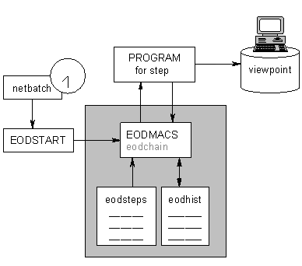

The End Of Day chaining is composed of individual tasks which have to be executed in sequence.

This sequence is guaranteed by a TACL macro, the ‘CHAINING’ macro (EODCHAIN). The ‘CHAINING’ macro starts via Netbatch (in file is EODSTART), every EOC day on a predefined time. The EODSTART begins with the default netbatch_precheck, so alhough it is started on all 3 production nodes, this macro will stop the batch on the non active nodes already after the first line. Once the batchcom job has executed it is auto destroyed, but the EOD itself creates the job for the following day (step 18) on all three production nodes (also on the non active ones).

All task to execute are defined in an edit file, the task definition file (EODSTEPS)

A task may only be executed when the preceding task is completed successfully.
For restart purposes, the ‘CHAINING’ macro uses an edit file called the history file (EODHIST). This file contains the completion code of each step.

The End Of Day chaining will be started via NETBATCH and the obey file is EODSTEPS.

The chaining macro (EODCHAIN)

Description

- Retrieve the history file of a previous run (EODHIST) to determine the last task that has been completed successfully.
- Execute the next task in the chain. The commands to execute are found in the task definition file (EODSTEPS)
- Add a line in the history file, replicate the file (EODHIST) on the non active production nodes (backup and contingency machine)
- Perform action 2 through 3 until all tasks are executed or a task is aborted

REMARKS :

• The first action is bypassed when the macro is started with no arguments

EODCHAIN

Or with the BYPASS argument set to ‘Y’

EODCHAIN Y

• To start the EOD chain from an aborted task, the macro must be started
with the BYPASS argument set to ‘N’

LOAD /KEEP 1/ EODMACS

EODCHAIN N

- When the macro is started from NETBATCH, no argument is given.

Task definition file

The task definition file is an edit file (EODSTEPS) which contains the commands to execute for every task of the EOD chaining.

This file has following layout :
! Number of tasks : <j>
! Task 1 : <short description>
<command(s)>
! Task 2 : <short description>
<command(s)>
…
! Task j : <short description>
<command(s)>

REMARKS :

The <command(s)> of a task are executed as a TACL macro. It implies that the commands are valid TACL commands

When no <command(s)> are provided, the task will be considered as completed and the next task will be executed.

History file

The history file is an edit file (EODHIST) which has the following layout :
EOD task <i> completed (completion code <cc> ) <datetime>

End Of Day tasks

Overview

Following tasks must be executed at End Of Day (high level)

Check if no backlog in the Swift queues | Send swift messages to ourselves to check if there is no pending swift for the validation
Check UMFA | Check if the load has been received
Alter system state | Change the system state to « EOD freezing Announced », wait a given number of minutes and change the system state to « EOD freezing in Progress »
Extraction | Start the extract server to start the EOD extraction.  The extraction will change the system state to FE « Frozen for EOD »
Master file load | Send an 03 to the IBMOUTQ to process the load-UMFA
House keeping | Perform several tasks while the system is frozen
Alter system state | Change back the system state to OP « Open »
Distribution | Transfer the launched SQL objects to the backup center.

End Of Day tasks : step by step

Pre-EOD : Warn EOD has started

At start of EOD a TNG message is sent to inform EOD has started

EUCLID ENDOFDAY STARTED

Task 1 : Check load UMFA present in =PT_SYS_LOD_CTL

This task checks if the load UMFA has arrived on Tandem. If not the task is looping and the EOD procedure is waiting.

Program
$DATA10.PRODP0.TDE838P0

Process
$EOD1

! Task 1 : Check load UMFA present in SYSLDCTL
ASSIGN *.SYSCTL-FILE,$DATA5.ETQUEUE.SYSCTL
assign *.SYSLDCTL-FILE,$DATA5.ETQUEUE.SYSLDCTL
param TIME-DELAY 6000
run $DATA10.PRODP0.TDE838P0/name $EOD1/

Task 2 : Send MT533, MT540, MT565 to check that all SWIFT received before the end of day are treated

Program
$DATA10.PRODP0.TDE852P0

Process
$EOD2

! Task 2 : Send MT553, MT540, MT565 to check SWIFT
param WARNING-INTERVAL "01"
ASSIGN *.MONSWIFT-FILE,$DATA5.ETQUEUE.EODWTCTL
ASSIGN *.MONMSGS-FILE,$DATA5.ETQUEUE.EODMSGS
PARAM START-OF-DAY "0600"
PARAM END-OF-DAY "1800"
PARAM WARNING-INTERVAL-DAY "001"
PARAM WARNING-INTERVAL-NIGHT "001"
PARAM START-CLOSEVAL "SAT2000"
PARAM END-CLOSEVAL "SUN1500"
PARAM TIME-LIMIT "0120"
PARAM EUT-USR-ID "S0000002"
PARAM PAR-ACC-ID "90000"
PARAM OPR-ADD-SEQ-CT "0007"
PARAM WAIT-FOR-REPLY "Y"
PARAM NBR-OF-MESSAGES 08
PARAM EOC-SWI-ADD "MGTCBEBE"
PARAM SVR-NM "DELAY-EOD"
PARAM MQEMSEVENTS "127"
PARAM MQDEFAULTPREFIX "$SYSTEM"
PARAM SAVE-ENVIRONMENT "ON"
PARAM MQNSKVARPATH "/mqvar/var/mqm"
RUN $DATA10.PRODP0.TDE852P0 /NAME $EOD2/
RESTORE_DEFINES $DATA10.PRDDEFS.DEFSEG

Task 3 : Stop unsolicited reporting to Euclid server

Program
$DATA10.PRODP0.TDE679P0

Process
$EOD3/

! Task 3 : Stop unsolicited reporting to Euclid server
clear all
param SERVER-NAME "UNSOL-AUTH"
param SERVICE-TYPE-01 "CLINR"
param SERVICE-TYPE-02 "MTINR"
param NBR-OF-MESSAGES 02
run $DATA10.PRODP0.tde679p0 /name $EOD3/ NOAUTH

Task 4 : Check if trigger dates have been updated

This task checks if the trigger dates have been correctly updated by the Netbatch job at 20 :28. If the trigger dates are not updated, the program sends a message to viewpt and loops until the dates are correct.
The trigger dates are contained in the main record of SYSCTL
To bypass the looping of this task, just update the trigger dates via DSO.

Program
$DATA10.PRODP0.TDE577P0

Process
$EOD4/

! Task 4 : Check if trigger dates have been updated at 20:28

ASSIGN *.SYSCTL-FILE,$DATA5.ETQUEUE.SYSCTL
PARAM SERVER-NAME CHECK-TRIGGER-DATES
RUN $DATA10.prodp0.TDE577P0 /NAME $EOD4/

Task 5 : Alter System State

This module will change the System State into a given state
The possible values of the system state are :

OP Open FA Freeze Announcing
EA EOD freeze Announced FP Freezing in Progress
EP EOD freezing in Progress FR Frozen
FE Frozen for End of Day CL Closed

The current system status can be found in the main record (record 1) of SYSCTL

The task will :

- change the system state on the SYSCTL file into the given state
- when the given state is ‘EA’ or ‘FA’, delay the processing for a given number of minutes
- when the given state is ‘EA’ or ‘FA’ change the system state into ‘EP’ or ‘FP’
- if the system state is not ‘OP’ when this task starts, the program puts ‘FE’ with a message on Viewpt

The given state and delay are passed via the startup message. The layout is :

STATE : xx DELAY : mm
Where : xx the new state
mm the delay in seconds (only used when given state is ‘EA’ or ‘FA’)

REMARKS :
- any change of the system state is reporting in the activity log
- when the system state changes from ‘EP’ to ‘FE’, the EOD record in SYSCTL is updated to set EOD-FROZEN-TIMESTAMP to the current timestamp
- when the system state changes from ‘FE’ to ‘OP’, the EOD record in SYSCTL is updated to set EOD-THAWED-TIMESTAMP to the current timestamp and sets the EOD-CURRENT-TIMESTAMP to the calculated timestamp of the next deadline. The next deadline is calculated from the previous EOC-DATE in the DATES record in SYSCTL and the EOD-DEADLINE of EOD record of SYSCTL.

Program
$DATA10.PRODP0.TDE242P0

Process
$EOD5/

! Task 5 : Change System State (Freezing Announced)

ASSIGN *.SYSCTL-FILE,$DATA5.ETQUEUE.SYSCTL

PARAM SERVER-NAME CHG-STATE-SV
SET_SYSNAME_PARAMS
RUN $DATA10.prodp0.TDE242P0 /NAME $EOD5/ State: EA Delay: 0060

Task 6 : Extraction CL to IBM

This task will extract Clearing data to be sent to IBM.
After the extraction it changes the System State to ‘FE ‘.

Program
$DATA10.PRODP0.TDE182P0

Process
$EOD6

! Task 6 : Extraction CL

ASSIGN *.SYSCTL-FILE,$DATA5.ETQUEUE.SYSCTL

ASSIGN *.TTYINQ-FILE,$DATA5.ETQUEUE.TTYINQ
ASSIGN *.FTPINQ-FILE,$DATA5.ETQUEUE.FTPINQ
ASSIGN *.CDINQ-FILE,$DATA5.ETQUEUE.CDINQ
ASSIGN *.SWNINQ-FILE,$DATA5.ETQUEUE.SWNINQ
ASSIGN *.RDNQ-FILE,$DATA5.ETQUEUE.RDNQ
PARAM MQNSKVARPATH "/mqvar/var/mqm"
PARAM SAVE-ENVIRONMENT "ON"
PARAM SERVER-NAME EXTRACT-SV
PARAM BRK-OUT 005
PARAM EXTR-DELAY "0000"
PARAM LOG-FLAG "ON"
RUN $DATA10.prodp0.TDE182P0 /NAME $EOD6/ CL 2037 Y N

Task 7 : Extraction CU to IBM

This task will extract Custody data to be sent to IBM.
After the extraction it changes the System State to ‘FE ‘.

Program
$DATA10.PRODP0.TDE182P0

Process
$EOD7

! Task 7 : Extraction CU

ASSIGN *.SYSCTL-FILE,$DATA5.ETQUEUE.SYSCTL

ASSIGN *.TTYINQ-FILE,$DATA5.ETQUEUE.TTYINQ
ASSIGN *.FTPINQ-FILE,$DATA5.ETQUEUE.FTPINQ
ASSIGN *.CDINQ-FILE,$DATA5.ETQUEUE.CDINQ
ASSIGN *.SWNINQ-FILE,$DATA5.ETQUEUE.SWNINQ
ASSIGN *.RDNQ-FILE,$DATA5.ETQUEUE.RDNQ
PARAM MQNSKVARPATH "/mqvar/var/mqm"
PARAM SAVE-ENVIRONMENT "ON"
PARAM SERVER-NAME EXTRACT-SV
PARAM BRK-OUT 005
PARAM EXTR-DELAY "0000"
PARAM LOG-FLAG "ON"
RUN $DATA10.prodp0.TDE182P0 /NAME $EOD7/ CU 2037 Y N

Task 8 : Master File load (UMFA)

This module will start the load of all the master files (UMFA).

The program puts a trigger ‘03’ ‘UMFA’ in the IBMOUTQ file.
The LOAD-CONTROL server takes care of the trigger and puts the UMFA load record to ‘S’tartable in the =PT_SYS_LOD_CTL table. The LOAD-UMF is invoked.

Program
$DATA10.PRODP0.TDE244P0

Process
$EOD8

! Task 8 : Master File Load
clear all
ASSIGN *.SYSCTL-FILE,$DATA5.ETQUEUE.SYSCTL
ASSIGN *.IBMOUTQ-FILE,$DATA5.ETQUEUE.IBMOUTQ
PARAM SERVER-NAME MF-LOAD-SV
PARAM TIME-OUT 99
RUN $DATA10.prodp0.TDE244P0 /NAME $EOD8/

Task 9 : Reset worksheet generator

This task sends a request to the worksheet generator to reset the used counters. The processname of the worksheet generator is found in the main record of SYSCTL.

The module will :
- Retrieve the processname of the worksheet generator from SYSCTL
- Send a request to this process to reset the counters
- this request must contain the following information :
- command 21
- subcommand 4
- wait for a reply from the worksheet generator process
- check this reply

Program
$DATA10.PRODP0.TDE247P0

Process
$EOD9

! Task 9 : House Keeping - Reset WorkSheet Generator
ASSIGN *.SYSCTL-FILE,$DATA5.ETQUEUE.SYSCTL
RUN $DATA10.prodp0.TDE247P0 /NAME $EOD9/

Task 10 : Deferred processing

This module switches the users from TEST to life.

Program
$DATA10.PRODP0.TDE308P0

Process
$EOD10

! Task 10 : Deferred processing

ASSIGN *.SYSCTL-FILE,$DATA5.ETQUEUE.SYSCTL
PARAM SERVER-NAME DEFERRED-EOD
PARAM TMF-COUNT-PARAM 0020
PARAM TMF-DELAY-TIME 000000
PARAM ATY-STATS Y
RUN $DATA10.prodp0.TDE308P0 /NAME $EOD10/

Task 11 : Wait LOAD_UMFA is completed

This part checks in =PT_LOD_CTL if the LOAD-UMFA is completed (LOD_STU_CD of =PT_LOD_CTL = “E”). If yes, then the chain continues else the program waits and re-checks every x secs (as specified in the delay parameter).

Program
$DATA10.PRODP0.TDE257P0

Process
$EOD11

! Task 11 : wait end of load-umfa

ASSIGN *.SYSCTL-FILE,$DATA5.ETQUEUE.SYSCTL

ASSIGN *.SYSLDCTL-FILE,$DATA5.ETQUEUE.SYSLDCTL
PARAM DELAY-VALUE-IN-SECS 0050
RUN $DATA10.prodp0.TDE257P0 /NAME $EOD11/

Task 12 : Stop monitoring (Maintenance phase)
Before the launch (step 14) monitoring is stopped so the launched programs will not cause alerts on missing processes.
The actual stop of the monitoring will only be done if the launch file is filled.

Macro

! Task 12 : Stop Monitoring

EOD_STOPMON

Task13 : Launch SQL programs (Maintenance phase)

This is the Maintenance phase of the launch. It is executed when the System State is ‘CL’ Closed in order to stop the servers in the pathways.

This step stops the pathway servers using he SQL objects to launch. Then it (re)creates the objects (save current version from PRODP0 to PRODP1 and copy the object from LNCHP0 to PRODP0). Finally the step restarts the server in the pathway.

The <launch> file has the layout :
[<servername> [,] ] <progname>
…
[<servername> [,] ] <progname>

<progname> is the name of the object to launch WITHOUT the P0 at the end !

Macro

! Task 13 : Launch programs

RUN $DATA10.ACMTOOLS.ETLAUNCH $DATA10.ETEOD.LAUNCH M E90

Task 14 : Start monitoring (Maintenance phase)
After the launch (step 14) monitoring is started again.
Always done even if it is still running, no check done on the launch file as this is emptied during the launch.

Macro

! Task 14 : Start Monitoring

EOD_STRTMON

Task15 : Change Next System Dates

This module updates the dates record in the SYSCTL. It changes all previous dates and next dates.

Program
$DATA10.PRODP0.TDE562P0

Process
$EOD16

! Task 15 : Change Next System dates

clear all
ASSIGN *.SYSCTL-FILE,$DATA5.ETQUEUE.SYSCTL
PARAM SERVER-NAME NEXT-DATES-EOD
RUN $DATA10.prodp0.TDE562P0 /NAME $EOD16/

Task 16 :Load system dates into table
This task reads the EOC-DATES from SYSCTL and puts them into =PT_EOC_DAY which is used by the BAM platform to trigger the triparty database.

Program
$DATA10.PRODP0.TDE334P0

Process
$EOD17

! Task 16 : Load System dates into Table

clear all
ASSIGN *.SYSCTL-FILE,$DATA5.ETQUEUE.SYSCTL
PARAM SERVER-NAME BUS-DAY-EOD
RUN $DATA10.prodp0.TDE334P0 /NAME $EOD17/

Task 17 : Change System State (Open)

This task changes back the System State to ‘OP’ Open.

This task also creates the batchcom job for the following day. The function call SET_SYSNAME_PARAMS (from EODMACS) retrieves the names of the production nodes, required in the program that recreates the jobs (TDE242).

Program
$DATA10.PRODP0.TDE242P0

Process
$EOD18

! Task 17 : Change System State (Open)

ASSIGN *.SYSCTL-FILE,$DATA5.ETQUEUE.SYSCTL

PARAM SERVER-NAME CHG-STATE-SV
PARAM NB-SHEDULER $ZBAT
PARAM NB-JOBCLASS CLASS-ET-EOD
PARAM NB-IN-FILE $DATA10.ETEOD.EODSTART
PARAM NB-OUT-FILE $SBB.#BATCH.EOD
SET_SYSNAME_PARAMS
RUN $DATA10.prodp0.TDE242P0 /NAME $EOD16/ State: OP Delay: 00

Task18 : Distribution of program objects (Transfer phase)

This is the Transfer phase of the launch. It is executed when the System State is ‘OP’ OPen in order to reduce the time of leaving the Euclid system closed.

This step transfers the SQL objects (created in the maintenance phase) to the backup center and then purges the contents of the input file.

Macro

RUN $DATA10.ACMTOOLS.ETLAUNCH $DATA10.ETEOD.LAUNCH T E90

Task 19 : Master-file processing

Program
$DATA10.PRODP0.TDW017P0

Process
$EOD20

! Task 19 : master-file processing
PARAM SUBVOLUME "$EI5.ETMFU"
PARAM SERVER-NAME "MFU-EOD"
PARAM PRIMARY-EXTENT "16"
PARAM SECONDARY-EXTENT "16"
PARAM MAX-EXTENTS "16"

ASSIGN *.SYSCTL-FILE, $DATA5.ETQUEUE.SYSCTL

RUN $DATA10.PRODP0.TDW017P0/NAME $EOD20/

Task 20 : Warn unsolicited wire’s for End Of Day

Program
$DATA10.PRODP0.TDE497P0

Process
$EOD21

! Task 20 : warn unsolicited wire's for end of day
ASSIGN *.SYSCTL, $DATA5.ETQUEUE.SYSCTL
ASSIGN *.WIRE-CFG, $DATA5.ETQUEUE.WIRECFG

PARAM SERVER-NAME "EOD-NOTIFY"

PARAM EVENT-TO-NOTIFY "EOD"

RUN $DATA10.PRODP0.TDE497P0 /NAME $EOD21/

Task21 : Restart unsolicited reporting to Euclid servers

Program
$DATA10.PRODP0.TDE679P0

Process
$EOD22

! Task 21 : restart unsolicited reporting to Euclid servers

param SERVER-NAME "UNSOL-AUTH"
param SERVICE-TYPE-01 "CLINR"
param SERVICE-TYPE-02 "MTINR"
param NBR-OF-MESSAGES 02
run $DATA10.PRODP0.tde679p0 /name $EOD22/ AUTHOR

Post EOD : Warn EOD has ended

At start of EOD a TNG message is sent to inform EOD has ended successfully

EUCLID ENDOFDAY TERMINATED

Main delimiters received during the day

On certain times during the day, IBM sends through the real time links some ‘delimiters’. These delimiters are sent once a certain processing on IBM has been finished ( end of the positioning, etc. ). All these delimiters can be found in the table =PT_OLI_LOD_CTL.

An overview of the main ones:

ACE*

ARTSE
ARTS2
BALDN
BLB*
MAT1
MAT2
MAT3
MAT4
POSBE
POSDN
POSNL
POSOV
POSRT
RDN1
RDN2
SET1

On receipt of certain delimiters, we will trigger reporting ( see table =PT_LOD_TRG ) or we will allow certain reports to be available. That is the main processing behind a delimiter.
EB Gateway
(Euclid)
HP NonStop
IP
Message
Based
Screen
Based
File
Transfer
Screen
Based
ODBC (Vivaldi/Dace on Swift)
RSC (TRAINI)
iExplorer (NSGI)
Telnet (DSO)
Pelican (BRAID)
IP
Message Based
MQ
Swift
Swift
Message
Based
File
Transfer
Pelican
MQ
IP
Message
Based
File
Transfer
Telex
Swift
IP Networks
SWIFTNet
IP(Radianz)
Telex
Swift
EServer
SWIFTNet
FTP
CD
Other External Parties (Depositaries, Clearing Systems, Central Banks,…)
Internal EB Users
EB
Core
Systems
EB
Participants
EPC

Nil Payments (i.e. rate will not be paid) with cash amount of ‘0’ will also be mentioned in the PAR if known at the time of reversal notification

